Results of testing the CMSY-method against some fully assessed, simulated and data limited stocks at the WKLIFE IV workshop in Lisbon, 28-31 October 2014.
Prepared by Rainer Froese and Gianpaolo Coro, 30 October 2014
Introduction
CMSY is a method for estimating maximum sustainable yield (MSY) and related fisheries reference points from catch data and resilience. It is an advanced implementation of the Catch-MSY method of Martell & Froese (2013). If managers, experts or stakeholders have a perception about the depletion history and the current status of a given stock, then CMSY can test the compatibility of such hypothesis against observed catches and the known resilience of the species. If combinations of productivity and stock size are found that are compatible with catches and resilience, then the stock status and exploitation rate are presented in an MSY-framework.
As with the Catch-MSY method, prior parameter ranges for the maximum intrinsic range of population increase (r) and for unexploited population size or carrying capacity (k) are filtered with a Monte Carlo approach to detect ‘viable’ r-k pairs. A parameter pair is ‘viable’ if the corresponding biomass trajectories calculated with a Schaefer model are compatible with the observed catches, in the sense that they do not overshoot carrying capacity nor crash the stock. Also, predicted biomass shall be compatible with prior estimates of relative biomass ranges for the beginning and the end of the respective time series. Optionally, a third intermediate prior biomass range can be provided to reflect extraordinary year classes or stock depletions. Also optionally, an indication whether the stock is likely to crash within three years if current catches continue can be given. This will improve the estimation of biomass in the final years.
A plot of viable r-k pairs typically results in a triangular-shaped cloud in log-space. CMSY differs from the Catch-MSY method by searching the most probable r not in the center but rather in the tip-region of the triangle, because it is the mean of maximum viable r-values that is sought. The final CMSY algorithm is still under development.
Material and Methods
CMSY is written in R and the version used at the workshop was CMSY_22.r. This was made available from the share point to participants, several of whom installed it on their PCs and were able to run the software successfully, after installation of RJAGS and some required libraries.

The CMSY method requires prior information about the range of possible r-values for the considered species. As a proxy for r-ranges, the resilience of the species as stated in FishBase (www.fishbase.org) can be used. Similar to the original Catch-MSY method by Martell and Froese (2013), we used the r-ranges shown in Table 2 as corresponding to the respective resilience category. In a real CMSY application for stock assessment, experts are of course free to use more suitable prior ranges for r.

Resilience | prior r range
High | 0.6 – 1.5
Medium | 0.2 – 0.8
Low | 0.05 – 0.5
Very low | 0.015 – 0.1
Table 2. Prior ranges for parameter r, based on classification of resilience.
The CMSY method requires prior estimates of relative biomass at the beginning and end of the time series, and optional also in the middle. For the purpose of this test, one of the possible two broad ranges shown in Table 3 was applied. The stocks assessed at WKLIFE 4 were selected such that experts could provide guidance on stock depletion history and current status and whether the stock was likely to crash within 3 years if current catches were to continue. In a real CMSY application for stock assessment, experts are of course free to use more suitable prior ranges for relative biomass.

Point in time series | Strong depletion | Low depletion
Beginning | 0.1 – 0.5 | 0.5 – 0.9
Intermediate | 0.01 – 0.4 | 0.3 – 0.9
End | 0.01 – 0.4 | 0.4 – 0.8
Table 3. Prior relative biomass ranges B/k used by CMSY for analyzing the simulated data.
CMSY input data are contained in two files, here WKLIFE4Stocks.csv and WKLIFE4ID.csv. The first file contains time series of catch and total biomass, with mandatory headers for the stock ID “stock” (e.g. “her-47d3”), a column for the years with available data “yr” (e.g. 1947..2013), a column for catches “ct” (e.g. 581760..511416) and an optional column for total (=exploited) biomass or CPUE “TB” (e.g. 7053207..3937277). The second file contains information about the stock and the priors to be used for r, k, initial relative biomass and final relative biomass, and the “FutureCrash” indicator with options “Possible” or “No”. A column with header “Btype” classifies available total biomass data as “observed”, “simulated”, “CPUE”, or “None”, i.e., CMSY can also be used if no biomass or CPUE data are available.
In order to obtain suitable reference points for the evaluation of the quality of CMSY prediction, we also fitted a full Schaefer model using a Bayesian approach. In this case, the Schaefer function is taken as the model for estimating the most probable r-k pair from biomass and catch trends. The Bayesian model fits the real data by modifying the estimation of likelihood and prior density functions, which model the distribution of random variables associated to r and k. Once the model has estimated the probability densities of r and k, it calculates their most probable values. Differently from other approaches (e.g. MacAllister et al., 2001), our Bayesian model uses prior expert knowledge about the resilience of a species and the initial and final biomass status to restrict the search for the optimal pair in the r-k space. We implemented the Bayesian model using the JAGS package of the R programming language and the BUGS formalism. Although the applicability of the full Schaefer is limited to the cases in which a biomass trend is available, the model produces precise confidence levels, thus it can be considered a good reference against which the results of CMSY can be compared.

Results
CMSY was applied at the workshop to altogether 17 stocks, including fully assessed stocks (D1), data limited stocks (D3.2), and simulated stocks. The results are summarized in Table 1 and are given in full detail in Appendix I. For every analyzed stock, CMSY produces a screen printout describing the analyzed data, the priors, the results of the full Schaefer analysis, and the results of CMSY. For visual examination, CMSY also produces standardized graphs. Figure 1 shows such graph for North Sea herring (Clupea harengus, her-47d3).

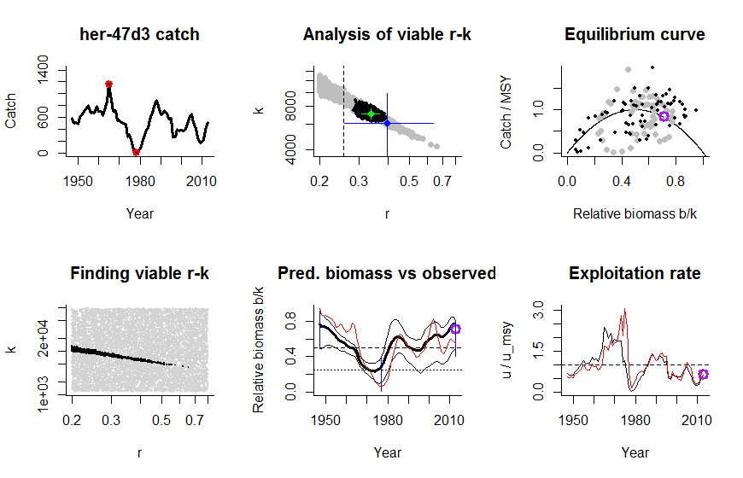
Figure 1. Graphical output of CMSY applied to the fully assessed North Sea herring stock.
The “[stock] catch” graph in the upper left indicates the acronym used for the stock by the assessment working group (here: her-47d3), and shows the time series of catch data used by CMSY. The red circles indicated the highest and the lowest catch, respectively. If the user does not provide prior information on biomass ranges, simple prior rules are applied to catch relative to maximum and minimum catch, and are used to establish likely relative biomass ranges for the beginning and the end of the time series, as well as for an intermediate year (blue vertical lines in in the “Pred. biomass vs observed” graph).
The “Finding viable r-k” graph shows the filtered log-r-k-space, with viable r-k pairs in black and initially tested pairs in grey. While CMSY is executed, this graphs shows progress by adding black dots as viable r-k pairs are found. This search for viable r-k pairs is the most time-demanding part of CMSY.
The “Analysis of viable r-k” graph shows the result of the CMSY-analysis, with viable pairs in grey and the predicted most probable r-k pair in blue, with 95% confidence limits. The black dots are viable pairs identified by the Bayesian implementation of the full Schaefer model, with the green dot showing the predicted most probably r-k pair, with approximated 95% confidence limits. The green dot from the full Schaefer analysis is deemed more reliable and is used as reference for the blue dot from CMSY. r-k pairs to the left of the vertical dashed line are excluded from the analysis, as this section of the viable r-k space is not expected to contain the maximum intrinsic rate of population increase.
The “Pred. biomass vs observed” graph shows in bold the median relative biomass trajectory predicted by CMSY, with 2.5th and 97.5th percentiles. The red line shows the biomass trajectory from the assessment relative to the k estimated by the full Schaefer method. The dashed horizontal line at 0.5 k indicates B_{msy} and the horizontal dotted line at 0.25 k indicates half B_{msy} and thus the border to stock sizes that may result in reduced recruitment. The blue vertical lines show the prior biomass ranges set by the user or by prior rules applied to the catch pattern. In the example of Figure 1, it was assumed that the user knew that the herring stock was, high (0.5-0.9 k) after World War II, low (0.01 – 0.4 k) in the 70s, and high (0.4-0.8 k) again at the end of the time series. The purple point in the final year indicates the 25th percentile of predicted biomass, which could be used as precautionary starting point for harvest control rules.
The “Equilibrium curve” graph shows the Schaefer parabola with catch expressed relative to MSY on the Y-axis and biomass relative to k on the X-axis. Grey dots are catch over biomass predicted by the CMSY method. Black dots are catch relative MSY from the full Schaefer model over biomass from the assessment over k from the full Schaefer model. Dots falling on the parabola indicate catches that will maintain the corresponding biomass. Dots above the parabola will shrink the biomass; dots below the parabola allow the biomass to increase. The purple point shows the catch in the last year over the 25th percentile of predicted biomass.
The “Exploitation rate” graph shows the time series of the catch/biomass ratio (u) relative to the ratio corresponding to MSY, where u_{msy} = 1 – e^{-r/2}. This conversion accounts for the fact that r relates catches to the average annual biomass, whereas the biomass data used in assessments represent biomass at the beginning of the year. The black curve is the exploitation rate resulting from catch relative to biomass predicted by CMSY. The red curve relates catch to the biomass from the assessment, scaled by using the r estimated by the full Schafer model. The dashed horizontal line indicates the maximum sustainable exploitation rate. The purple point in the final year shows catch over the 25th percentile of predicted biomass, as a potential precautionary starting point for harvest control rules.
Figure 2 shows an example for a data-limited stock (here: tusk, Brosme brosme, usk-oth), where only catch and catch-per-unit-effort data from standardized surveys were available. In such stocks, the full Schaefer model was not applied because the quality of the CPUE data was not considered reliable enough. Therefore, no reference point is available in the “Analysis of viable r-k” graph and no black dots are shown in the “Equilibrium curve” graph. Instead, the CPUE data are plotted on a second Y-axis (in red) in the “Predicted biomass vs CPUE” graph and in the “Exploitation rate graph. Here, we would expect the biomass trajectory predicted by CMSY to show a similar trend as the CPUE data, and the exploitation rate trajectory predicted by CMSY to show a similar trend as the catches relative to CPUE. If these trends are similar, as in the example shown in Figure 2, then this builds confidence in the CMSY-predictions.

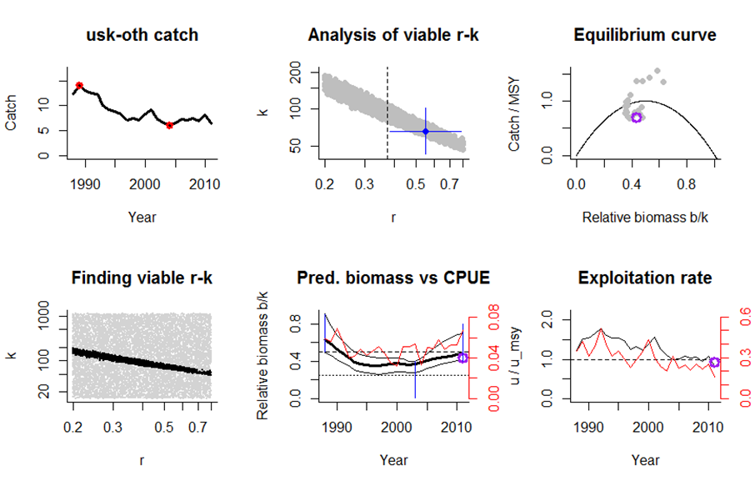
Figure 2. Tusk (Brosme bromse) as an example of CMSY graphical output for a stock where only catch and CPUE data are available. CPUE data are shown directly on a second Y-axis in red in the “Pred. biomass vs CPUE” graph. In the “Exploitation rate” graph, the catch/CPUE ratio is shown in red against a second Y-axis. Note that the trends for biomass and exploitation rate predicted by CMSY correspond well with the respective trends based on CPUE.

Stock | Name | Species | Biomass | Exploitation | Comment
bll-nsea* | Brill | Scophthalmus rhombus | Above B_{msy} | Below F_{msy} | Consistent with CPUE
cod-347d | Cod | Gadus morhua | At half B_{msy} | Below F_{msy} | Good fit with observed biomass; too optimistic in last years where B <= 0.5B_{msy}
dgs-nea | Spurdog | Squalus acanthias | At half B_{msy} | Below F_{msy} | Reasonable fit with observed biomass, too optimistic in last years where B <= 0.5 B_{msy}
her-47d3 | Herring | Clupea harengus | Above B_{msy} | Below F_{msy} | Good fit with observed biomass
had-346a | Haddock | Melanogrammus aeglefinus | Below half B_{msy} | Below F_{msy} | Catch data used; good fit with observed biomass
had-346a | Haddock | Melanogrammus aeglefinus | Below half B_{msy} | Below F_{msy} | Landings data used; same relative assessment as with catch
HLH_M | HLH_M | Simulated medium resilience, high-low-high biomass | Above B_{msy} | Below F_{msy} | Simulated catch used, good fit with simulated data
HLH_M07 | HLH_M | Simulated medium resilience, high-low-high biomass | Above B_{msy} | Below F_{msy} | Simulated landings = 0.7*catch used; same relative assessment as with catch data
gfb-comb* | Great Forkbeard | Phycis blennoides | Near half B_{msy} | At F_{msy} | Good fit with CPUE; maybe too optimistic in last years where B <= 0.5 B_{msy}
lem-nsea* | Lemon sole | Microstomus kitt | Near half B_{msy} | At F_{msy} | Reasonable fit with CPUE; maybe too optimistic in last years because B <= 0.5 B_{msy}
nep-2829* | Nephrops | Nephrops norwegicus | Near half B_{msy} | Near F_{msy} | Reasonable fit with CPUE trends; maybe too optimistic in last years because B <= 0.5 B_{msy}
Pan_bor_1* | Northern shrimp | Pandalus borealis | Near half B_{msy} | Near F_{msy} | Reasonable fit with CPUE trends; maybe too optimistic in last years because B <= 0.5 B_{msy}
Pan_bor_1* | Northern shrimp | Pandalus borealis | Near half B_{msy} | Near F_{msy} | Reasonable fit with CPUE trends; maybe too optimistic in last years because B <= 0.5 B_{msy}
ple-nsea | Plaice | Pleuronectes platessa | Above B_{msy} | BelowF_{msy} | Reasonable fit with recent exploitation, but catches before 1984 are not compatible with observed biomass
rjh-pore* | Blond ray | Raja brachyuran | Above B_{msy} | Below F_{msy} | Same trends as in CPUE
sar-78* | Sardine | Sardina pilchardus | Above B_{msy} | Below F_{msy} | Similar trends as in CPUE
usk-oth* | Tusk | Brosme brosme | Near B_{msy} | Near F_{msy} | Good fit with CPUE trends
Table 1. Overview of stocks assessed with the CMSY method at WKLIFE IV, with a summary of the assessment relative to the MSY framework, and some comments as to the perceived goodness of the assessment. Data-limited stocks are marked with an asterisk in the first column.

Discussion
CMSY Evaluation of fully assessed stocks and simulated stocks
CMSY predictions for relative biomass and relative exploitation rate were compared with those for several fully assessed stocks. Figure 1 showed good agreement between assessments for North Sea herring. A similar satisfying agreement between CMSY and full assessments with regard to relative biomass and relative exploitation rate was obtained for North Sea haddock and for the simulated stock HLH_M. These workshop results confirm the results of previous testing against 24 simulated stocks and 114 global fully assessed stocks (see documents made available for the workshop), where confidence limits of r, k, MSY and final biomass overlapped in more than 90% of the stocks. For North Sea plaice a reasonable CMSY prediction of biomass was only obtained for the years after 1985. For preceding years, the CMSY productivity of r ~ 0.5, which is confirmed by the full Schaefer model and the current official estimate of F_{msy} = 0.25, would predict much higher biomass given the catches.
Warning about reduced recruitment at low stock sizes
Productivity models such as used by CMSY assume average recruitment across all stock sizes, including stock sizes below half of B_{msy}, where fisheries textbooks predict an increased risk of reduced recruitment. In other words, if recruitment is indeed reduced, then production models and CMSY will overestimate production of new biomass and will underestimate exploitation rates. This is visible in Figure 1 for North Sea herring in the 1970s. It is also prominently visible for North Sea cod (see Appendix I). Thus, if the final biomass predicted by CMSY is close to half of B_{msy}, then extra precaution should be applied if CMSY is used for management. For example, instead of the median a lower percentile of predicted biomass could be used, such as the 25th percentile or even less. Stock recovery predicted by CMSY from low biomass should always be confirmed by independent data, such as CPUE.
Impact of using landings instead of catch
Whenever possible, stock assessment is based on true removals from the stock, i.e., including discards and other unallocated removals. But for data-limited stocks, estimates of discard are typically not available and only the reported landings can be used as indicator of removals. The effect of using landings instead of catch for CMSY assessment was explored in a simulated stock and also in North Sea haddock. For the simulated stock (HLH_M), the true catches corresponding to r, k and true biomass were reduced by 30%, and the CMSY analysis was rerun with all other data being the same (HLH_M07). As a result, the estimate of r remained practically unaffected, but the estimates of MSY, k and biomass were reduced by about 30%. However, the relative estimates of b/k and c/b remained unchanged (compare assessments of HLH_M and HLH_M07 in Appendix I). Similar results were obtained for the case of North Sea haddock, where discards constitute about 40% of the catch. Again, the CMSY estimate of r remained nearly unchanged, whereas the estimates of MSY, k and predicted biomass decreased by about 40%. The relative assessments, however, remained largely unchanged (compare assessments of had-346a and had-346a-land in Appendix I). Thus, the CMSY methods seems capable of providing reliable relative assessments for stocks for which only landing data are available.
CMSY evaluation of data-limited stocks
At WKLIFE IV, CMSY was applied to 9 data-limited stocks, including three invertebrates and one elasmobranch (see Table 1). Trends in CPUE data were compared with the trends in CMSY predictions for relative biomass and relative exploitation rate. Note that in the CMSY graphical output, CPUE and catch/CPUE are plotted on a second axis, i.e., the height and spread of the CPUE-based trajectories cannot be directly compared with the CMSY prediction, only the respective trends. There was no case of clearly contradictory trends, such as CPUE clearly increasing while CMSY predicted biomass was clearly decreasing. Rather, the trends were very similar, thus building confidence in the CMSY prediction (see summary in Table 1). In five of the data-limited stocks, final biomass predicted by CMSY was near half of B_{msy}, i.e., reduced recruitment cannot be ruled out and in these cases the CMSY prediction may be too optimistic.
Conclusion
The CMSY method produce reasonable predictions for relative biomass and relative exploitation rate when compared with fully assessed stocks, simulated stocks and data-limited stocks for which CPUE data were available. Application to stocks for which only landings data are available should not be a problem as long as the proportion of discards can be expected to be about the same throughout the time series. Confirmation of predictions should then be obtained from, e.g., length-based methods. Extra caution need to be applied when the assumption of average recruitment is likely to be incorrect, e.g. at stock sizes below half B_{msy} or during periods known to be unfavorable for recruitment.

References
Martell, S. and R. Froese, 2013. A simple method for estimating MSY from catch and resilience. Fish and Fisheries 14: 504-514, doi:10.1111/j.1467-2979.2012.00485.x available from http://www.fishbase.de/rfroese/CatchMSY_Final.pdf
McAllister, M. K., Ellen K. Pikitch, and E. A. Babcock. "Using demographic methods to construct Bayesian priors for the intrinsic rate of increase in the Schaefer model and implications for stock rebuilding." Canadian Journal of Fisheries and Aquatic Sciences 58.9 (2001): 1871-1890

Appendix I: Results of applying CMSY to 17 stocks

Species: Scophthalmus rhombus
Name: Brill
Region: Brill in Subarea IV, Divisions IIIa and VIId,e
Stock: bll-nsea
Catch data used from years 1980 - 2012 , biomass = CPUE
Prior initial relative biomass = 0.1 - 0.5
Prior intermediate rel. biomass= 0.3 - 0.9 in year 1992
Prior final relative biomass = 0.4 - 0.8
Future crash with current catches? No
Prior range for r = 0.2 - 0.8 , prior range for k = 3.14 - 251
Results of CMSY analysis with altogether 1648 unique viable r-k pairs
845 r-k pairs above the initial geometric mean of r = 0.379 were analysed
r = 0.549 , 95% CL = 0.384 - 0.784
k = 20.2 , 95% CL = 11.6 - 35.2
MSY = 2.78 , 95% CL = 1.88 - 4.09
Predicted biomass last year = 0.744 2.5th perc = 0.448 97.5th perc = 0.799
Predicted biomass next year = 0.742 2.5th perc = 0.439 97.5th perc = 0.818
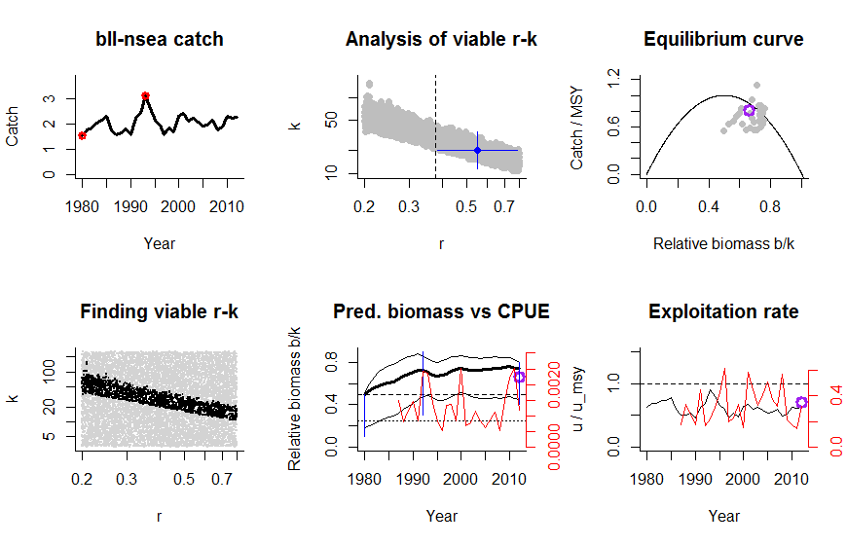

Species: Gadus morhua
Name: Atlantic cod
Region: Cod in Sub-area IV, Divison VIId & Division IIIa (Skagerrak)
Stock: cod-347d
Catch data used from years 1963 - 2013 , biomass = observed
Prior initial relative biomass = 0.1 - 0.5
Prior intermediate rel. biomass= 0.01 - 0.4 in year 2002
Prior final relative biomass = 0.01 - 0.4
Future crash with current catches? Possible
Prior range for r = 0.2 - 0.8 , prior range for k = 367 - 29327
Results from Bayesian Schaefer model using catch & biomass
r = 0.377 , 95% CL = 0.348 - 0.41
k = 3219 , 95% CL = 2312 - 4483
MSY = 304 , 95% CL = 231 - 400
Mean catch / MSY = 0.589
Results of CMSY analysis with altogether 147 unique viable r-k pairs
71 r-k pairs above the initial geometric mean of r = 0.23 were analysed
r = 0.289 , 95% CL = 0.233 - 0.363
k = 3797 , 95% CL = 2459 - 5815
MSY = 275 , 95% CL = 183 - 413
Predicted biomass last year = 0.258 2.5th perc = 0.0248 97.5th perc = 0.39
Predicted biomass next year = 0.296 2.5th perc = 0.0217 97.5th perc = 0.442

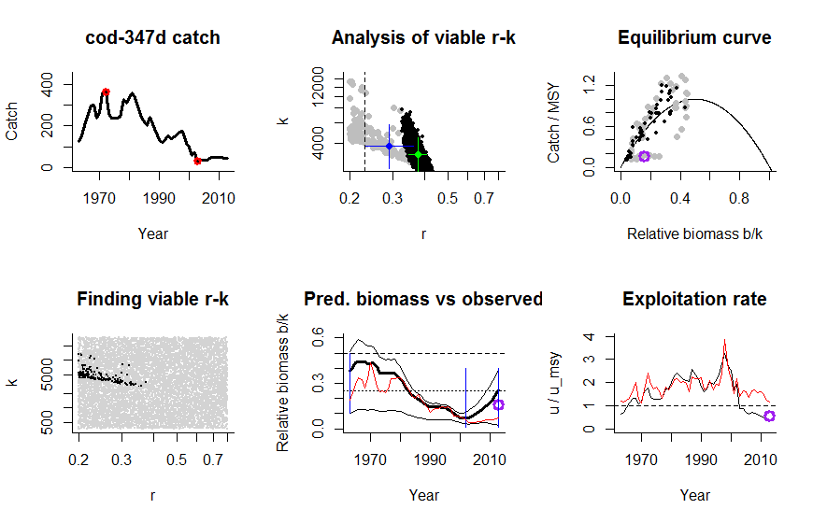

Species: Squalus acanthias
Name: Spurdog
Region: Spurdog in Northeast Atlantic
Stock: dgs-nea
Catch data used from years 1950 - 2009 , biomass = observed
Prior initial relative biomass = 0.5 - 0.9
Prior intermediate rel. biomass= 0.3 - 0.9 in year 1962
Prior final relative biomass = 0.01 - 0.4
Future crash with current catches? Possible
Prior range for r = 0.05 - 0.5 , prior range for k = 62.3 - 19932
Results from Bayesian Schaefer model using catch & biomass
r = 0.122 , 95% CL = 0.104 - 0.142
k = 1409 , 95% CL = 1227 - 1617
MSY = 42.9 , 95% CL = 36 - 51.2
Mean catch / MSY = 0.802
Results of CMSY analysis with altogether 2369 unique viable r-k pairs
1170 r-k pairs above the initial geometric mean of r = 0.0795 were analysed
r = 0.183 , 95% CL = 0.0834 - 0.4
k = 774 , 95% CL = 307 - 1951
MSY = 35.3 , 95% CL = 26.8 - 46.6
Predicted biomass last year = 0.28 2.5th perc = 0.0316 97.5th perc = 0.395
Predicted biomass next year = 0.301 2.5th perc = 0.0325 97.5th perc = 0.423
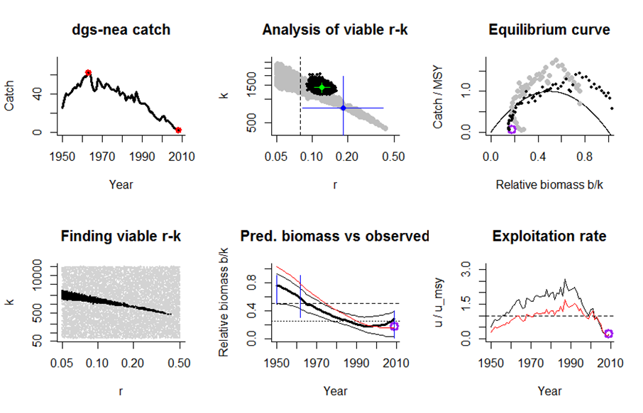
Species: Clupea harengus
Name: Atlantic herring
Region: Herring in Sub-area IV, Divisions VIId & IIIa (autumn-spawners)
Stock: her-47d3
Catch data used from years 1947 - 2013 , biomass = observed
Prior initial relative biomass = 0.5 - 0.9
Prior intermediate rel. biomass= 0.01 - 0.4 in year 1977
Prior final relative biomass = 0.4 - 0.8
Future crash with current catches? No
Prior range for r = 0.2 - 0.8 , prior range for k = 1169 - 93504
Results from Bayesian Schaefer model using catch & biomass
r = 0.336 , 95% CL = 0.307 - 0.369
k = 7094 , 95% CL = 6528 - 7710
MSY = 596 , 95% CL = 547 - 650
Mean catch / MSY = 0.871
Results of CMSY analysis with altogether 1393 unique viable r-k pairs
566 r-k pairs above the initial geometric mean of r = 0.257 were analysed
r = 0.397 , 95% CL = 0.259 - 0.639
k = 6140 , 95% CL = 3648 - 9828
MSY = 609 , 95% CL = 559 - 662
Predicted biomass last year = 0.765 2.5th perc = 0.487 97.5th perc = 0.799
Predicted biomass next year = 0.751 2.5th perc = 0.494 97.5th perc = 0.801

Species: Melanogrammus aeglefinus
Name: Haddock
Region: Haddock in the North Sea
Stock: had-346a
Catch data used from years 1972 - 2013 , biomass = observed
Prior initial relative biomass = 0.5 - 0.9
Prior intermediate rel. biomass= 0 - 1 in year 1992
Prior final relative biomass = 0.01 - 0.4
Future crash with current catches? No
Prior range for r = 0.2 - 0.8 , prior range for k = 500 - 39992
Results from Bayesian Schaefer model using catch & biomass
r = 0.287 , 95% CL = 0.26 - 0.316
k = 2831 , 95% CL = 2602 - 3080
MSY = 203 , 95% CL = 182 - 227
Mean catch / MSY = 0.891
Results of CMSY analysis with altogether 605 unique viable r-k pairs
323 r-k pairs above the initial geometric mean of r = 0.235 were analysed
r = 0.359 , 95% CL = 0.245 - 0.552
k = 2447 , 95% CL = 1440 - 3953
MSY = 219 , 95% CL = 180 - 267
Predicted biomass last year b/k = 0.259 2.5th perc b/k = 0.0486 97.5th perc b/k = 0.393
Precautionary 25th percentile b/k = 0.158

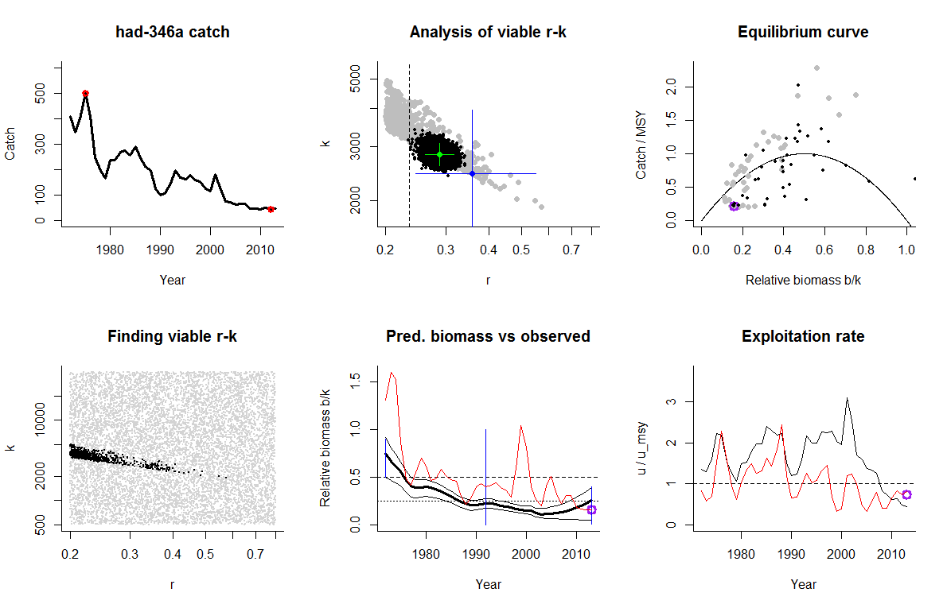

Species: Melanogrammus aeglefinus
Name: Haddock
Region: Haddock in the North Sea
Stock: had-346a-land
Landings data used from years 1972 - 2013 , biomass = observed
Prior initial relative biomass = 0.5 - 0.9
Prior intermediate rel. biomass= 0 - 1 in year 1992
Prior final relative biomass = 0.01 - 0.4
Future crash with current catches? No
Prior range for r = 0.2 - 0.8 , prior range for k = 237 - 18936
Results from Bayesian Schaefer model using catch & biomass
r = 0.252 , 95% CL = 0.227 - 0.28
k = 2498 , 95% CL = 2291 - 2723
MSY = 157 , 95% CL = 140 - 177
Mean catch / MSY = 0.665
Results of CMSY analysis with altogether 591 unique viable r-k pairs
343 r-k pairs above the initial geometric mean of r = 0.241 were analysed
r = 0.387 , 95% CL = 0.246 - 0.655
k = 1294 , 95% CL = 702 - 2211
MSY = 125 , 95% CL = 106 - 148
Predicted biomass last year b/k = 0.265 2.5th perc b/k = 0.0647 97.5th perc b/k = 0.395
Precautionary 25th percentile b/k = 0.168

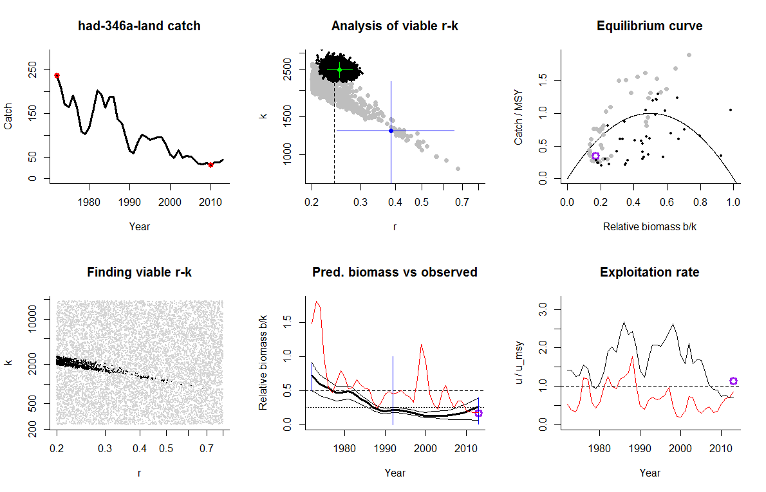

Species: Simulated stock with medium resilience and high-low-high biomass
Name: NA
Region: NA
Stock: HLH_M
Catch data used from years 1 - 50 , biomass = simulated
Prior initial relative biomass = 0.5 - 0.9
Prior intermediate rel. biomass= 0.01 - 0.4 in year 25
Prior final relative biomass = 0.4 - 0.8
Future crash with current catches? No
Prior range for r = 0.2 - 0.8 , prior range for k = 178 - 14236
Results from Bayesian Schaefer model using catch & biomass
r = 0.497 , 95% CL = 0.461 - 0.537
k = 994 , 95% CL = 907 - 1089
MSY = 124 , 95% CL = 115 - 132
Mean catch / MSY = 0.934
Results of CMSY analysis with altogether 1933 unique viable r-k pairs
1066 r-k pairs above the initial geometric mean of r = 0.344 were analysed
r = 0.522 , 95% CL = 0.349 - 0.782
k = 974 , 95% CL = 623 - 1520
MSY = 127 , 95% CL = 117 - 138
Predicted biomass last year b/k = 0.679 2.5th perc b/k = 0.444 97.5th perc b/k = 0.769
Precautionary 25th percentile b/k = 0.597
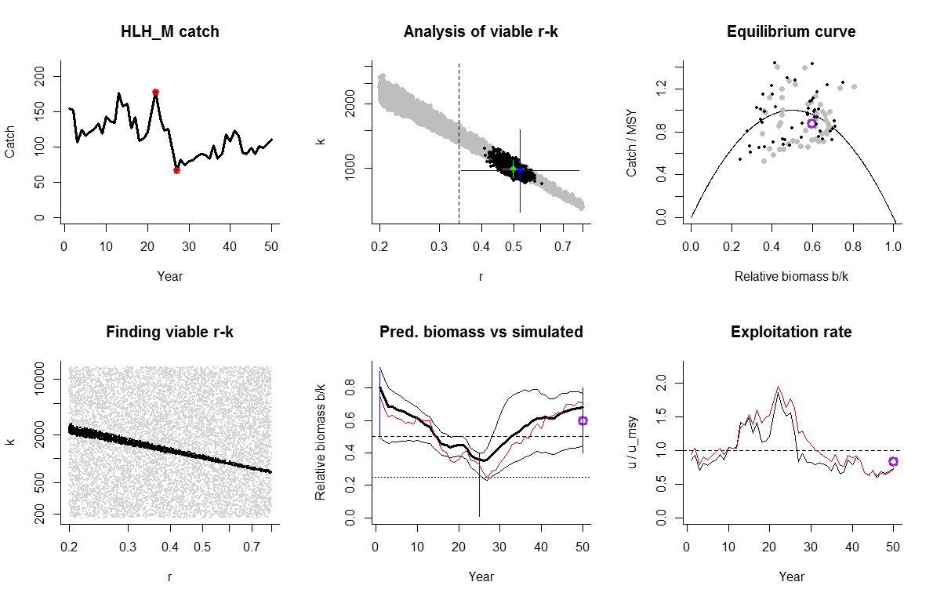

Species: Simulated stock with medium resilience and high-low-high biomass
Name: NA
Region: NA
Stock: HLH_M07
Landings obtained as catches -30% of HLH_M used from years 1 - 50 , biomass same as HLH_M
Prior initial relative biomass = 0.5 - 0.9
Prior intermediate rel. biomass= 0.01 - 0.4 in year 25
Prior final relative biomass = 0.4 - 0.8
Future crash with current catches? No
Prior range for r = 0.2 - 0.8 , prior range for k = 125 - 9965
Results from Bayesian Schaefer model using catch & biomass
r = 0.425 , 95% CL = 0.373 - 0.483
k = 863 , 95% CL = 783 - 952
MSY = 91.7 , 95% CL = 83.9 - 100
Mean catch / MSY = 0.881
Results of CMSY analysis with altogether 1970 unique viable r-k pairs
1096 r-k pairs above the initial geometric mean of r = 0.344 were analysed
r = 0.522 , 95% CL = 0.349 - 0.782
k = 683 , 95% CL = 438 - 1063
MSY = 89.1 , 95% CL = 82.5 - 96.2
Predicted biomass last year b/k = 0.679 2.5th perc b/k = 0.436 97.5th perc b/k = 0.767
Precautionary 25th percentile b/k = 0.597
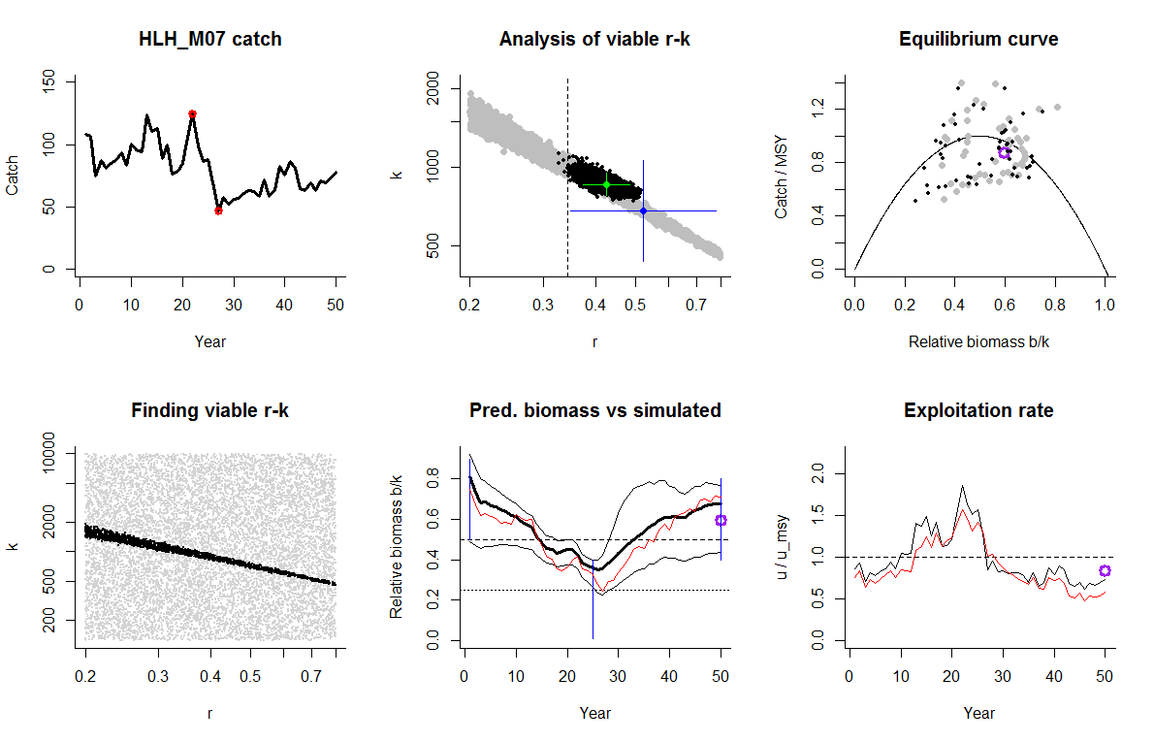
Species: Phycis blennoides
Name: Great Forkbeard
Region: Great Forkbeard in Northeast Atlantic
Stock: gfb-comb
Catch data used from years 1988 - 2013 , biomass = CPUE
Prior initial relative biomass = 0.1 - 0.5
Prior intermediate rel. biomass= 0.3 - 0.9 in year 1999
Prior final relative biomass = 0.01 - 0.4
Future crash with current catches? No
Prior range for r = 0.2 - 0.8 , prior range for k = 5.52 - 442
Results of CMSY analysis with altogether 1071 unique viable r-k pairs
629 r-k pairs above the initial geometric mean of r = 0.298 were analysed
r = 0.484 , 95% CL = 0.301 - 0.779
k = 27.7 , 95% CL = 15.5 - 49.6
MSY = 3.35 , 95% CL = 2.72 - 4.13
Predicted biomass last year = 0.295 2.5th perc = 0.1 97.5th perc = 0.396
Predicted biomass next year = 0.318 2.5th perc = 0.0837 97.5th perc = 0.442
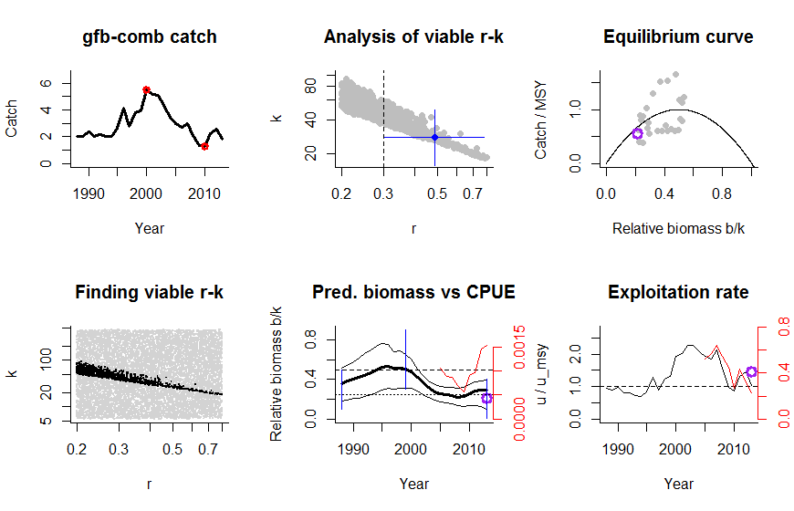

Species: Microstomus kitt
Name: Lemon sole
Region: Lemon sole in Subarea IV (North Sea) and Divisions IIIa (Skagerrak–Kattegat) and VIId (Eastern Channel)
Stock: lem-nsea
Catch data used from years 1975 - 2012 , biomass = CPUE
Prior initial relative biomass = 0.1 - 0.5
Prior intermediate rel. biomass= 0.3 - 0.9 in year 1982
Prior final relative biomass = 0.01 - 0.4
Future crash with current catches? No
Prior range for r = 0.2 - 0.8 , prior range for k = 9.51 - 761
Results of CMSY analysis with altogether 1151 unique viable r-k pairs
615 r-k pairs above the initial geometric mean of r = 0.258 were analysed
r = 0.449 , 95% CL = 0.26 - 0.776
k = 63.6 , 95% CL = 34.2 - 118
MSY = 7.15 , 95% CL = 6.17 - 8.29
Predicted biomass last year = 0.282 2.5th perc = 0.0943 97.5th perc = 0.396
Predicted biomass next year = 0.3 2.5th perc = 0.0777 97.5th perc = 0.434
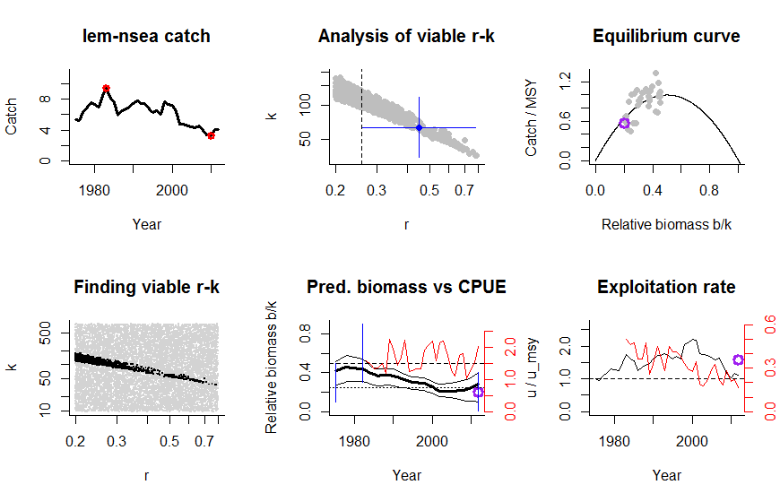
Species: Nephrops norvegicus
Name: Nephrops
Region: Nephrops in FUs 28 and 29
Stock: nep-2829
Catch data used from years 1984 - 2013 , biomass = CPUE
Prior initial relative biomass = 0.1 - 0.5
Prior intermediate rel. biomass= 0.01 - 0.4 in year 1995
Prior final relative biomass = 0.01 - 0.4
Future crash with current catches? No
Prior range for r = 0.2 - 0.8 , prior range for k = 0.524 - 41.9
Results of CMSY analysis with altogether 1915 unique viable r-k pairs
1159 r-k pairs above the initial geometric mean of r = 0.247 were analysed
r = 0.417 , 95% CL = 0.259 - 0.687
k = 4.85 , 95% CL = 2.06 - 11.1
MSY = 0.505 , 95% CL = 0.252 - 1.01
Predicted biomass last year = 0.269 2.5th perc = 0.0711 97.5th perc = 0.395
Predicted biomass next year = 0.292 2.5th perc = 0.0643 97.5th perc = 0.43
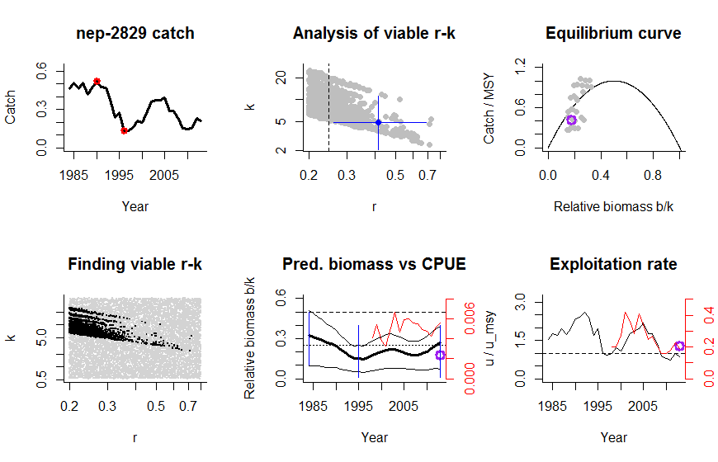

Species: Pandalus borealis
Name: Northern shrimp
Region:
Stock: Pan_bor_1
Catch data used from years 1988 - 2013 , biomass = CPUE
Prior initial relative biomass = 0.1 - 0.5
Prior intermediate rel. biomass= 0.01 - 0.4 in year 2005
Prior final relative biomass = 0.01 - 0.4
Future crash with current catches? Possible
Prior range for r = 0.2 - 0.8 , prior range for k = 0.853 - 68.2
Results of CMSY analysis with altogether 1992 unique viable r-k pairs
1093 r-k pairs above the initial geometric mean of r = 0.255 were analysed
r = 0.449 , 95% CL = 0.26 - 0.776
k = 7.2 , 95% CL = 3.01 - 17.2
MSY = 0.808 , 95% CL = 0.426 - 1.53
Predicted biomass last year = 0.253 2.5th perc = 0.0269 97.5th perc = 0.394
Predicted biomass next year = 0.288 2.5th perc = 0.018 97.5th perc = 0.462

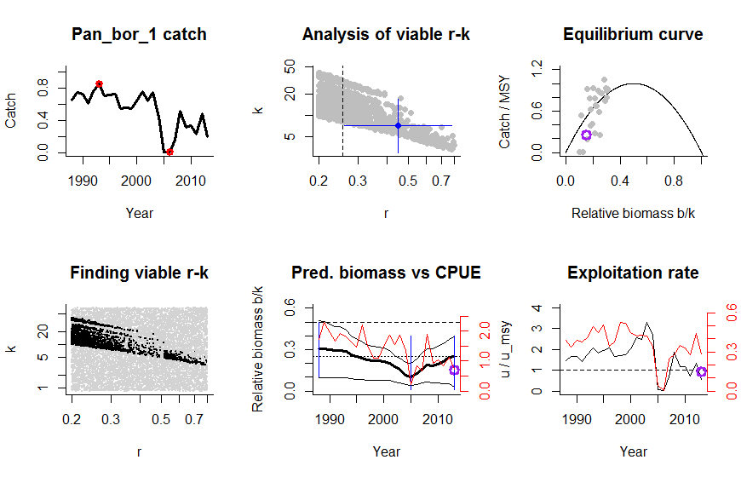

Species: Pandalus borealis
Name: Northern shrimp
Region: Isafjardardjup
Stock: Pan_bor_2
Catch data used from years 1988 - 2013 , biomass = CPUE
Prior initial relative biomass = 0.1 - 0.5
Prior intermediate rel. biomass= 0.01 - 0.4 in year 2002
Prior final relative biomass = 0.01 - 0.4
Future crash with current catches? Possible
Prior range for r = 0.2 - 0.8 , prior range for k = 3.1 - 248
Results of CMSY analysis with altogether 1236 unique viable r-k pairs
669 r-k pairs above the initial geometric mean of r = 0.244 were analysed
r = 0.359 , 95% CL = 0.245 - 0.541
k = 29.2 , 95% CL = 13.2 - 62.4
MSY = 2.62 , 95% CL = 1.24 - 5.51
Predicted biomass last year = 0.267 2.5th perc = 0.0482 97.5th perc = 0.394
Predicted biomass next year = 0.284 2.5th perc = 0.0288 97.5th perc = 0.436
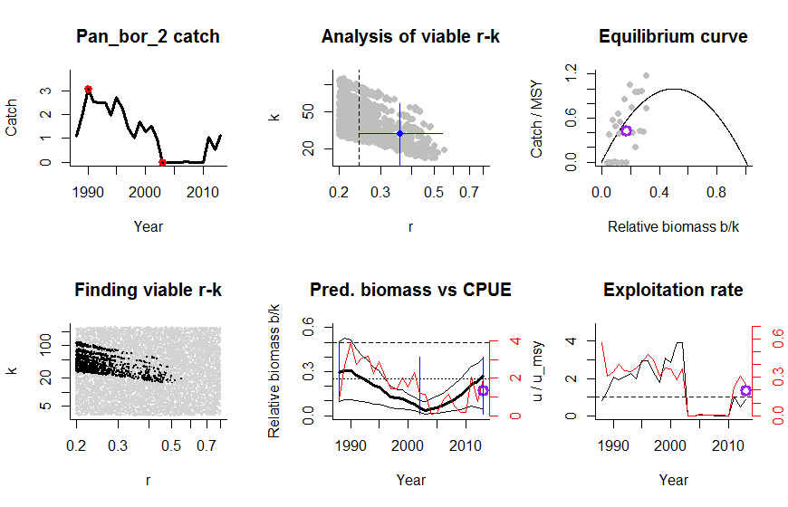

Species: Pleuronectes platessa
Name: Plaice
Region: Plaice in the North Sea
Stock: ple-nsea
Catch data used from years 1957 - 2013 , biomass = observed
Prior initial relative biomass = 0.1 - 0.5
Prior intermediate rel. biomass= 0.01 - 0.4 in year 1997
Prior final relative biomass = 0.4 - 0.8
Future crash with current catches? No
Prior range for r = 0.2 - 0.8 , prior range for k = 346 - 27650
Results from Bayesian Schaefer model using catch & biomass
r = 0.495 , 95% CL = 0.457 - 0.537
k = 2057 , 95% CL = 1478 - 2864
MSY = 255 , 95% CL = 196 - 332
Mean catch / MSY = 0.632
Results of CMSY analysis with altogether 2604 unique viable r-k pairs
745 r-k pairs above the initial geometric mean of r = 0.298 were analysed
r = 0.484 , 95% CL = 0.301 - 0.779
k = 1715 , 95% CL = 1019 - 2888
MSY = 208 , 95% CL = 190 - 227
Predicted biomass last year b/k = 0.73 2.5th perc b/k = 0.434 97.5th perc b/k = 0.799
Precautionary 25th percentile b/k = 0.616
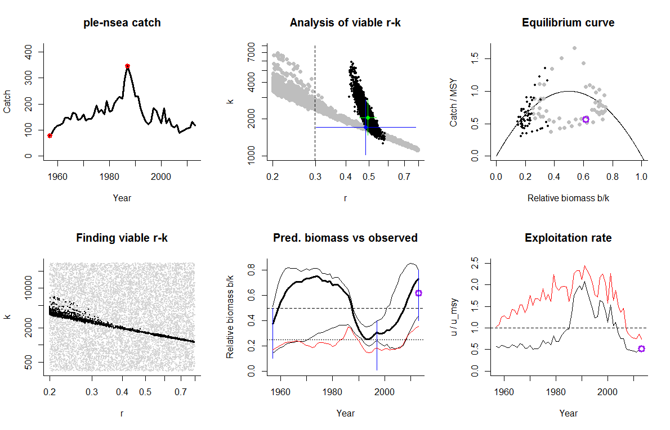
Species: Raja brachyura
Name: Blond ray
Region: Blond ray in Division Ixa
Stock: rjh-pore
Catch data used from years 2003 - 2013 , biomass = CPUE
Prior initial relative biomass = 0.5 - 0.9
Prior intermediate rel. biomass= 0 - 1 in year 2008
Prior final relative biomass = 0.4 - 0.8
Future crash with current catches? No
Prior range for r = 0.2 - 0.8 , prior range for k = 0.586 - 46.9
Results of CMSY analysis with altogether 2002 unique viable r-k pairs
1153 r-k pairs above the initial geometric mean of r = 0.32 were analysed
r = 0.509 , 95% CL = 0.332 - 0.781
k = 3.06 , 95% CL = 1.6 - 5.87
MSY = 0.389 , 95% CL = 0.251 - 0.604
Predicted biomass last year = 0.765 2.5th perc = 0.434 97.5th perc = 0.799
Predicted biomass next year = 0.768 2.5th perc = 0.428 97.5th perc = 0.83
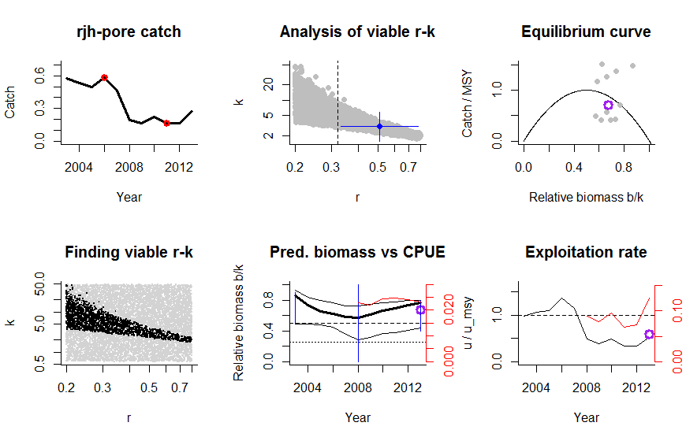
Species: Sardina pilchardus
Name: Sardine
Region: Sardine in Divisions VIIIa,b,d and Subarea VII
Stock: sar-78
Catch data used from years 1989 - 2012 , biomass = CPUE
Prior initial relative biomass = 0.5 - 0.9
Prior intermediate rel. biomass= 0.3 - 0.9 in year 2002
Prior final relative biomass = 0.4 - 0.8
Future crash with current catches? No
Prior range for r = 0.2 - 0.8 , prior range for k = 42.5 - 3397
Results of CMSY analysis with altogether 1841 unique viable r-k pairs
972 r-k pairs above the initial geometric mean of r = 0.379 were analysed
r = 0.549 , 95% CL = 0.384 - 0.784
k = 313 , 95% CL = 177 - 552
MSY = 42.9 , 95% CL = 28.3 - 65
Predicted biomass last year = 0.722 2.5th perc = 0.413 97.5th perc = 0.798
Predicted biomass next year = 0.711 2.5th perc = 0.382 97.5th perc = 0.814
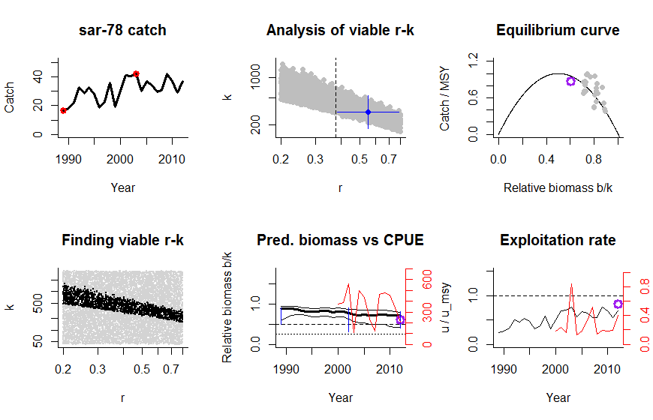
Species: Brosme brosme
Name: Tusk
Region: Tusk in Divisions IIIa, Vb, VIa, and XIIb and Subareas IV, VII, VIII, and IX (other areas).
Stock: usk-oth
Catch data used from years 1988 - 2011 , biomass = CPUE
Prior initial relative biomass = 0.5 - 0.9
Prior intermediate rel. biomass= 0.01 - 0.4 in year 2003
Prior final relative biomass = 0.4 - 0.8
Future crash with current catches? Possible
Prior range for r = 0.2 - 0.8 , prior range for k = 14.1 - 1130
Results of CMSY analysis with altogether 2041 unique viable r-k pairs
1033 r-k pairs above the initial geometric mean of r = 0.373 were analysed
r = 0.549 , 95% CL = 0.384 - 0.784
k = 66.3 , 95% CL = 42.9 - 103
MSY = 9.1 , 95% CL = 7.79 - 10.6
Predicted biomass last year = 0.48 2.5th perc = 0.403 97.5th perc = 0.693
Predicted biomass next year = 0.503 2.5th perc = 0.412 97.5th perc = 0.729

