Report of the breakout group on CMSY at the WKLIFE V workshop at IPMA

in Lisbon, 5-9 October 2015

Produced by Rainer Froese and Gianpaolo Coro, October 2015

Members of breakout group:
Rainer Froese, GEOMAR, Germany (chair), rfroese@geomar.de
Gianpaolo Coro, CNR, Italy, gianpaolo.coro@isti.cnr.it
Holger Haslob, Thünen Institute of Sea Fisheries, Germany
Luis Ridao Cruz, Faroe Marine Research Institute, Faroes Islands
David Miller, IMARES, Netherlands

Content of Report
General introduction to CMSY 1

How to find the most probable estimates of r and k among viable r-k pairs 3

Testing the sensitivity of CMSY to depletion patterns and resilience of stocks 4

CMSY analysis of catch data of fully assessed stocks 7

CMSY analysis of catch data of data-limited stocks 13

Comparing results with observation error of catch with sigma 0.1 and 0.2 23

References 27

General introduction to CMSY
CMSY is a method for estimating maximum sustainable yield (MSY) and related fisheries reference points (B_{msy}, F_{msy}) from catch data and resilience, developed by Froese et al. (2015). It is an advanced implementation of the Catch-MSY method of Martell & Froese (2013). CMSY was tested and found satisfactory at the WKLIVE IV workshop in Lisbon, October 2014 (ICES 2014) and at an ICCAT workshop on data limited stocks in Madrid, June 2015 (Froese 2015). If managers, experts or stakeholders have a perception about the depletion history and the current status of a given stock, then CMSY can test such hypotheses against observed catches and the known resilience of the species. If combinations of productivity and stock size are found that are compatible with catches and resilience, then the stock status and exploitation rate are presented in an MSY-framework. CMSY has been tested against simulated data, where the “true” parameter values were known, and against over one hundred fully assessed stocks, with good agreement between CMSY predictions and “true” or observed data. The full documentation of these tests was available to the participants of WKLIFE V and will be published as online supplement to Froese et al. (2015), which was accepted pending revision as of this writing. This report contains several examples of applying CMSY to catch data made available at WKLIFE V. Note that part of the CMSY code is a Bayesian state-space implementation of a full Schaefer model (BSM). If abundance data are made available, e.g. as total biomass, catch per unit of effort, or stock size index, then BSM will analyze these data and show the results in the printout and in the graphical output, so that CMSY results are put in perspective. BSM results can also be used in their own right. Note that time series of abundance can be shorter (=start later) than those for catches. If abundance data are available for fewer than e.g. 9 years, then they are not analyzed by BSM but shown with a second Y-axis in the CMSY graphical output.
With the CMSY method, prior parameter ranges for the maximum intrinsic range of population increase (r) and for unexploited population size or carrying capacity (k) are filtered with a Monte Carlo approach to detect ‘viable’ r-k pairs. A parameter pair is deemed ‘viable’ if the corresponding biomass trajectories calculated with a Schaefer model are compatible with the observed catches, in the sense that predicted biomass does not overshoot assumed carrying capacity nor crash the stock. Also, predicted biomass shall be compatible with prior estimates of relative biomass ranges for the beginning and the end of the respective time series. Optionally, a third intermediate prior biomass range can be provided to reflect extraordinary year classes or stock depletions. Also optionally, an indication whether the stock is likely to crash within three years if current catches continue can be given. This will improve the estimation of biomass in the final years. Examples of questions to be put to experts to derive the priors required by CMSY are shown in Table 1.
Table 1. Examples of questions to be put to experts to establish priors for CMSY analysis.
Prior | Question to experts
Start year for catch time series | From what year onward are catch data deemed reliable?
Relative start- and end biomass  B/B₀ | What was the most likely exploitation level at the beginning and end of that time series: light, full, or overfishing? Given this exploitation level, what was the most likely status of the stock, good or bad?
Relative intermediate biomass  B/B₀ | Is there an intermediate year where, e.g., exploitation changed from light to full, or where an extraordinary large year class entered the fishery?
2 M ≈ r | What is your best guess for the range of values including natural mortality of adults (M)?
2 F_{msy} ≈ r | What is your best guess for the range of values including maximum sustainable fishing mortality (F_{msy})?
Resilience | What is the classification of resilience for this species: very low, low, medium or high?
B/B₀ < 0.2 : Possible / No | If current catches continue, is it likely that the stock will be outside of safe biological limits within the next 3 years?

Based on the answers of the experts, the most probable ranges for relative biomass are chosen from Table 2 and the most probable ranges for r are chosen from Table 3.

Table 2. Prior relative biomass ranges B/k used by CMSY for analyzing the simulated data.
Point in time series | Strong depletion | Low depletion
Beginning | 0.1 – 0.5 | 0.5 – 0.9
Intermediate | 0.01 – 0.4 | 0.3 – 0.9
End | 0.01 – 0.4 | 0.4 – 0.8

Table 3. Prior ranges for parameter r, based on classification of resilience.
Resilience | prior r range
High | 0.6 – 1.5
Medium | 0.2 – 0.8
Low | 0.05 – 0.5
Very low | 0.015 – 0.1

A fit-for-use-in-assessments version of the R code for CMSY and BSM was produced and tested at the WKLIVE V meeting, together with a user manual. These were made available at the share point of the meeting and will be publicly available as part of the online material of Froese et al. (2015).

How to find the most probable estimates of r and k among viable r-k pairs
A question that came up during the WKLIVE V meeting was how CMSY determines the most probable r-k pair.
A plot of viable r-k pairs typically results in a triangular-shaped cloud in log r-k space. A special algorithm is applied by CMSY to select the most probable r-k pair from the tip-side section of the triangle and to establish approximate confidence limits. This algorithm is guided by the following considerations:
(1) We are searching for the highest rate of increase that a given population can support. Obviously, this rate should be found among the highest r-values identified as “viable” within the prior r-range, i.e., in the tip-side of the triangle.
(2) The uniform prior ranges for r as used by CMSY (see Table 3) are derived from expert knowledge, basically saying that a central value with a log-normal distribution of r is expected to occur somewhere within these ranges, with a low probability that the central value will fall on the upper or lower bound of the ranges. However, by design, the triangle of “viable” r-k pairs found by CMSY always touches the lower bound of the prior r-range, because observed catches can always be explained by large stock sizes, such as predicted for low values of r. Including these low-r-high-k pairs in the search for the most probable r-k pair makes the most probable r highly dependent on the lower bound of the prior r range, and it creates a bias of underestimating r and overestimating k, such as documented in Martell and Froese (2013). Figure 1 shows some examples (black dots) of probable r-k pairs as identified by a full Schaefer model (BSM). As can be seen, these clouds of probable r-k pairs typically occur in the right-hand or tip-side of the triangle of viable r-values, and very rarely in the left-hand side.
A 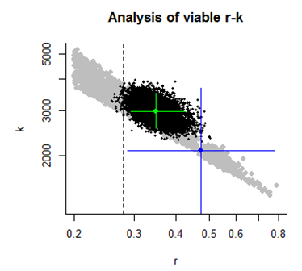 | B 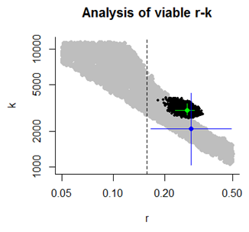
C 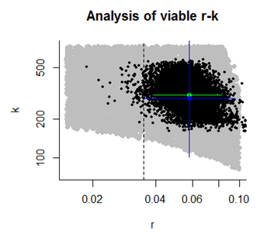 | D 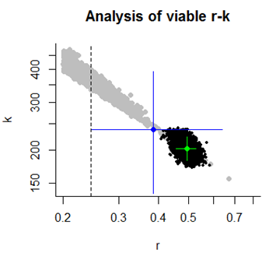
Figure 1. The ellipsoid clouds of black dots show the distribution of probable r-k pairs based on a Bayesian Schaefer model analysis. These clouds typically overlap with the right-hand side of viable r-k pairs estimated by CMSY. The green cross shows the most probable r-k pair from a full Schaefer analysis, whereas the blue cross shows the most probable r-k pair from CMSY analysis. The extension of the cross indicates approximate 95% confidence limits.
CMSY overcomes the bias in Martell and Froese (2013) by a very simple procedure: it estimates the geometric mean of the viable r-values and discards values below the geometric mean. The remaining r-values are then split into 25 bins of equal width in log-space. The median of the mid-values of occupied bins is taken as the most probable estimate of r. This procedure gives equal weight to all occupied bins and reduces the bias caused by the triangular (instead of ellipsoid) shape of the tip section. Taking the median instead of the mean gives less weight to outliers. Approximate 95% confidence limits of r are obtained as 2.5th and 97.5th percentiles of the mid-values of occupied bins.

Testing the sensitivity of CMSY to depletion patterns and resilience of stocks
CMSY assessments of 48 simulated stocks were analysed to detect the sensitivity of the CMSY method to different patterns and contrasts in stock biomass and to different levels of resilience of the species. Resilience ranges of Very low, Low, Medium and High resilience were analysed (Table 3). The simulations covered a range of biomass scenarios, including strongly as well as lightly depleted stocks, with monotone stable or monotone changing (i.e., steadily decreasing or increasing) or with alternating biomass trajectories: patterns of high-high (HH), high-low (HL), high-low-high (HLH), low-low (LL), low-high (LH), and low-high-low (LHL) biomass trends. Resilience categories were translated into r-ranges as shown in Table 3. The detailed analyses of the 48 simulated stocks were available to WKLIFE V participants (on the share point). The results of the sensitivity analysis are shown in Table 4 for the intrinsic rate of population increase r and in Table 5 for the unexploited stock size k.

Table 4. CMSY estimates of r relative to the “true” r used in the simulations. Four estimates that diverge 20% or more from the “true” value are shown in bold.

 | Very low | Low | Medium | High | Median
HH | 1.19 | 1.18 | 1.14 | 1.20 | 1.18
HL | 1.13 | 0.89 | 0.94 | 1.08 | 1.01
HLH | 1.22 | 1.18 | 1.10 | 1.08 | 1.14
LL | 1.16 | 0.92 | 0.94 | 0.87 | 0.93
LH | 1.52 | 1.09 | 0.94 | 1.26 | 1.18
LHL | 1.16 | 1.06 | 1.02 | 1.06 | 1.06
Median | 1.17 | 1.08 | 0.98 | 1.08

With regard to resilience, CMSY estimates exceeded the “true” values of r by 17% (median) in simulated stocks with very low resilience and deviated 2-8 % (medians) in the low to high resilience categories. With regard to biomass patterns, CMSY overestimated the “true” value of r by 14-18% in lightly exploited stocks, where the catches took only a small fraction of the available biomass (HH, HLH, LH). For the other biomass patterns, deviations of CMSY estimates ranged from -7% to +6% (medians). The combination of very low resilience with very light exploitation (LH) led to the largest overestimation of r by 52%.

Table 5. CMSY estimates of unexploited biomass k relative to the “true” k used in the simulations. Two estimates that diverge 20% or more from the “true” value are shown in bold.

 | Very low | Low | Medium | High | Median
HH | 0.87 | 0.85 | 0.94 | 0.96 | 0.90
HL | 0.91 | 1.07 | 1.03 | 0.89 | 0.97
HLH | 1.02 | 0.94 | 0.91 | 0.97 | 0.95
LL | 0.86 | 1.00 | 0.87 | 1.00 | 0.93
LH | 0.36 | 1.14 | 1.11 | 0.73 | 0.92
LHL | 0.90 | 0.94 | 0.96 | 0.92 | 0.93
Median | 0.89 | 0.97 | 0.95 | 0.94

CMSY underestimated the “true” value of unexploited stock size k by 11% (median) in simulated stocks with very low resilience and underestimated the “true” value by 3-5 % (medians) in the low to high resilience categories. In lightly exploited stocks, where the catches took only a small fraction of the available biomass (HH, HLH, LH), CMSY underestimated the “true” values of k by 5-10% (medians). For the other biomass patterns, “true” unexploited stock size was underestimated by 3-8% (medians). The combination of very low resilience and very light exploitation (LH-VL) led to the strongest underestimation of “true” k by 64%.

In conclusion, CMSY analysis appears to be less well suited for lightly exploited stocks where the catches have very little impact on biomass, and for species with very low resilience, where sustainable levels of exploitation represent a very small fraction of biomass.

CMSY analysis of catch data of fully assessed stocks
Species: Melanogrammus aeglefinus , stock: had-faro
Name and region: Faroes grounds haddock , Faroes grounds, ICES Vb
Catch data used from years 1957 - 2014 , biomass = observed
Prior initial relative biomass = 0.4 - 0.8
Prior intermediate rel. biomass= 0.3 - 1 in year 2002
Prior final relative biomass = 0.01 - 0.4
If current catches continue, is the stock likely to crash within 3 years? Possible
Prior range for r = 0.2 - 0.8 , prior range for k = 33.9 - 407
Results from Bayesian Schaefer model using catch & observed biomass
r = 0.476 , 95% CL = 0.399 - 0.521 , k = 153 , 95% CL = 130 - 196
MSY = 18.1 , 95% CL = 14.9 - 22.2
Biomass in last year = 20.9 or 0.136 k
Exploitation rate in last year = 0.14 or 0.589 u.msy
Results of CMSY analysis with altogether 1224 viable trajectories for 1053 r-k pairs
489 r-k pairs above r = 0.237 and 419 trajectories within r-k CLs were analyzed
r = 0.341 , 95% CL = 0.245 - 0.492 , k = 204 , 95% CL = 133 - 302
MSY = 17.4 , 95% CL = 15.4 - 19.6
Relative biomass last year= 0.287 , 2.5th = 0.0246 , 25th = 0.173 , 97.5th = 0.396
Relative biomass next year= 0.33 , 2.5th = 0.0197 , 25th = 0.207 , 97.5th = 0.456
Relative exploitation rate in last year= 0.321 , 25th = 0.532
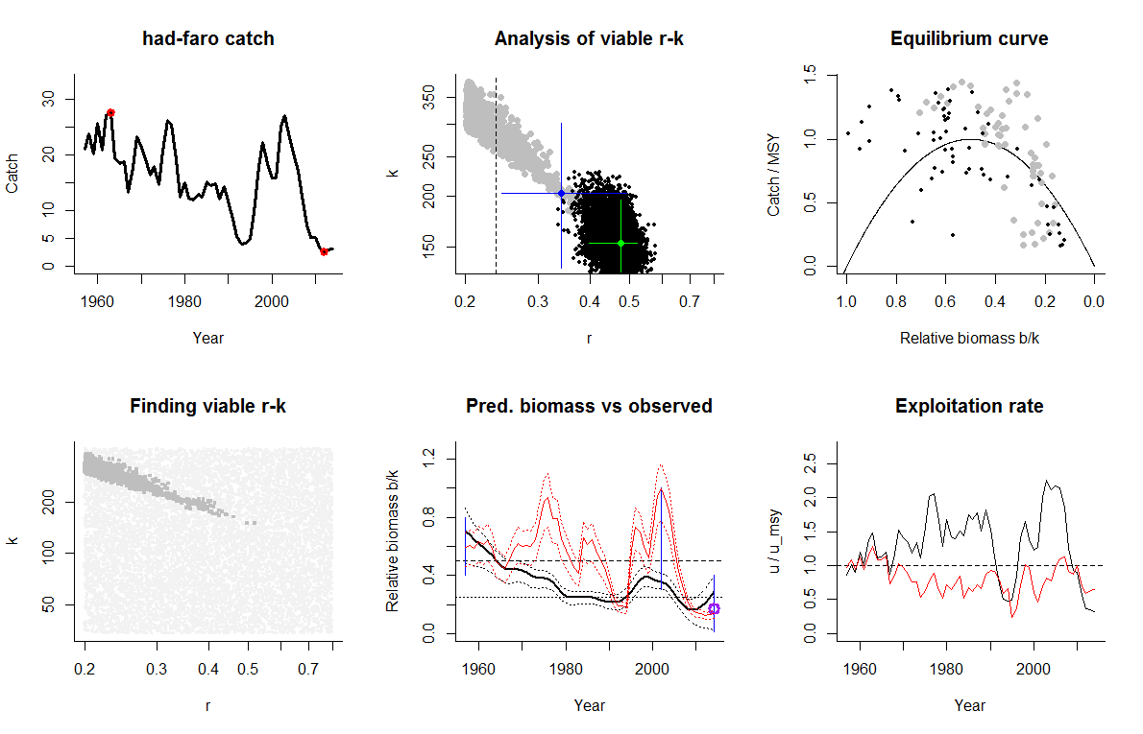
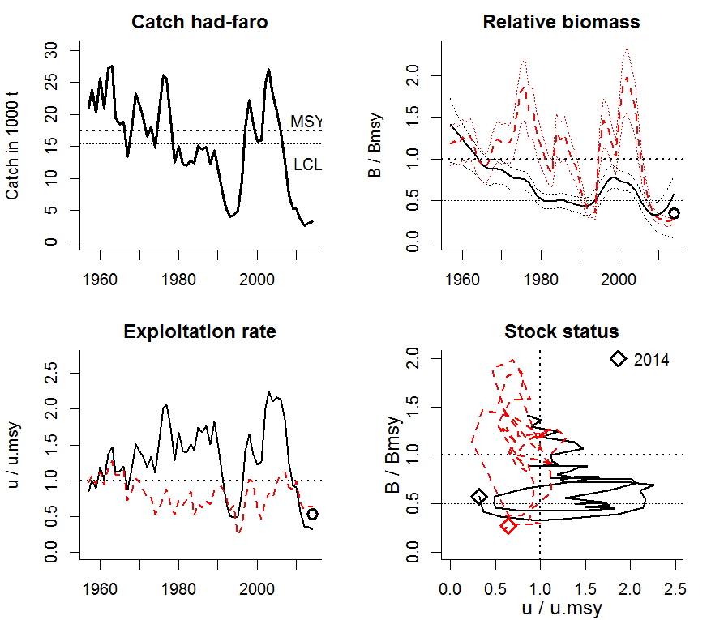

Comment: Good agreement in reference points between CMSY results based on catch and BSM results based on catch and biomass; also good agreement in overall trends and start and end values. But CMSY did not reproduce the observed abundance variability and underestimates total biomass in intermediate years. A higher prior on start biomass (0.4 – 0.8 instead of 0.2 – 0.6) slightly improved the fit. CMSY overestimates stock size and underestimates exploitation in the last years, because CMSY assumes constant productivity, whereas the stock is likely to suffer from reduced recruitment (red curve below half of Bmsy, which is a proxy for Bpa). Therefore, the black circles derived from the 25th percentile of predicted biomass should be used for management advice from CMSY.
Species: Gadus morhua , stock: cod-farp
Name and region: Faroe Plateau cod , ICES Vb1
Catch data used from years 1959 - 2014 , biomass = observed
Prior initial relative biomass = 0.1 - 0.4
Prior intermediate rel. biomass= 0.3 - 0.9 in year 1975
Prior final relative biomass = 0.01 - 0.3
If current catches continue, is the stock likely to crash within 3 years? Possible
Prior range for r = 0.2 - 0.8 , prior range for k = 49.7 - 597
Results from Bayesian Schaefer model using catch & observed biomass
r = 0.499 , 95% CL = 0.449 - 0.554 , k = 199 , 95% CL = 167 - 267
MSY = 25 , 95% CL = 21.1 - 32.4
Biomass in last year = 27.7 or 0.139 k
Exploitation rate in last year = 0.219 or 0.876 u.msy
Results of CMSY analysis with altogether 333 viable trajectories for 324 r-k pairs
128 r-k pairs above r = 0.248 and 101 trajectories within r-k CLs were analyzed
r = 0.407 , 95% CL = 0.259 - 0.671 , k = 272 , 95% CL = 154 - 455
MSY = 27.6 , 95% CL = 24.3 - 31.3
Relative biomass last year= 0.175 , 2.5th = 0.0309 , 25th = 0.104 , 97.5th = 0.289
Relative biomass next year= 0.204 , 2.5th = 0.0246 , 25th = 0.117 , 97.5th = 0.338
Relative exploitation rate in last year= 0.656 , 25th = 1.105
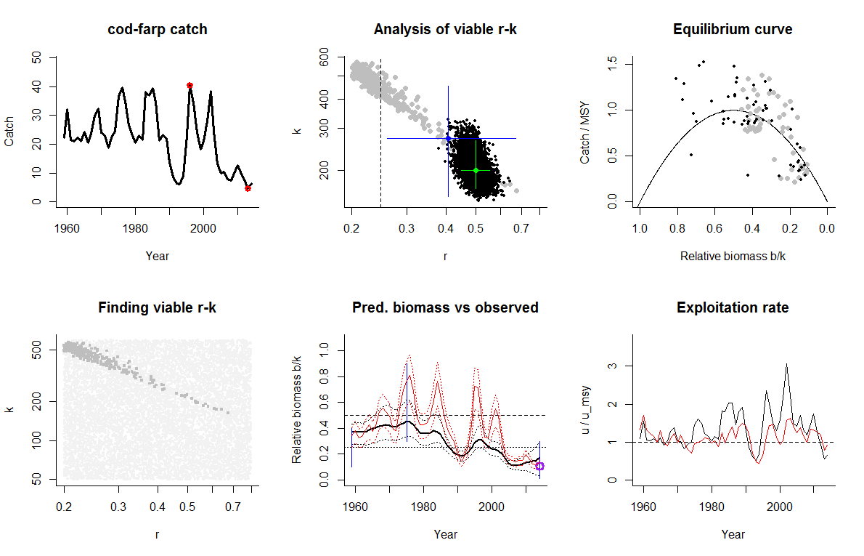
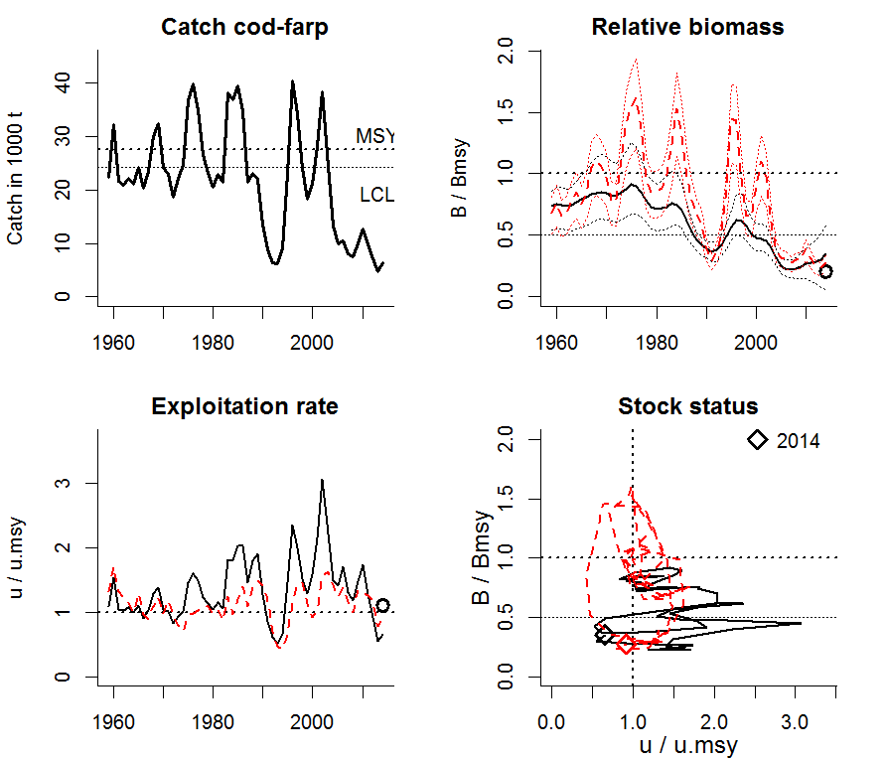

Comment: Reasonable agreement between CMSY results and biomass and exploitation rate trends from the full stock analysis. Note that CMSY slightly overestimates stock size and underestimates exploitation in the last years, because CMSY assumes constant productivity, whereas the stock is likely to suffer from reduced recruitment (red curve below half of Bmsy, which is a proxy for Bpa). Therefore, the black dots derived from the 25th percentile of predicted biomass should be used for management advice based on CMSY.

Species: Pollachius virens , stock: sai-faro
Name and region: Faroe saithe , ICES Vb
Catch data used from years 1961 - 2014 , biomass = observed
Prior initial relative biomass = 0.1 - 0.5
Prior intermediate rel. biomass= 0.4 - 0.9 in year 2005
Prior final relative biomass = 0.2 - 0.6
If current catches continue, is the stock likely to crash within 3 years? No
Prior range for r = 0.2 - 0.8 , prior range for k = 83.6 - 1004
Results from Bayesian Schaefer model using catch & observed biomass
r = 0.486 , 95% CL = 0.412 - 0.524 , k = 360 , 95% CL = 320 - 442
MSY = 43.3 , 95% CL = 38.5 - 49.2
Biomass in last year = 213 or 0.592 k
Exploitation rate in last year = 0.134 or 0.553 u.msy
Results of CMSY analysis with altogether 8802 viable trajectories for 1199 r-k pairs
550 r-k pairs above r = 0.384 and 4229 trajectories within r-k CLs were analyzed
r = 0.549 , 95% CL = 0.384 - 0.784 , k = 340 , 95% CL = 219 - 528
MSY = 46.7 , 95% CL = 39.6 - 55
Relative biomass last year= 0.48 , 2.5th = 0.215 , 25th = 0.356 , 97.5th = 0.596
Relative biomass next year= 0.529 , 2.5th = 0.215 , 25th = 0.394 , 97.5th = 0.661
Relative exploitation rate in last year= 0.532 , 25th = 0.717
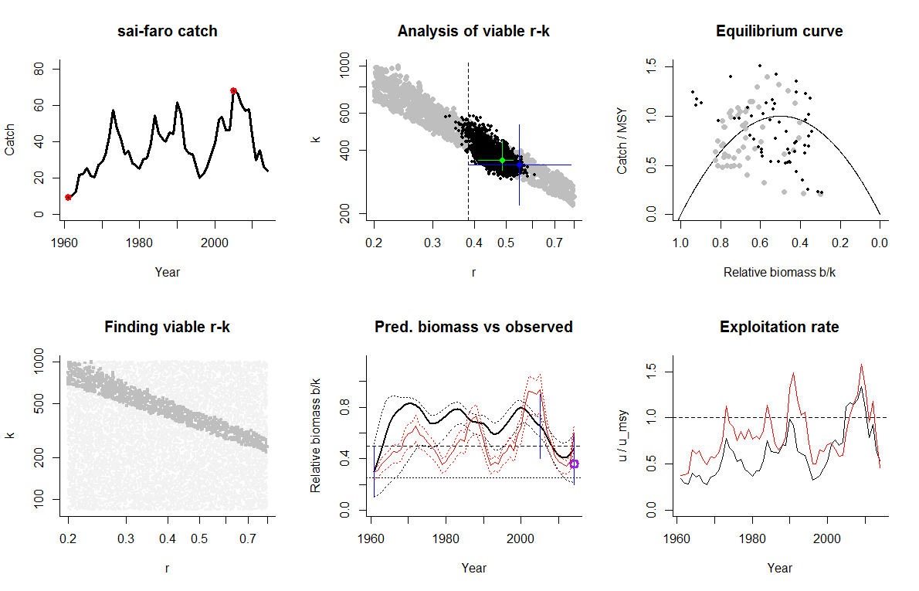
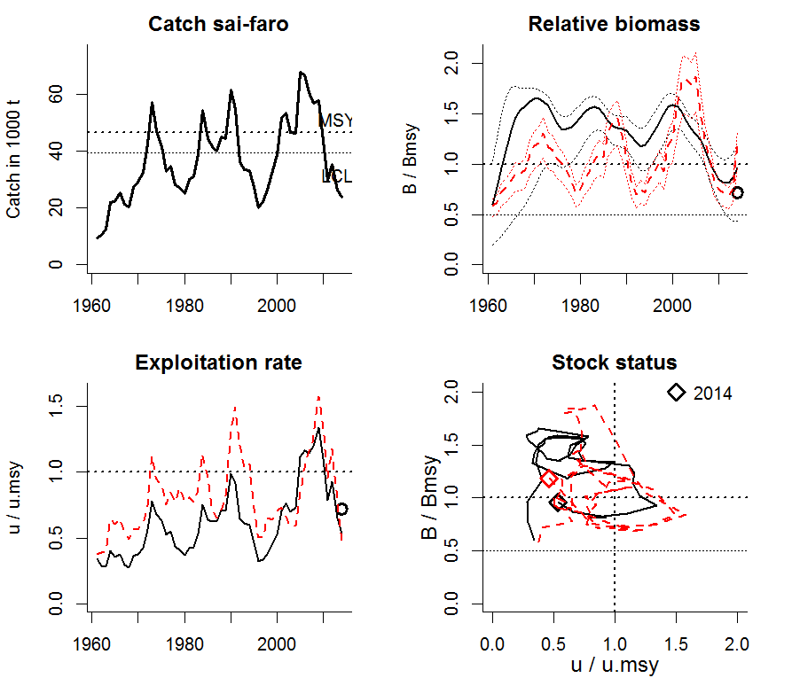
Comment: Reasonable match between CMSY results and results of full stock assessment.

Running CMSY on catch data and CPUE of data-limited stocks

Species: Gadus morhua , stock: cod-farob
Name and region: Faroebank cod , ICES Vb2
Catch data used from years 1965 - 2014 , biomass = CPUE
Prior initial relative biomass = 0.1 - 0.5
Prior intermediate rel. biomass= 0.01 - 0.4 in year 1992
Prior final relative biomass = 0.01 - 0.3
If current catches continue, is the stock likely to crash within 3 years? Possible
Prior range for r = 0.2 - 0.8 , prior range for k = 6.38 - 76.5
Prior range of q = 0.0457 - 0.183
Results from Bayesian Schaefer model using catch & CPUE
r = 0.499 , 95% CL = 0.439 - 0.562 , k = 37.6 , 95% CL = 27.5 - 59
MSY = 4.67 , 95% CL = 3.42 - 7.44
q = 0.0803 , lcl = 0.062 , ucl = 0.103
Biomass in last year from q*CPUE = 0.321 or 0.00854 k
Exploitation rate in last year = 0.183
Results of CMSY analysis with altogether 489 viable trajectories for 478 r-k pairs
215 r-k pairs above r = 0.235 and 182 trajectories within r-k CLs were analyzed
r = 0.31 , 95% CL = 0.238 - 0.421 , k = 32.1 , 95% CL = 19.8 - 50.2
MSY = 2.49 , 95% CL = 1.75 - 3.55
Relative biomass last year= 0.17 , 2.5th = 0.0167 , 25th = 0.1 , 97.5th = 0.296
Relative biomass next year= 0.205 , 2.5th = 0.0195 , 25th = 0.124 , 97.5th = 0.355
Relative exploitation rate in last year= 0.0355 , 25th = 0.06
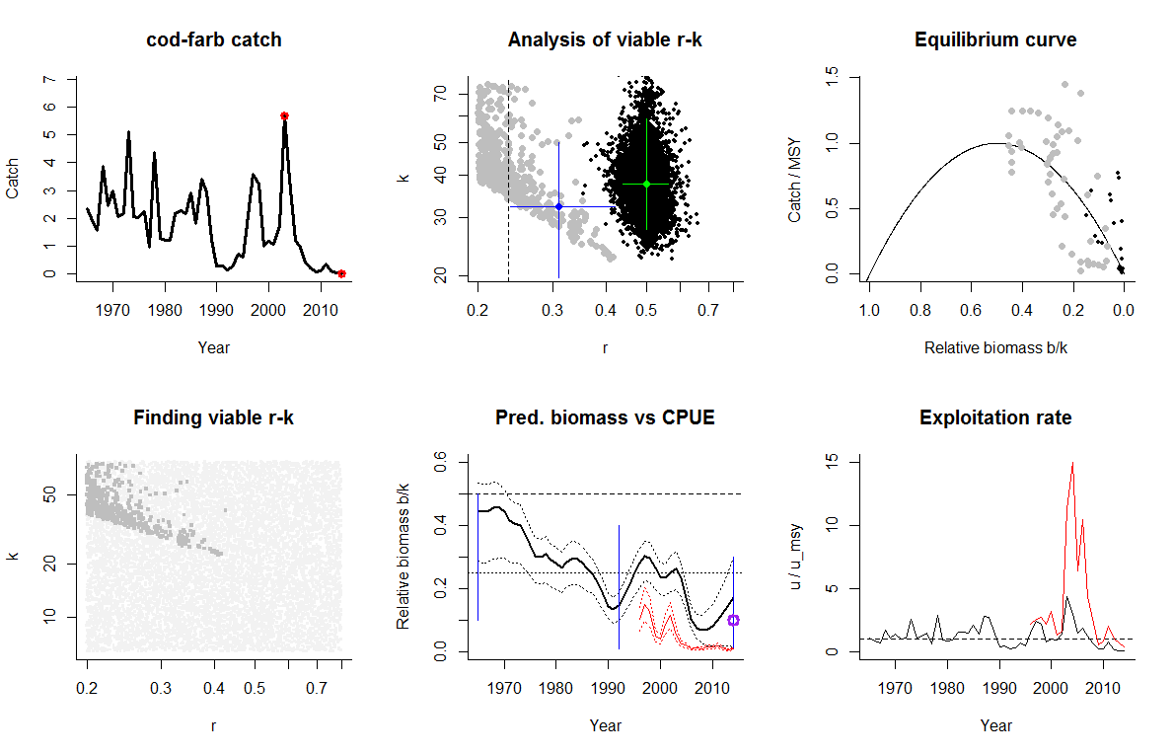

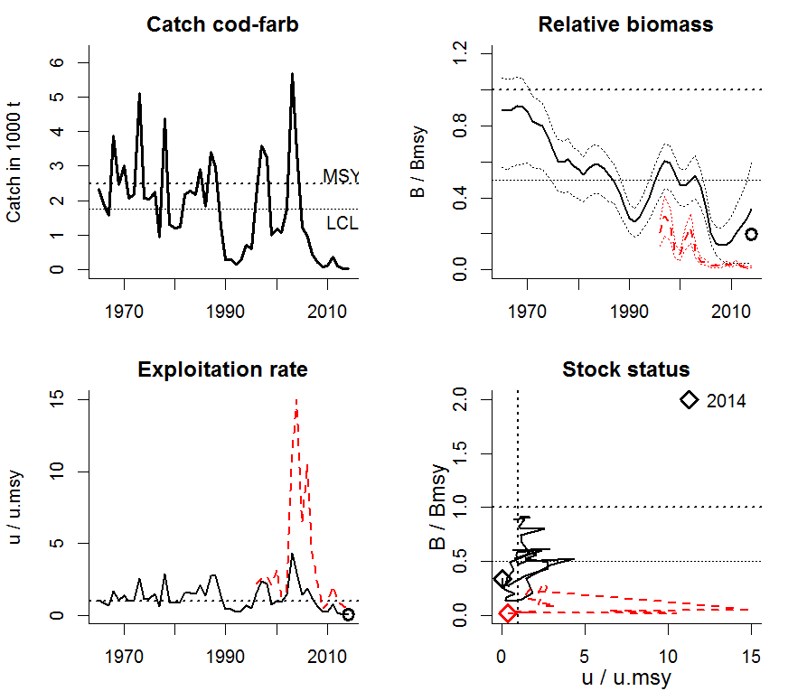
Comment: CMSY overestimates stock size and underestimates exploitation, because CMSY assumes ongoing productivity as in the 1970s and 1980s, whereas the stock is clearly suffering from reduced recruitment at least since the late 1990s. Even the black dots derived from the 25th percentile of predicted biomass are too optimistic. Here, precautionary management would not follow CMSY but rather the CPUE results as scaled by BSM. But both CMSY and BSM show the stock as well outside of safe biological limits.

Species: Nephrops norvegicus , stock: nep-2829
Name and region: Nephrops , Southwest and South Portugal
Catch data used from years 1997 - 2014 , biomass = CPUE
Prior initial relative biomass = 0.1 - 0.5
Prior intermediate rel. biomass= 0.1 - 0.9 in year 2005
Prior final relative biomass = 0.1 - 0.5
If current catches continue, is the stock likely to crash within 3 years? Possible
Prior range for r = 0.2 - 0.8 , prior range for k = 0.448 - 5.37
Prior range of q = 0.00781 - 0.0313
Results from Bayesian Schaefer model using catch & CPUE
r = 0.511 , 95% CL = 0.465 - 0.602 , k = 2.3 , 95% CL = 1.63 - 3.31
MSY = 0.298 , 95% CL = 0.213 - 0.422
q = 0.01 , lcl = 0.00792 , ucl = 0.0124
Biomass in last year from q*CPUE = 0.762 or 0.331 k
Exploitation rate in last year = 0.259
Results of CMSY analysis with altogether 4993 viable trajectories for 2236 r-k pairs
1220 r-k pairs above r = 0.341 and 2030 trajectories within r-k CLs were analyzed
r = 0.522 , 95% CL = 0.349 - 0.782 , k = 2.3 , 95% CL = 1.19 - 4.44
MSY = 0.3 , 95% CL = 0.183 - 0.493
Relative biomass last year= 0.345 , 2.5th = 0.115 , 25th = 0.234 , 97.5th = 0.494
Relative biomass next year= 0.364 , 2.5th = 0.0675 , 25th = 0.229 , 97.5th = 0.534
Relative exploitation rate in last year= 0.882 , 25th = 1.305
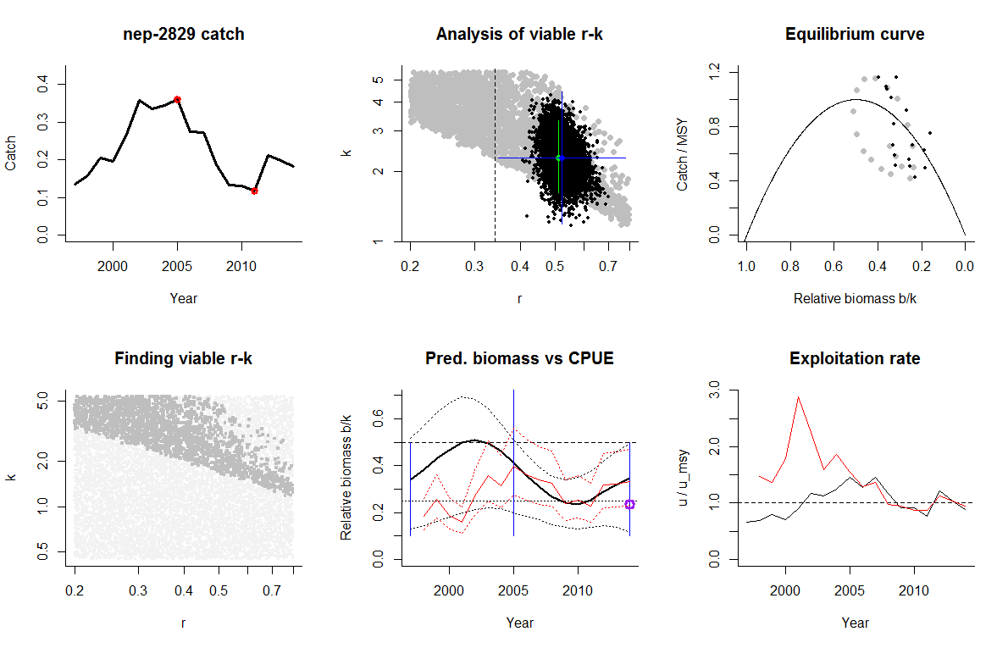
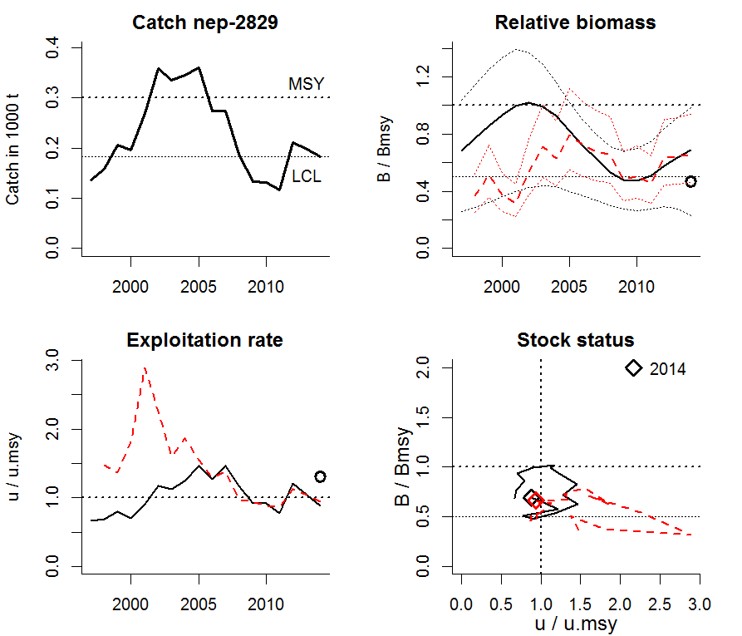
Comment: Good agreement after 2005 between CMSY results and biomass and exploitation rate trends from commercial cpue, as scaled by BSM.

Species: Argentina silus , stock: arg-5b6a
Name and region: Greater silver smelt , Northeast Atlantic
Catch data used from years 1996 - 2014 , biomass = CPUE
Prior initial relative biomass = 0.2 - 0.8
Prior intermediate rel. biomass= 0.1 - 0.9 in year 2005
Prior final relative biomass = 0.01 - 0.5
If current catches continue, is the stock likely to crash within 3 years? Possible
Prior range for r = 0.2 - 0.8 , prior range for k = 28.9 - 347
Prior range of q = 0.000349 - 0.00139
Results from Bayesian Schaefer model using catch & CPUE
r = 0.502 , 95% CL = 0.448 - 0.571 , k = 133 , 95% CL = 110 - 181
MSY = 16.7 , 95% CL = 14.4 - 22
q = 0.000589 , lcl = 0.000455 , ucl = 0.000739
Biomass in last year from q*CPUE = 33.3 or 0.25 k
Exploitation rate in last year = 0.471
Results of CMSY analysis with altogether 9037 viable trajectories for 2443 r-k pairs
1161 r-k pairs above r = 0.368 and 3681 trajectories within r-k CLs were analyzed
r = 0.549 , 95% CL = 0.384 - 0.784 , k = 134 , 95% CL = 77.6 - 233
MSY = 18.4 , 95% CL = 12.6 - 26.9
Relative biomass last year= 0.361 , 2.5th = 0.0348 , 25th = 0.218 , 97.5th = 0.496
Relative biomass next year= 0.359 , 2.5th = -0.0847 , 25th = 0.18 , 97.5th = 0.523
Relative exploitation rate in last year= 1.17 , 25th = 1.947
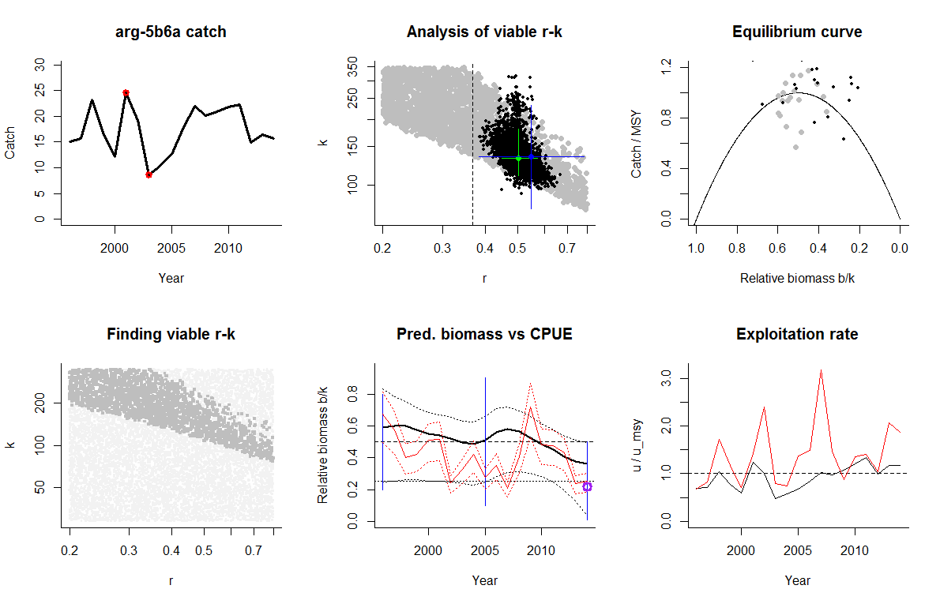

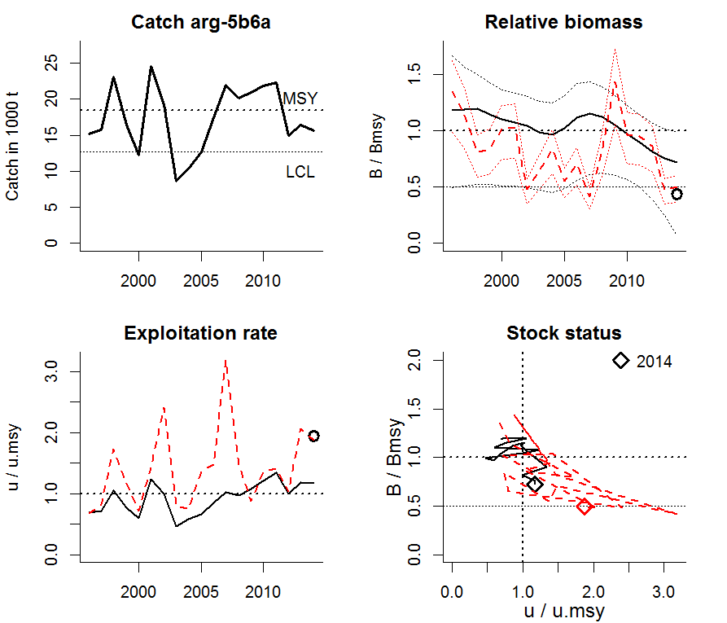
Comment: Reasonable agreement between CMSY results and biomass and exploitation rate trends from cpue data, as scaled by BSM. Note that CMSY overestimates stock size and underestimates exploitation in the last years, because CMSY assumes constant productivity, whereas the stock may suffer from reduced recruitment (red curve at half of Bmsy, which is a proxy for Bpa). Therefore, the black dots derived from the 25th percentile of predicted biomass should be used for management.

Species: Limanda limanda , stock: dab-2232
Name and region: Western Baltic dab , Baltic areas 22 - 32
Catch data used from years 1970 - 2014 , biomass = CPUE
Prior initial relative biomass = 0.2 - 0.8
Prior intermediate rel. biomass= 0.1 - 0.5 in year 2001
Prior final relative biomass = 0.2 - 0.8
If current catches continue, is the stock likely to crash within 3 years? No
Prior range for r = 0.2 - 0.8 , prior range for k = 3.68 - 44.1
Prior range of q = 0.00809 - 0.0324
Results from Bayesian Schaefer model using catch & CPUE
r = 0.508 , 95% CL = 0.46 - 0.599 , k = 13.9 , 95% CL = 9.9 - 19.6
MSY = 1.81 , 95% CL = 1.25 - 2.49
q = 0.0117 , lcl = 0.00893 , ucl = 0.0157
Biomass in last year from q*CPUE = 12.3 or 0.882 k
Exploitation rate in last year = 0.107
Results of CMSY analysis with altogether 4611 viable trajectories for 1047 r-k pairs
403 r-k pairs above r = 0.35 and 1985 trajectories within r-k CLs were analyzed
r = 0.535 , 95% CL = 0.366 - 0.783 , k = 14.3 , 95% CL = 9.23 - 22.1
MSY = 1.91 , 95% CL = 1.71 - 2.14
Relative biomass last year= 0.755 , 2.5th = 0.413 , 25th = 0.712 , 97.5th = 0.797
Relative biomass next year= 0.76 , 2.5th = 0.443 , 25th = 0.725 , 97.5th = 0.802
Relative exploitation rate in last year= 0.44
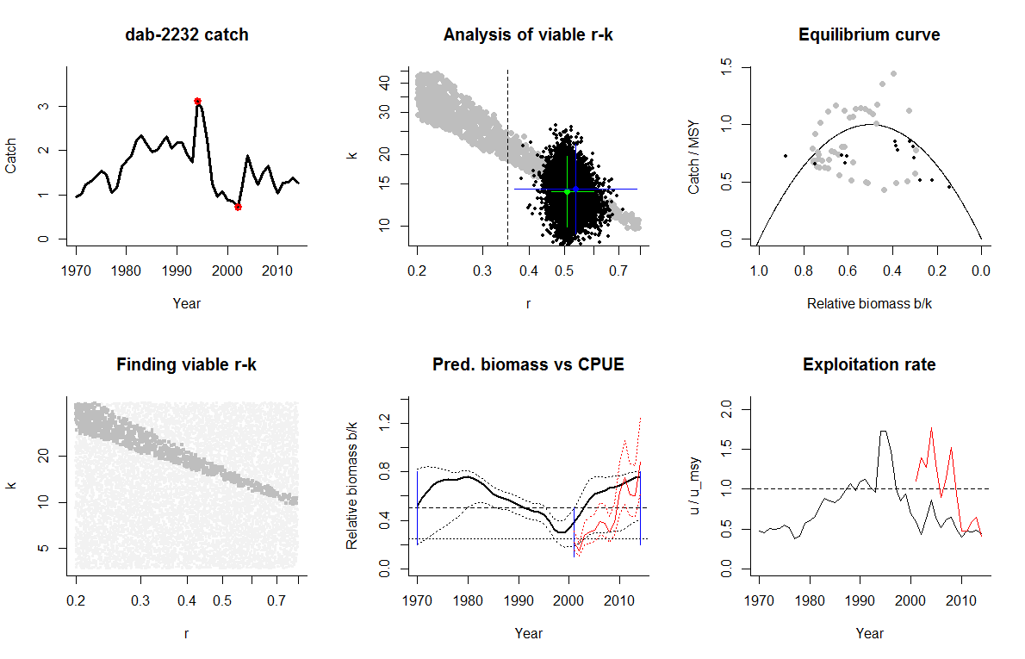
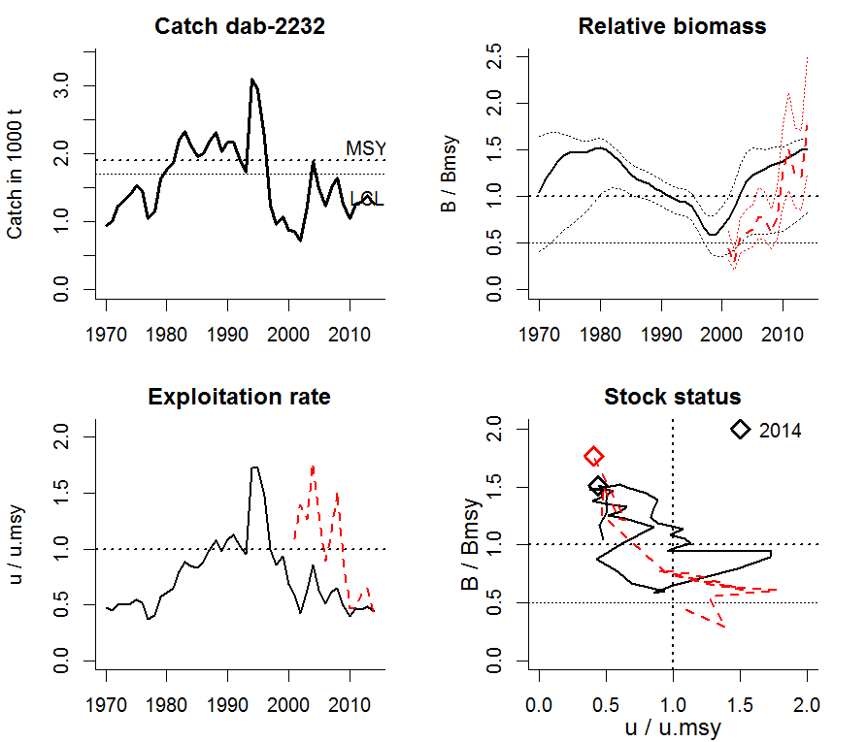

Comment: Landings data used, though discards may be substantial. No good idea of stock size, so very wide prior biomass windows (0.2 – 0.8) for start and end biomass used. Drop in unrestricted catches in 1998-2001 was interpreted as low biomass (0.1-0.5) for intermediate year (2001). Good agreement between CMSY and CPUE as scaled by BSM, with similar and converging estimates in the last years.

Species: Gadus morhua , stock: cod-2532
Name and region: Eastern Baltic cod , Eastern Baltic, areas 25-32
Catch data used from years 2003 - 2014 , biomass = CPUE
Prior initial relative biomass = 0.1 - 0.5
Prior intermediate rel. biomass= 0.1 - 0.9 in year 2007
Prior final relative biomass = 0.01 - 0.4
If current catches continue, is the stock likely to crash within 3 years? Possible
Prior range for r = 0.2 - 0.8 , prior range for k = 95.6 - 1147
Prior range of q = 0.000733 - 0.00293
Results from Bayesian Schaefer model using catch & CPUE
r = 0.512 , 95% CL = 0.464 - 0.61 , k = 643 , 95% CL = 386 - 1011
MSY = 83.3 , 95% CL = 50 - 131
q = 0.000864 , lcl = 0.00067 , ucl = 0.00124
Biomass in last year from q*CPUE = 146 or 0.227 k
Exploitation rate in last year = 0.356
Results of CMSY analysis with altogether 5641 viable trajectories for 2612 r-k pairs
1623 r-k pairs above r = 0.371 and 2520 trajectories within r-k CLs were analyzed
r = 0.549 , 95% CL = 0.384 - 0.784 , k = 632 , 95% CL = 333 - 1198
MSY = 86.7 , 95% CL = 49.7 - 151
Relative biomass last year= 0.237 , 2.5th = 0.0197 , 25th = 0.134 , 97.5th = 0.395
Relative biomass next year= 0.247 , 2.5th = -0.0559 , 25th = 0.106 , 97.5th = 0.45
Relative exploitation rate in last year= 1.11 , 25th = 1.964
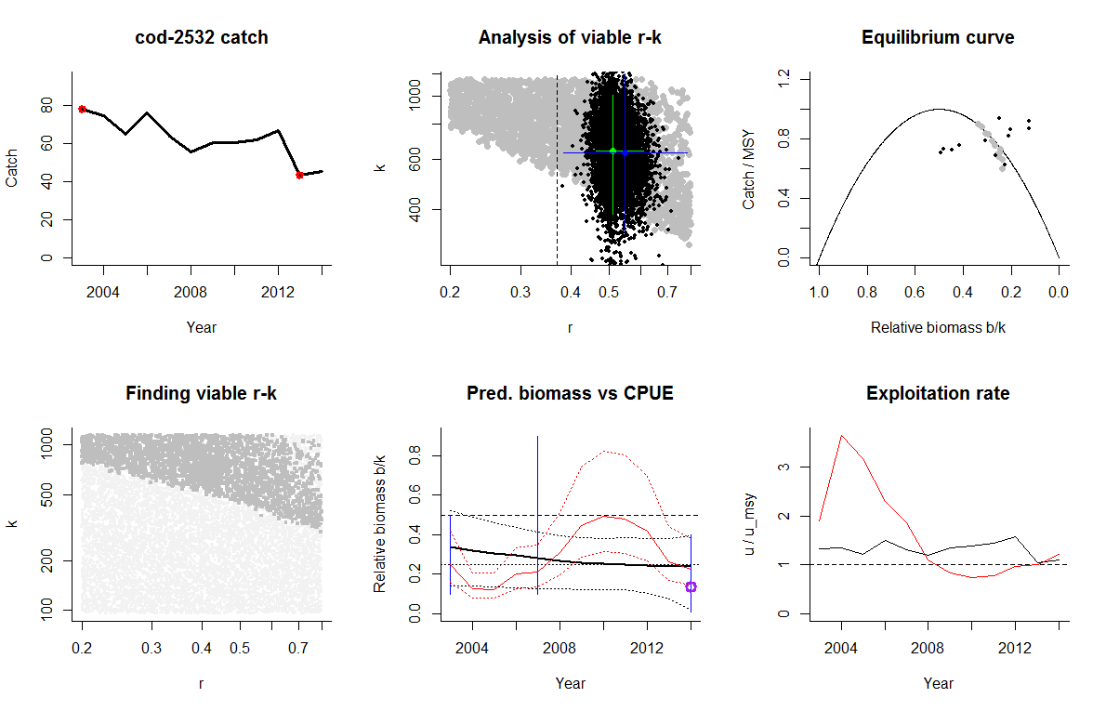
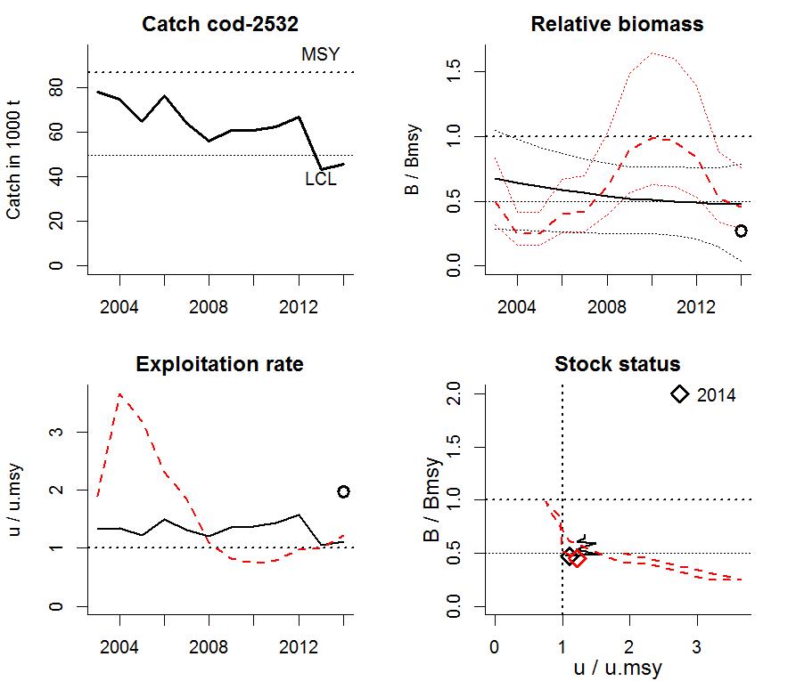
Comment: Short time series. CMSY does not capture the variability in stock index data as scaled by BSM, but gives similar results for final biomass and exploitation rate.

Comparing results with observation error of catch with sigma 0.1 and 0.2
CMSY analysis with sigma 0.1 on catch
----------------------------------------------------
Species: Merluccius merluccius , stock: hke-nrtn
Name and region: Northern hake , Subareas IV, VI, and VII and Divisions IIIa, VIIIa,b,d
Catch data used from years 1978 - 2014 , biomass = observed
Prior initial relative biomass = 0.2 - 0.6
Prior intermediate rel. biomass= 0.1 - 0.4 in year 2005
Prior final relative biomass = 0.5 - 0.9
If current catches continue, is the stock likely to crash within 3 years? No
Prior range for r = 0.2 - 0.8 , prior range for k = 245 - 1961
Results from Bayesian Schaefer model using catch & observed biomass
r = 0.807 , 95% CL = 0.715 - 0.892 , k = 520 , 95% CL = 385 - 735
MSY = 104 , 95% CL = 81.3 - 140
Biomass in last year = 275 or 0.528 k
Results of CMSY analysis
Altogether 244 viable trajectories for 244 r-k pairs were found
111 r-k pairs above r = 0.286 and 103 trajectories within r-k CLs were analyzed
r = 0.438 , 95% CL = 0.286 - 0.672 , k = 772 , 95% CL = 477 - 1247
MSY = 84.5 , 95% CL = 76.3 - 93.7
Predicted biomass in last year = 0.54 , 2.5th perc = 0.505 25th perc = 0.521 97.5th perc = 0.608
Predicted biomass in next year = 0.528 , 2.5th perc = 0.475 25th perc = 0.507 , 97.5th perc = 0.596
Comment: Strange recent increase in biomass after 2008
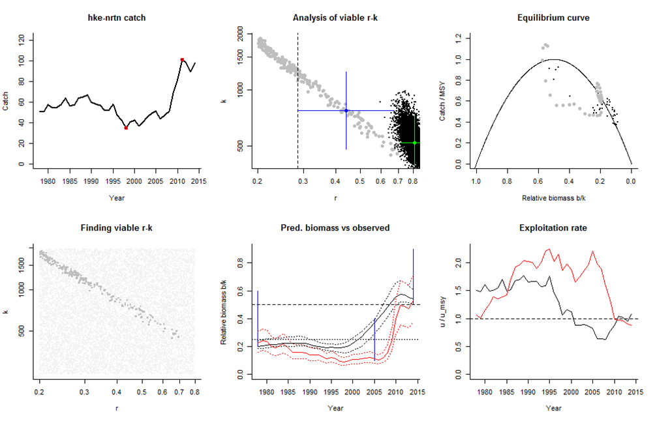
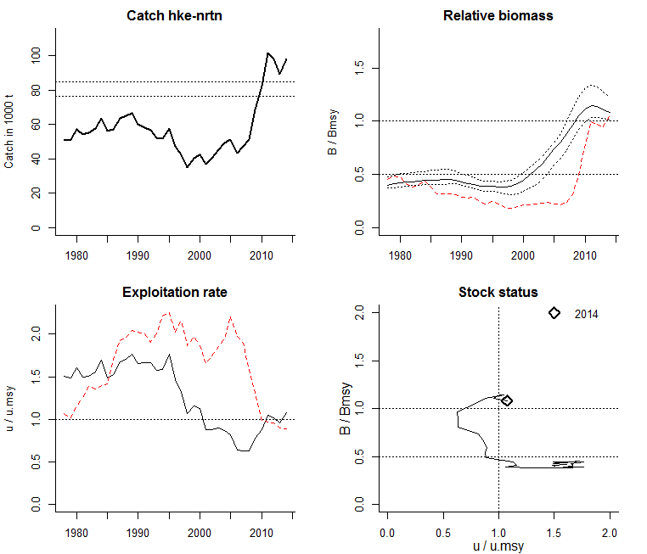
Comment: Northern Hake had a modest biomass in the beginning of the time series and a very strong increase in biomass in 2007, which lasted until the end of the time series. Accordingly, prior biomass windows were set 0.2-0.6 for the beginning and 0.5-0.9 for the end. CMSY assumes average productivity of the stock and thus has difficulties to reproduce the extraordinary biomass increase in 2007. CMSY modelling was improved by setting a low (10-40% of unexploited biomass) intermediate biomass window to 2005, before the increase, effectively informing the system of the common knowledge that the stock had low biomass throughout most of the time series until it increased drastically in 2007.
Repetition of previous analysis with sigma=0.2 uncertainty on catch
---------------------------------------
Species: Merluccius merluccius , stock: hke-nrtn
Name and region: Northern hake , Subareas IV, VI, and VII and Divisions IIIa, VIIIa,b,d
Catch data used from years 1978 - 2014 , biomass = observed
Prior initial relative biomass = 0.2 - 0.6
Prior intermediate rel. biomass= 0.1 - 0.4 in year 2005
Prior final relative biomass = 0.5 - 0.9
If current catches continue, is the stock likely to crash within 3 years? No
Prior range for r = 0.2 - 0.8 , prior range for k = 245 - 1961
Results from Bayesian Schaefer model using catch & observed biomass
r = 0.799 , 95% CL = 0.701 - 0.89 , k = 542 , 95% CL = 392 - 850
MSY = 108 , 95% CL = 83.2 - 157
Biomass in last year = 275 or 0.507 k
Results of CMSY analysis
Altogether 385 viable trajectories for 384 r-k pairs were found
189 r-k pairs above r = 0.29 and 163 trajectories within r-k CLs were analyzed
r = 0.438 , 95% CL = 0.3 - 0.641 , k = 779 , 95% CL = 483 - 1255
MSY = 85.3 , 95% CL = 70.5 - 103
Predicted biomass in last year = 0.547 , 2.5th perc = 0.501 25th perc = 0.519 97.5th perc = 0.66
Predicted biomass in next year = 0.533 , 2.5th perc = 0.444 25th perc = 0.499 , 97.5th perc = 0.637
Comment: Strange recent increase in biomass after 2008
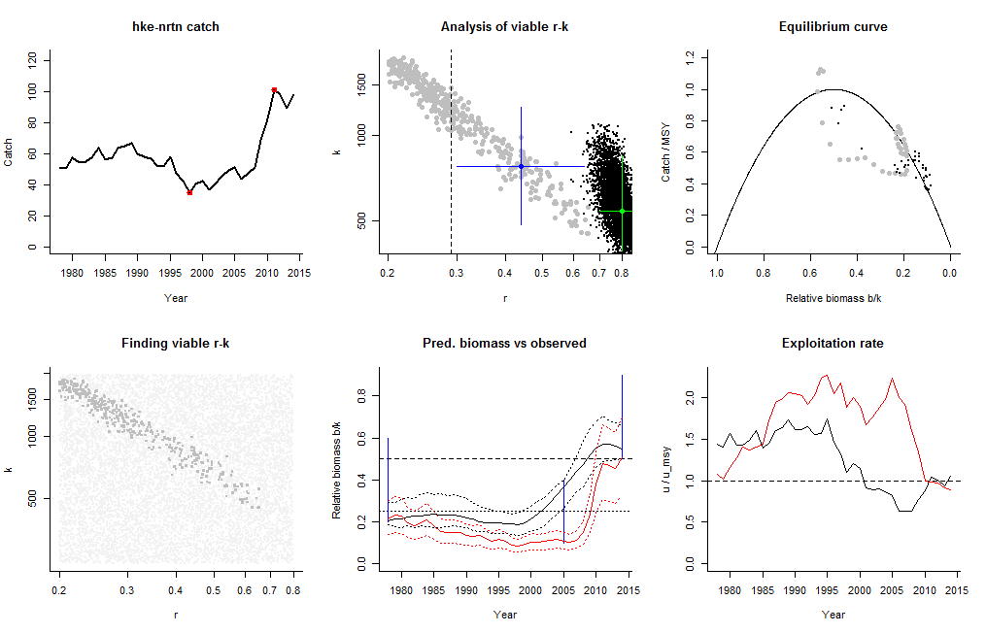
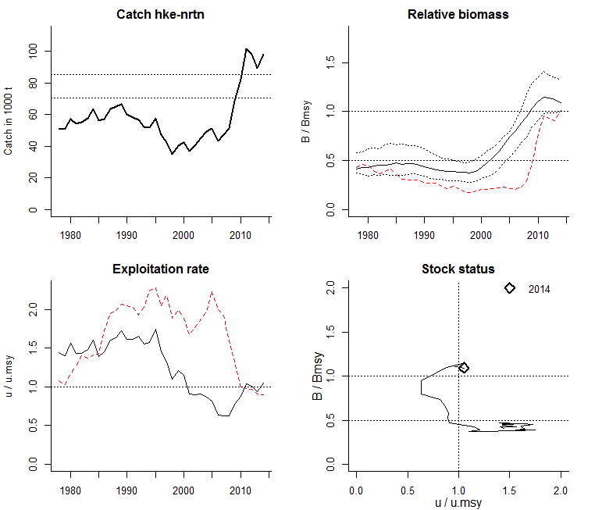
Comment: CMSY assumes as default a process error of sigma=0.05 and an observation error on catch of sigma=0.1. In the latest version of CMSY_WKLIFEV_7.r, observation error and process error can be set independently. Above analysis of northern hake used an observation error of 0.2 instead of 0.1. This doubling of uncertainty in the catch increased the variability in viable r-k pairs found by CMSY (compare lower left graphs in the CMSY output between the two runs), but the increased uncertainty did not affect the estimates of the fisheries reference points in any significant way.

References
Froese, R., Demirel, D., Coro, G., Kleisner, K.M., Winker, H. Estimating fisheries reference points from catch and resilience. Submitted to Fish and Fisheries on 28 February 2015
Froese, R. 2015. Results of preliminary runs of the CMSY-method against data-limited ICCAT stocks. SCRS 2015/113, ICCAT, Madrid. Available from www.fishbase/rfroese/ under “Other publications”
ICES, 2014. Report of the Workshop on the Development of Quantitative Assessment Methodologies based on LIFE-history traits, exploitation characteristics, and other relevant parameters for data-limited stocks (WKLIFE IV), 27–31 October 2014, Lisbon, Portugal. ICES CM 2014/ACOM:54. 241 pp.
Martell, S. and R. Froese, 2013. A simple method for estimating MSY from catch and resilience. Fish and Fisheries 14: 504-514

