**The scaling of brain growth during ontogeny**

Draft of analyzing brain data in FishBase, October 2018, RF

**Abstract**

**Introduction**

It has long been known that brains grow slower than the rest of the body, both in across species comparisons and during ontogenic development (Snell, 1891). Here we present a large data set of brain sizes in fishes. We propose adult body weight at generation time as an appropriate development stage to compare relative brain sizes among species, which is the average adult size in e.g. birds and mammals and 30% of maximum weight in species with indeterminate grow, such as fishes and reptiles. We then explore possible explanations for significant differences in brain – body weight ratios within and across species.



Figure 1. [We need a figure like this to show a typical fish brain]

**Materials and Methods**

Data on phylogeny, brain and body weights were derived from studies compiled in FishBase (Albert et al. 1999; Froese and Pauly 2018; Pauly et al. 2011).

Every species with brain data was assigned a maximum weight derived from maximum length and length-weight relationships available in FishBase. This maximum weight was used to identify and exclude BRAIN records where reported body weight was higher than the known maximum weight for the species. Maximum weights were also used for calculating adult body weight at the age equivalent to generation time (= the mean age of parents at birth of their offspring, Pianka1999), which is about 30% of maximum weight in species with indeterminate growth (Roff 1984; Froese et al. 2016).

Within-species linear regressions of log10 brain weight as a function of log10 body weight were run for all species fulfilling the following conditions: (1) four or more observations were available, including three or more distinct observations; and (2) observations spanned a minimum range of body weights, determined as a ratio larger than 3 for maximum divided by minimum weight. Regressions were accepted for further analysis if the regression accounted for at least 90% of the variability in the data (r2 >= 0.9) and if the standard error of the slope was less than 0.1. For the species that met these conditions, regressions were used to predict brain weight at generation time. For other species where some observed body weights fell within 0.1 CV of generation time weight, geometric mean values were used as approximations of generation time brain and body weight. These weights were then used to estimate the across-species slope of brain weight as a function of body weight.

Non-overlapping 95% confidence limits were used as indication of significantly different parameter estimates.

**Results**

After clean-up, 4125 observations of brain and body weight were available for 1264 species in 668 genera, 219 families, 53 orders and 6 classes of fishes (Table 1).

Table 1. Phylogenetic breakdown of species analyzed in this study.

|  |  |  |  |  |
| --- | --- | --- | --- | --- |
| **Class** | **Orders (n)** | **Families (n)** | **Genera (n)** | **Species (n)** |
| Myxini | 1 | 1 | 2 | 2 |
| Cephalaspidomorphi | 1 | 2 | 3 | 3 |
| Holocephali | 1 | 1 | 1 | 1 |
| Elasmobranchii | 12 | 32 | 48 | 68 |
| Sarcopterygii | 2 | 3 | 3 | 3 |
| Actinopterygii | 36 | 180 | 611 | 1187 |
| **Total** | 53 | 219 | 668 | 1264 |

Across-species regressions of brain weight (mg; log*10*) over body weight (g; log*10*) were done for all 4125 observations of different life stages and for calculated adult brain weights, for all species and for the two largest Classes, sharks and rays (Elasmobranchii) and rayfinned fishes (Actinopterygii) (Table 2). The scaling of brain weight with body weight was significantly higher for the mixture of juvenile, adult and large adult data (0.615, 95% CL 0.607-0.623) compared to all generation time data (0.582, 95% CL 0.564-0.599) and compared to generation time data for Actinopterygii. The uncertainty in scaling in Elasmobranchii was wide (0.467, 95% CL 0.211 – 0.723) because of the low number of species (10) including one outlier in the primitive deep-water shark (*Megachasma pelagios*) with much lower relative brain size than other sharks.

Table 2. Regressions of brain weight (mg; log10) over body weight (g; log10) for all available data, all generation time data, and for generation time data for two selected Classes and Families, respectively. In Elasmobranchii, Megachasma pelagios was considered as an outlier and was excluded from the analysis.

|  |  |  |  |  |  |  |  |
| --- | --- | --- | --- | --- | --- | --- | --- |
| **Grouping** | **n** | **Slope** | **95% CL** | **Intercept** | **95% CL** | **r2** | **SD residuals** |
| All data | 4125 | 0.615 | 0.607 – 0.623 | 1.13 | 1.11 – 1.14 | 0.848 | 0.277 |
| Generation time adults | 733 | 0.582 | 0.564 – 0.599 | 1.17 | 1.13 – 1.21 | 0.854 | 0.285 |
| Actinopterygii | 722 | 0.575 | 0.557 – 0.593 | 1.18 | 1.14 – 1.22 | 0.847 | 0.281 |
| Elasmobranchii | 10 | 0.467 | 0.211 – 0.723 | 2.04 | 0.91 – 3.18 | 0.688 | 0.301 |

The scaling of brain weight with body weight during ontogeny was explored with data for 130 species of Actinopterygii. The mean ontogenic scaling across these species was 0.493 (95% CL = 0.478 – 0.507), which is significantly lower than the across species scaling in Actinopterygii (Table 2). Ninety-five percent of the observed slopes fell within the range of 0.325 – 0.661.

**Discussion**

**What brain size to use for species with indeterminate growth**

Most species, with the exception of birds and mammals and a few others, grow throughout their lives, reaching their maximum size at maximum age. Since relative brain size declines as individuals grow, it makes little sense to compare the relative large brain of an early juvenile with the relatively smaller brain of an individual near maximum size (Ngwenya et al. 2016). A reasonable development stage to compare species is the brain weight reached at the average body weight of reproductively active parents, which in birds and mammals is the maximum body and brain weight, and in species with indeterminate growth, it is the body weight corresponding to the peak in the biomass of a cohort. This body weight can be approximated as 30% of maximum body weight (Roff 1984; Froese et al. 2016).

This study derived estimates of adult body weight at generation time for 1264 species of fishes. Corresponding brain weights were estimated from linear regressions for species with sufficient data or from the mean of brain weights of individuals near the approximated adult body weight. This gave adult brain size estimates for 733 species of fishes. A comparison of the scaling of adult brain weights over body weight with that of brain weights for individuals of mixed live stages showed a significant difference, with the mixed data set showing a steeper scaling (Table 2, Figure 3), probably due to the fact that sampling of brains was biased towards large individuals with relatively small brains in small species and small individuals with relatively large brains in large species. In other words, it is easier to obtain, store and process large individuals of small species and small individuals of large species, but this will lead to an underestimation of relative brain size in small species and overestimation in large species, with a resulting slope that is too steep. Therefore, for comparison of species of fishes and non-fishes, it is better to use data for brain size at generation time only.

**Understanding the growth of the spinal cord in species with indeterminate growth**

In one of the rare brain studies of non-mammalian species, Ngwenya et al. (2016) explore the growth of the nervous system in the Nile crocodile *Crocodylus niloticus*, a species that grows throughout its life with probably representative characteristics for other species with indeterminate growth. According to their findings, the length of the axons of the central neuronal cells grow with the same speed as the vertebral column. The added new length sections of the axons are supported by new Schwan cells, and growth in mass of this section of the spinal cord scales directly with vertebral column length, i.e., 0.33. However, there is an addition of new presumably peripheral neurons such that the number of neurons per unit of length of the spinal cord remains constant. These peripheral neurons have their own supportive glial cells and are thought to be “the result of a more fundamental mechanism that sustains the formation of the spinal cord with a fixed number of neurons per millimeter, in individual crocodiles as across primate species” (Ngwenya et al. 2016, p. 19) and presumably also in fish. The combined growth of the central neurons and the addition of new neurons, both with supportive glial-type cells, results in an overall scaling of spinal cord mass with body mass of 0.6 in the case of the Nile crocodile, which is close to the scaling of 0.67 of body areas with mass.

**Understanding ontogenic scaling of brain growth**

In the course of ontogenic development, all species have to grow through early live stages of embryos, larvae or juveniles of less than 1 g of body weight, even if their maximum body weight is 100 kg or more. During this development, total brain mass scales uniformly over at least three orders of magnitude of body mass, albeit with significantly different scaling in different species (Figures 1 and 2). In six selected species with wide ranges of body weight (Figure 1), brain-body mass scaling ranges from 0.34 to 0.53. Across all 130 species with accepted regressions (see criteria in Material and Methods), scaling ranges from 0.29 (95% CL 0.21 – 0.37) in the grouper *Plectropomus leopardus* to 0.733 (95% CL 0.49 – 0.97) in the snapper *Lutjanus fulvus*, with 95% of the scalings falling into the range of 0.33-0.66.

Brains consist of three types of cells: neurons, glial cells and endothelial cells (= blood vessel walls). In order not to break connections or to curl up unnecessarily, neuronal axons have to grow at the same speed as the linear dimension of the body or organ they innervate. As a result, the mass of the neuron may far exceed the mass of the neuronal cell body and determines the overall neuronal cell growth in mass (Smith 2009). "Stretching" of axons by growing body parts or organs has been proposed by Smith (2009) as mechanism that triggers, facilitates and determines axon growth. Such mechanism would allow different growth rates of axons and thus neurons in asymmetrically growing body parts or brain structures.

Glial cells come in different types and with different functions, but their main mass is supposedly formed by the structure they provide by enveloping the neuronal axons. Glial cells have a more or less constant average mass and their overall mass therefore is directly proportional to glial cell numbers (Herculano-Houzel 2016). Glial tissue grows by adding new cells, created by cell division. Neuronal axon diameter is constant (Bray 1984) and if glial cells provide an envelope of constant thickness around axons of neurons, then their tissue growth scales the same as neuronal growth. This is confirmed by a ratio of neuronal mass to glial mass of about 2 to 1 found in mammals across all brain structures (Herculano-Houzel 2016).

Endothelial cell growth scales proportional to the contained blood volume, which scales directly proportional to the organ it supports. Thus, presumably the mass of endothelial cells grows isometric (exponent ~ 1.0) with total brain mass. Endothelial mass is low compared to neuronal and glial cell mass (Herculano-Houzel 2016) and may have been partly removed before measurements (Bauchot et al. 1989).

In summary, other than the spinal cord, it seems like brain structures grow initially from the addition of new neurons and their supportive glial tissue. The resulting increase in volume of the respective brain structure leads to an increase in linear dimensions, stretching the axons of the existing neurons and triggering them to also increase in length and mass and supportive glial tissue.

The observed ontogenic scaling of brain weight with body weight from 0.3 to 0.6 is therefore indicative of how many new neurons are continuously added to the brain. It appears that the lower range of 0.3 is indicative of a constitutive minimum amount of new neurons, required to maintain basic brain functioning. Higher additions are typically found in brain structures innervating specialized organs, such as olfactory or electro-sensing or tactile or visual organs. One would also expect more addition of neurons in brain structures that control complex behavior (Snell 1891, Dunbar et al. 2010). Such brain structures grow continuously and significantly faster than the rest of the brain, occupying an increased proportion of the total brain (Ngwenya et al. 2016) and resulting in an overall brain – body mass scaling higher than 0.3.

**What determines ontogenic scaling?**

|  |  |
| --- | --- |
|  |  |
|  |  |
|  |  |

Figure 2. Six Species in six Families selected because of their wide range of body sizes, confirming constant scaling of brain weight with body weight over two to three orders of magnitude. The red line indicates the regression line, extended from 0.1 g body weight to maximum body weight. The dashed red curves indicate the 95% confidence limits of the slope, the dashed vertical line indicates adult body weight at generation time, and the dotted lines indicate the range that contains 95% of the observed brain weight in Actinopterygii. Note that although specific regression lines tend to be flatter than the overall slope of Actinopterygii (0.575), they stay with the observed range for brain sizes, even at early live stages down to 0.1 g body weight, with the exception of Sebastes norvegicus.

Looking at the six species depicted in Figure 2, the reasoning that brain development is triggered by special needs suggests that the deep-water rockfish (*Sebastes norvegicus,* 0.36) and the solitary bottom-dwelling Atlantic wolffish (*Anarhichas lupus*, 0.34) do not add many new neurons to their brains as they grow, presumably because they do not have special organs and have all the cognitive abilities they need for their niche and life style (Pauly et al. 2011). In contrast, the other four species, all of which live in the euphotic zone and in more “challenging” environments, have scalings of 0.45 to 0.53 and thus add more neurons then the constitutive minimum to their brain as they grow.

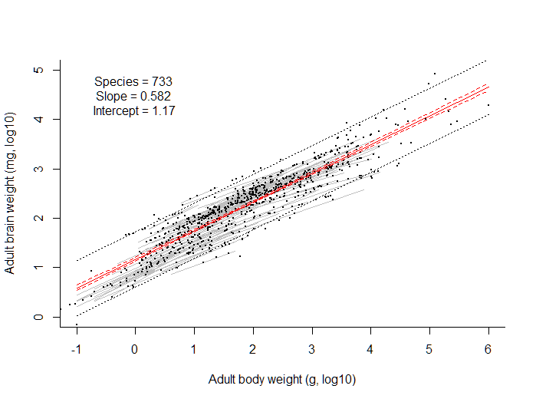

Figure 3. Scatterplot of generation time brain mass for 733 species of fishes, with indication of 130 ontogenic regressions (grey lines). The solid red line indicates the regression across the adult brain weights, and the dashed red curves indicate the 95% confidence limits of the regression. The dotted black lines include 95% of the data. Note that the grey regression lines do not always include the black dot indicating adult size, i.e., the available data were for juveniles and adult body weight was extrapolated.

Analyzing ontogenic scaling of brain – body mass for 130 species with suitable data gave a range of 0.33 to 0.66 which included 95% of the observations. Interestingly, this is the geometric scaling of length and area with body mass, respectively, which seem to bracket the viable space for ontogenic brain growth. The 0.66 scaling may be explained by the fact that the brain is a very energy-demanding organ and is unlikely to scale higher than overall scaling of metabolism with body mass (~ 0.75, Kleiber 1947) or oxygen supply in fish (~ 0.67 Pauly 2010). On the other end, a scaling less than 0.33 would imply that early life stages of a species with mean or smaller than mean adult brain size would have much larger brains than other species of that size, which does not seem to make evolutionary sense.

Looking at the ontogenic regression lines in Figure 3, it seems like species with larger brains than the average for their body weight have steeper scaling then species with smaller brains.

A segmented regression of ontogenic scaling over residual brain weight (Table 3, Figure 4) shows indeed a break-point near the mean and increased scaling with higher than mean brain mass for the given body mass. In other words, the common sense notion holds that species with larger adult brains than average have also larger brains at early development stages and add more than average neurons as they grow. In contrast, species with less than average adult brain size may add relatively fewer new neurons to their brains during ontogeny, in which case their distance to overall mean brain size for their respective body mass increases during development. Their brain does not shrink but gets relatively smaller, compared to other species of similar body weight.

Table 3. Statistics of a segmented regression applied to ontogenic scaling as a function of residual brain weight (mg, log10) for 130 species with available data. Residual standard error: 0.0813 on 126 degrees of freedom. Multiple r2: 0.0843, adjusted r2: 0.0625, n=130.

|  |  |  |  |
| --- | --- | --- | --- |
|  | **Estimate** | **Std. Error** | **t value** |
| **Break-point** | 0.037 | 0.076 |  |
| **Intercept** | 0.4715 | 0.0137 | 34.30 |
| **First slope** | -0.0579 | 0.0447 | -1.29 |
| **Second slope** | 0.3065 | 0.0991 | 3.09 |

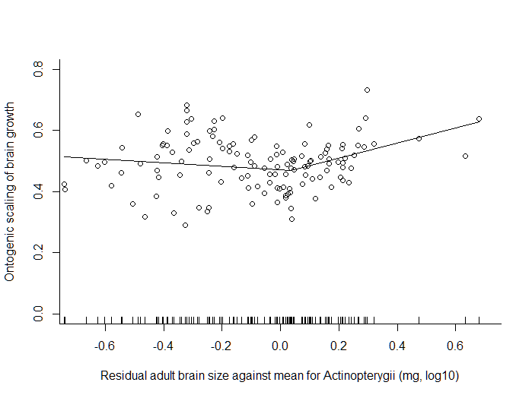

Figure 4. Segmented regression of ontogenic scaling of brain – body mass over residuals for 130 species of fishes with suitable data. See Table 3 for statistics.

**Examples of species with large and small brains**

Species have the relative brain size they need for their niche (Pauly et al. 2011, other Refs?) and Figure 5 shows some examples of fishes with large or small brains for their body weight. [add some prose why the selected groups have large or small brains].

**Some thoughts about encephalization in birds and mammals**

Birds and mammals distinguish themselves from other lineages through a unique combination of traits, such as air-breathing, constant body temperature, fast growth to a terminal body size, relative large offspring, and parental care. Other lineages, with which birds and mammals share common ancestors, have evolved some of these traits, but never all of them in combination. The large brains of birds and mammals have to be explained as part of their unique combination of traits.   
  
For example, the maximum body size of a given bauplan of birds or mammals stems from balancing of body weight above the ground, and hence the constrains set by gravity: put simply, an antelope of the size of an elephant would immediately break its legs and an eagle of the size of an ostrich would break its wings. Balancing on legs and wings requires increased processing of relevant information and thus larger brains than, e.g., needed by a snake.   
  
Parental care and the corresponding learning also benefit from larger brains.   
  
Air-breathing means that the cost of acquiring oxygen for metabolic processes is low and constant body temperature throughout all development stages means that enzymes always operate at their optimum temperatures. This combination allows the uniquely fast build-up of body tissues and maintenance, throughout ontogeny and adult life, of oxygen-demanding organs such as large brains.   
  
Maintaining the high food intake required to sustain constant body temperature while avoiding predation during the exposure caused by feeding requires fast processing of relevant information such as sound, sight or smell, and thus an enlarged brain.   
  
In summary, large brains in birds and mammals have co-evolved as a required component of the unique combination of traits that characterize birds and mammals. Large brains are possible because of air-breathing combined with endothermy, and they are required because of dealing with gravity, an increased and constant need for food, and a related increased need for processing of relevant signals. The variability in adult brain-body slopes, proposed by Tsuboi et al. (2016) as cause of larger encephalization, is just a symptom of some of the underlying causes. The decreased difference between body weight at birth or hatching and terminal adult weight, and the need for a large brain immediately after birth or hatching may explain the flatter brain-body slopes during the slow ontogenetic growth phase observed in birds and mammals. The scope for developing large brains lies in the combination of endothermy with air-breathing. The combination of scope and need explains the larger brains of birds and mammals.

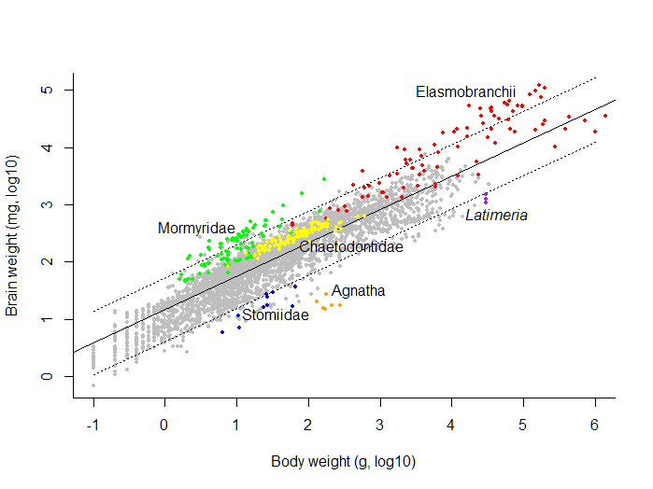

Figure 5. Scatter plot of 4125 observations of brain weight over bodyweight for1264 species of fishes. Elasmobranchii (red dots) and Mormyridae (green dots) are known for their large brains used for processing of electro-sensing signals. Stomiidae (blue dots) are deep-sea fishes, Agnatha (hagfish and lampreys, orange dots) are the evolutionary eldest groups of fishes, and Latimeria (purple dots) is a living fossil, all with relative small brains. Chaetodontidae (butterfly fishes, yellow dots) are roaming in pairs in reefs and are known for their skill in predator-avoidance, presumably with helped by larger than average brains.

**Acknowledgements**

We thank R. Bauchot and his collaborators for entrusting their valuable records FishBase, and J.-C. Hureau for painstakingly extracting them from a Multiplan spreadsheet. This original donation still forms the bulk of brain data available in FishBase.

**References**

Albert, J., R. Froese, R. Bauchot and H. Ito. 1999. Diversity of brain size in fishes: preliminary analysis of a database including 1174 species in 45 orders, p. 647-656. In B. Séret and J.-Y. Sire (eds.) Proceedings of the 5th IndoPacific Fisheries Conference, Noumea, New Caledonia, 3-8 November 1997. Soc. Fr. Ichthyol., Paris, France.

Bauchot, R., J.M. Ridet and M.-L. Bauchot. 1989. The brain organization of butterflyfishes. Environ. Biol. Fish. 25(1/3):205-219

Bray D. 1984. Axonal growth in response to experimentally applied mechanical tension. Dev Biol. 102(2):379–389.

Dunbar, R., Gamble, C., Gowlett, J. 2010. Social brain, distributed mind. OUP/British Academy, 548 p.

Froese, R. and D. Pauly. Editors. 2018. FishBase. World Wide Web electronic publication. www.fishbase.org, version (02/2018).

Froese, R., Winker, H., Gascuel, D., Sumaila, U.R., Pauly, D. 2016. Minimizing the impact of fishing. Fish and Fisheries, 17(3):785-802.

Herculano-Houzel, S. 2016. The human advantage: a new understanding of how our brain became remarkable. The MIT Press, Massachusetts, 256 p.

Kleiber, M. 1947. Body size and metabolic rate. Physiol. Rev. 27: 511-541

Ngwenya, A., Patzke, N., Manger, P.R., Herculano-Houzel, S. 2016.Continued growth of the central nervous system without mandatory addition of neurons in the Nile Crocodile *(Crocodylus niloticus)*. Brain Behav Evol DOI: 10.1159/000443201 [needs full citation]

Pauly, D. 2010. Gasping fish and panting squids: Oxygen, temperature and the growth of water-breathing animals. *In* Excellence in Ecology (22), Ed by O. Kinne. International Ecology Institute, Oldendorf/Luhe, Germany. xxviii + 216 pp.

Pauly, D., R. Froese and J.S. Albert. 2011. The BRAINS table in FishBase. In: Froese, R. and D. Pauly. Editors. 2010. FishBase. World Wide Web electronic publication. www.fishbase.org, version (04/2011).

Pianka, E.R. Evolutionary ecology. [needs full citation]

Roff, D.A. 1984. The evolution of life history parameters in teleosts. Canadian Journal of Fisheries and Aquatic Sciences 41, 989–1000.

Smith, D.H 2009. Stretch growth of integrated axon tracts: extremes and exploitations. Prog Neurobiol 89: 231–239. Available at <https://www.ncbi.nlm.nih.gov/pmc/articles/PMC3019093/>

Snell, O. 1891. Die Abhängigkeit des Hirngewichts von dem Körpergewicht und den geistigen Fähigkeiten. Arch Psychiatr Nervenkr 110: 2801-2808