Preliminary evaluation of hsCPUE
Draft written by Rainer Froese, 30.10.2014
At WKLIFE IV, an ad-hoc group evaluated hsCPUE, i.e. the method used by Froese et al. (2015) and Froese and Sampang (2013) to classify the environmental status of data-limited stocks in German marine waters. The concept was explained using the example of North Sea cod (Gadus morhua) (Fig. 1).
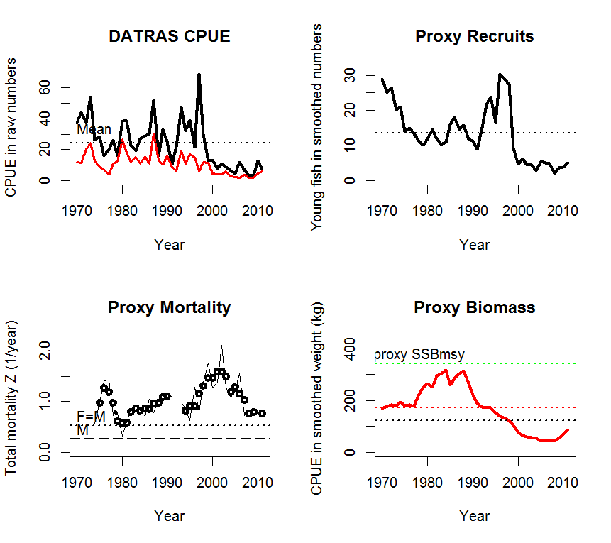
Figure 1. Example of the output of hsCPUE, here for North Sea cod. The “DATRAS CPUE” graph shows total CPUE in numbers per hour as well as number of mature individuals (red curve). The “Proxy Recruits” graph shows CPUE of immature individuals, treated as recruits. The “Proxy Biomass” graph shows the summed-up weight of the mature individuals, treated as proxy for spawning stock biomass, relative to proxies for Blim and Bpa and 2*Bpa as proxy for Bmsy. The “Proxy Mortality” graph shows estimates of total mortality Z in a framework of M and Z if F=M.
Basically, hsCPUE uses DATRAS SMALK data to obtain a length-weight relationship, von Bertalanffy growth parameters, and a length-at-maturity ogive. An estimate of natural mortality M is also needed. hsCPUE then analyzes DATRAS CPUE-per-Length-per-Area data for a given stock. It uses length at 50% maturity to split CPUE in numbers into numbers of immature and mature specimens. The length-weight relationship is then used to turn the length of the mature specimens into weight. Multiplied with numbers at length and summed up, this gives a proxy for spawning stock biomass. The number of immature fish are considered as proxy-recruits and a plot of proxy recruits over proxy spawning biomass in the year when the recruits were born then gives a stock-recruitment plot. A rule-based hockey stick is fitted to that plot and gives proxies for B_{lim} and B_{pa}, which can be used to evaluate current stock status (Figure 2).
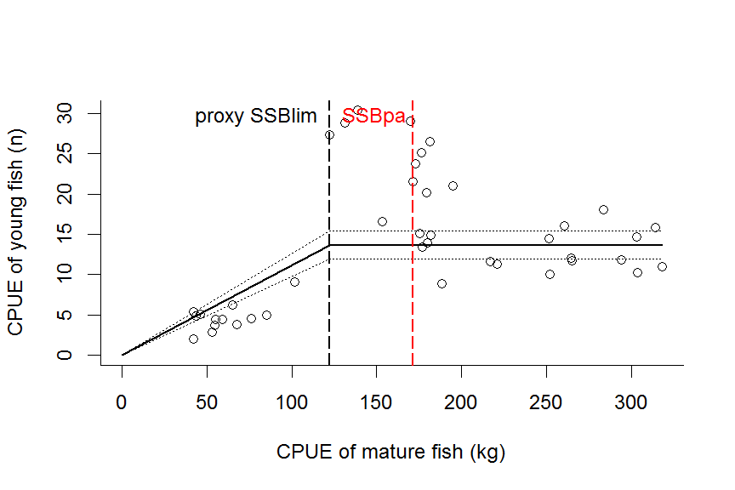
Figure 2. Rule-based hockey stick fitted to proxy recruits and proxy spawners, with indication of proxies for Blim and Bpa.

The trends for biomass and exploitation shown in Figure 1 for North Sea cod are in reasonable agreement with the full assessment for this stock (see http://www.ices.dk/sites/pub/Publication%20Reports/Advice/2014/2014/cod-347d.pdf)
The group then tried to apply this method to some of the selected data-limited stocks. Examples are shown below for Lemon sole (Microstomus kitt) (Figures 3 and 4) and for North Sea brill (Scophthalmus rhombus) (Figures 5 and 6). DATRAS data were insufficient for Great Forkbeard (Phycis blennoides).
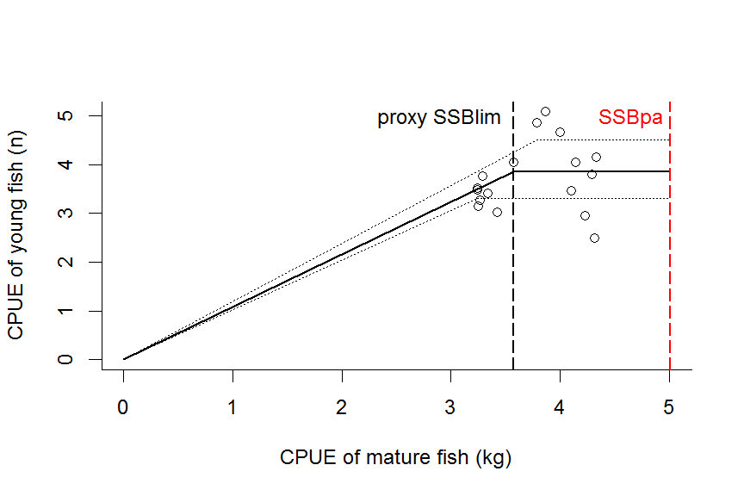
Figure 3. Proxy stock-recruitment relationship for Lemon sole.
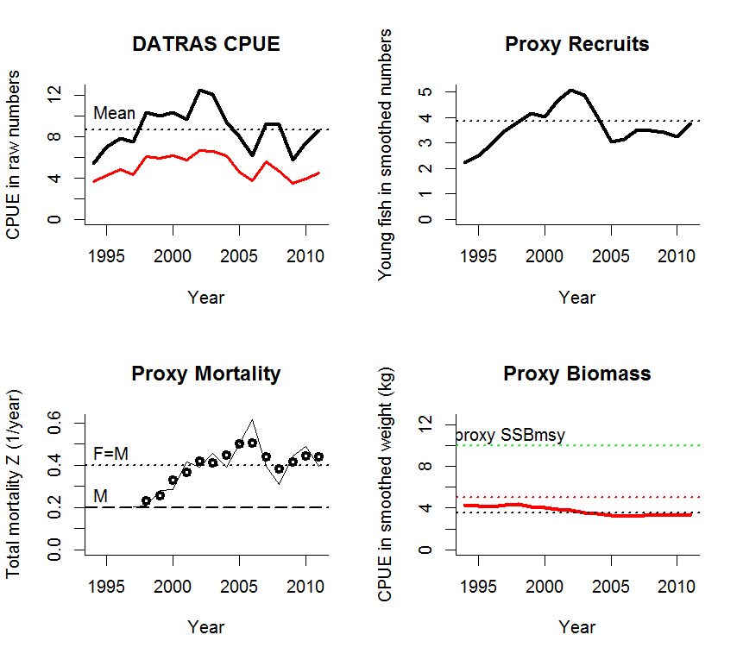
Figure 4. Results of hsCPUE analysis for Lemon sole.

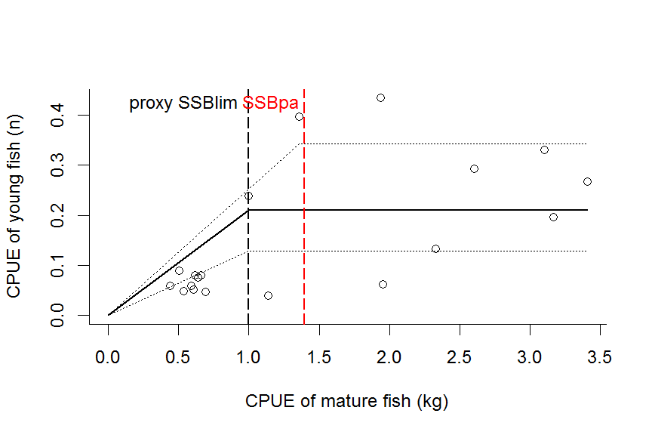
Figure 5. Hockey stick fitted to CPUE data for North Sea Brill.
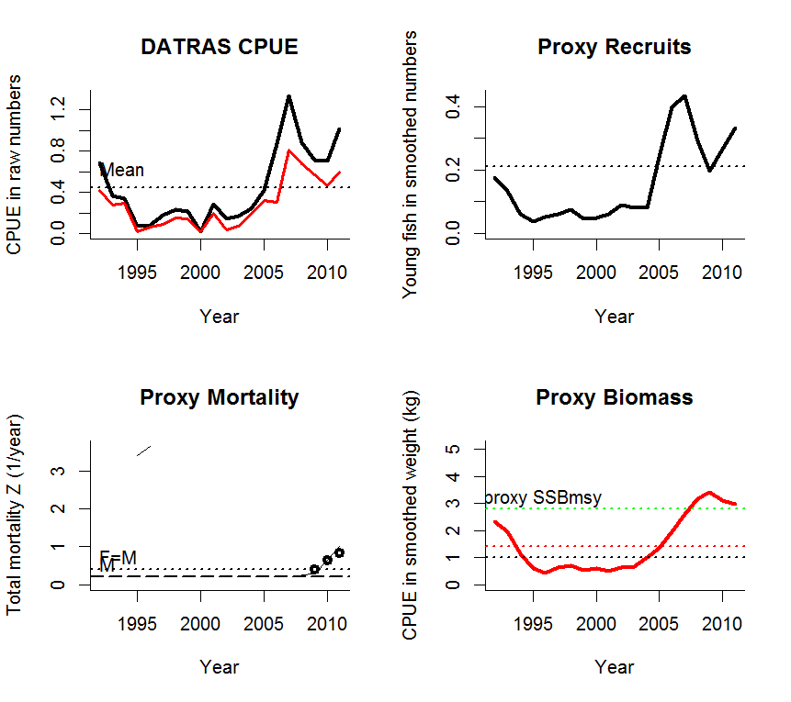
Figure 6. Results of the hsCPUE analysis for North Sea Brill.

The results for Lemon sole and North Sea brill seem consistent with other assessment, but clearly more testing is needed. For example, it is well known that CPUE data vary widely between areas and even quarters. It is therefore important to decide before the hsCPUE analysis which area(s) and quarter (only one!) is to be used consistently for a given stock. There were also concerns about the determination of recruits when the length at full selection by the gear overlapped with the length at first maturity.
The hsCPUE code used at the workshop was apparently not the latest version, which should instead be tested. For example, the hockey stick did not fit the data in at least one example.

In summary, while this approach appears promising and makes good use of available data, it needs more scrutiny and maybe recoding of the R-code before it can be used on a regular basis.

References
Froese, R. and A. Sampang. 2013. Potential indicators and reference points for good environmental status of commercially exploited marine fishes and invertebrates in the German EEZ. World Wide Web electronic publication, available from http://oceanrep.geomar.de/22079/
Froese, R., N. Demirel and A.Sampang. 2015. An overall indicator for the good environmental status of marine waters based on commercially exploited species. Marine Policy 51: 230-237

