Report of SG1 at WKIND3.3ii, 1-4 November 2016, Copenhagen, ICES HQ
Members: Rainer Froese (Chair, rfroese@geomar.de), Antti Lappalainen, Eric Foucher
Summary
Three potential indicators for “healthy” size structure were examined for 17 stocks using annual standard survey data for the North Sea (NS-IBTS) and the Baltic (BITS): the 95th percentile of lengths, the proportion of mature individuals, and the proportion of large individuals (mega-spawners) among spawners. Length frequencies from these surveys were comparable with length frequencies from commercial fisheries and thus deemed representative of the population and fit for use with the examined gadoids. For flatfish, it seemed that large individuals were under-represented in the surveys. Length structure of herring, sprat and mackerel seemed to be represented correctly, although there was some doubt with regard to large individuals. Pelagic control catches done in the context of acoustic surveys may be better suited for pelagic species than bottom trawls. These data should be made available in DATRAS.
The 95th percentile of length is one of the two indicators for MSFD 3.3 contained in the likely updated version of the directive. Three different implementations were examined for the 95th percentile of length: across all length classes (L95), across mature length classes (L95.mat) and across length classes above half of maximum length (L95.5). While L95.mat and L95.5 are less sensitive to fluctuations in recruitment, they are also less sensitive to changes in length structure and underestimate cases of severe truncation. L95.mat, in addition, is sensitive to inter-specific differences in relative length at maturity. Thus, L95 across all length classes appears to be the best and most parsimonic choice, with broad applicability across all species. On the other hand, L95 is clearly survey specific while the two other options are likely more suitable for commercial data, too, if the selectivity of the gear begins below the maturity ogive. Potential thresholds are the length Lopt where unexploited cohort biomass has its maximum. L95 relative to Lopt indicated correctly the presence or absence of large individuals in the examined length frequencies.
The proportion of mature fish (pp.mat) is the other indicator apparently proposed in the updated MSFD. The indicator is easy to calculate and to communicate. Its trends correctly indicated the changes in length-frequencies of the examined stocks, albeit with overlaid variability stemming from fluctuations in recruitment. Variability could be reduced and the visibility of the trends could be improved by using moving averages on the indicator. Also, it should be verified that any increase does not stem from a fisheries-induced reduction in size at maturity. However, there are no obvious thresholds based on life history and the proportion of spawners is influenced by the relative length at first maturity (Lm50/Linf). Thus, thresholds derived from simulations will have to be gear- and species specific.
The proportion of large fish (mega-spawners, pp.mega) among spawners is an indicator that was proposed in WKIND3.3i. The indicator is less sensitive to recruitment fluctuations than pp.mat and also not survey-specific, if the selectivity of the survey is below the maturity ogive, and if the survey correctly reflects the length frequency in the stock. However, the indicator is sensitive to the relative length at first maturity, giving higher values in species with high Lm50/Linf ratios, such as small pelagics. There are no obvious thresholds based on life history. Long-term simulations can be sued to derive thresholds, but these have to be species-specific and will depend on the chosen exploitation (F/Fmsy) and selectivity (Lc/Linf) patterns.
Plan of Work of SG1
- Get representative data for length-frequency analysis
  - Try DATRAS CPUE by length by subarea
- Evaluate data for suitability
- Check for difference by area
- Possibility to aggregate to stock level
- Compare length frequencies from survey with commercial ones
- Apply proposed indicators across a variety of stocks
- Present possible indicators with thresholds and with pros and cons

Material and Methods
Length frequencies available in DATRAS-by-length-by-subarea were analyzed for the NS-IBTS and for the BITS surveys. Length frequencies were aggregated by summing them up by length class across all sub-areas. This would give larger numbers and thus weight to areas with more sub-areas, but it was assumed that such areas would also be larger and thus the larger weight was appropriate.
DATRAS SMALK data for females were used to determine length at 50% maturity (Lm50) by fitting an ogive. This worked well for most stocks, with the exception of Baltic sprat (spr-2232) and flounder in Sounds and Belt Sea (fle-2223), where too few data were available. Also a Wetherall analysis was used to get a preliminary estimate of asymptotic length (Linf) from SMALK. If this method did not converge or the results looked unreasonable compared to observed maximum lengths, then the median of annual maximum lengths in DATRAS CPUE-by-length-by-subarea was used to derive a reasonable proxy for Linf.
The 95th percentile of length was determined after repeating length classes by their summed frequencies. L95 was estimated across all lengths, L95.mat across lengths >= Lm50, and L95.5 across lengths >= 0.5 Linf.
Number of all individuals are the sum of all frequencies. Number of mature individuals are the number of all individuals multiplied by the proportion of maturity given by the maturity ogive. Number of mega-spawners is the number of mature individuals with a length >= 1.1 * Lopt, where Lopt is the length where unexploited cohorts reach maximum biomass, here approximated by 2/3 Linf.
The R-code (SMALK&CPUE_Analysis_12.r) and the data used (SMALK_NS-IBTS_2016-10-31.csv, NSCPUE per length per subarea_2016-11-02 16_43_26.csv, SMALK_BITS_2016-10-31.csv, BalticCPUE per length per subarea_2016-11-01 15_32_54.csv) are available from the sharepoint in the SG1 directory.

Get representative data for length-frequency analysis, try CPUE-by-length-by-subarea, evaluate data for suitability, and explore possibility to aggregate to stock level
DATRAS CPUE-by-length-by-subarea gave better results for length frequencies (higher numbers, no gaps) then DATRAS CPUE-by-length-by-area, which had been used before. Length frequencies were aggregated by summing them up by length class across all sub-areas. The area of the stock was reflected by including data from the areas assigned to the ICES stocks in the stock assessment documents.
Check for difference by area
There was not enough time in SG1 to do an in-depth analysis of the difference in LF results caused by selection of different areas for the analysis. Below is one example for North Sea cod, where the northern region (Roundfish Area 1) is compared with the southern region (Roundfish Area 6). Especially in 2015, the resulting length frequencies are strikingly different, suggesting a slight recovery in numbers and size structure in Area 1 but not in Area 6, where numbers are very low and fragmented.
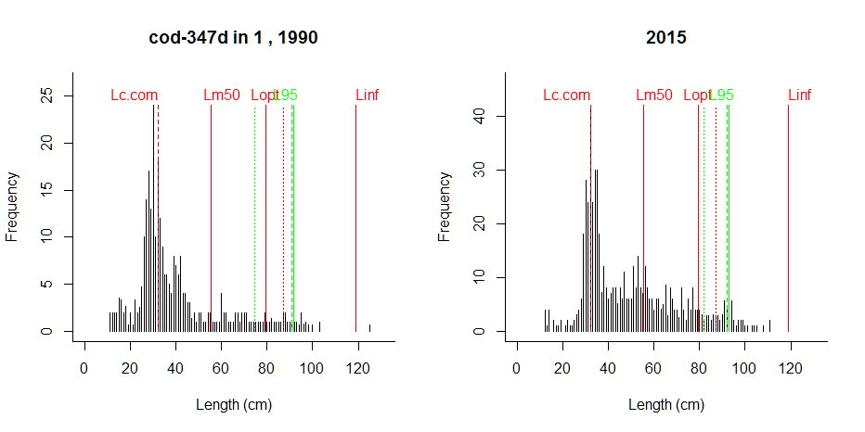
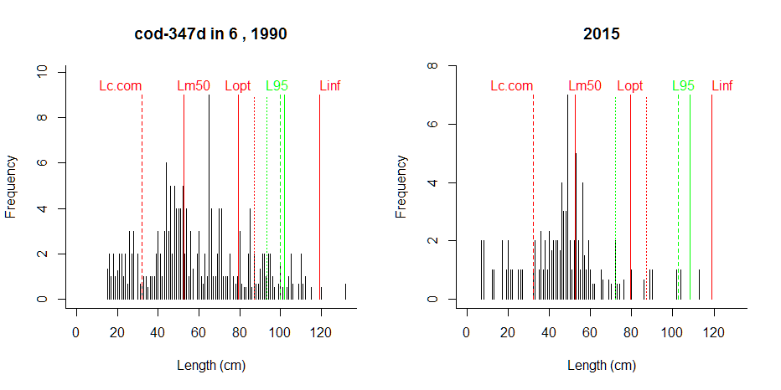

Compare length frequencies from survey with commercial ones
Commercial length frequencies were available from WKIND3.3i for only three of the analyzed stocks: Eastern Baltic cod, North Sea cod and North Sea plaice. These length frequencies are compared in the next pages with those from DATRAS CPUE-by-length-by-subarea, where the survey data have been selected for the same years and areas. In conclusion, the length frequencies derived from commercial and from survey data agree well for Eastern Baltic cod, but are completely different for North Sea cod, where the commercial data appear unrealistic, resembling a nearly unexploited stock. Survey and commercial data are similar for North Sea plaice, however, large plaice seem to be underestimated by the survey gear.
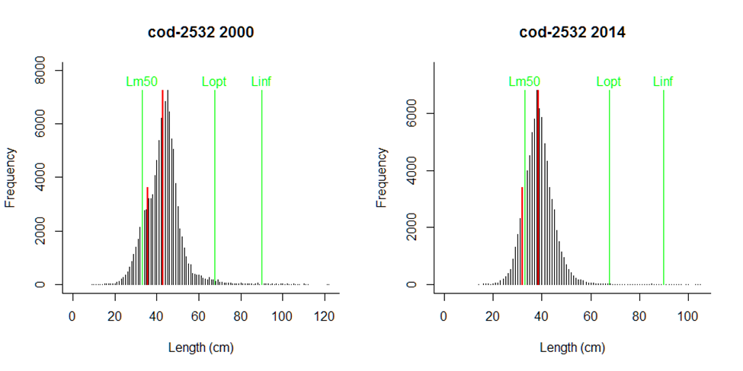
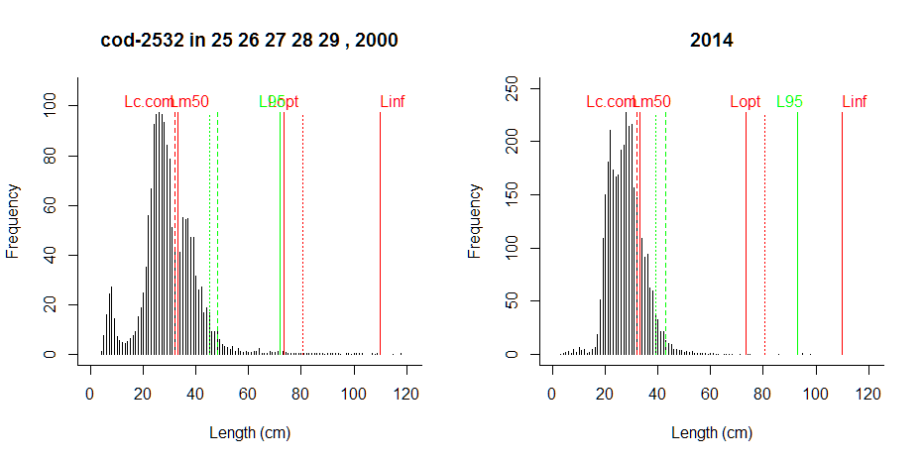
Comment: The commercial data miss some of the individuals below 35 cm (the commercial Lc for these years), but the low abundance of larger individuals is correctly reflected by the survey gear.

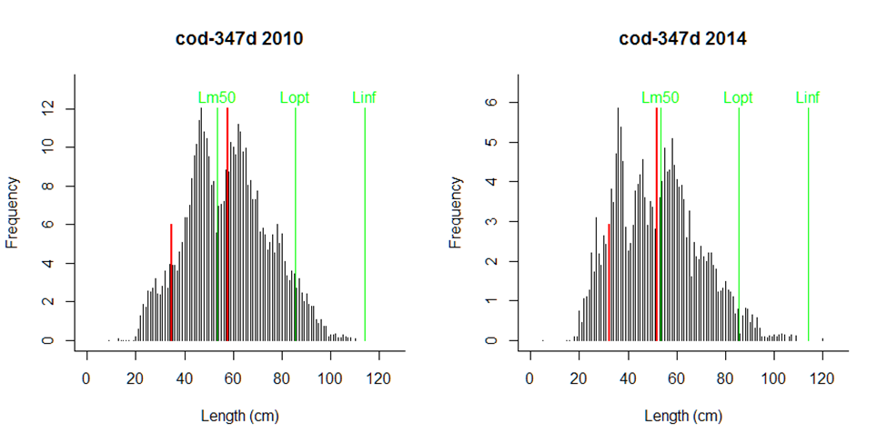
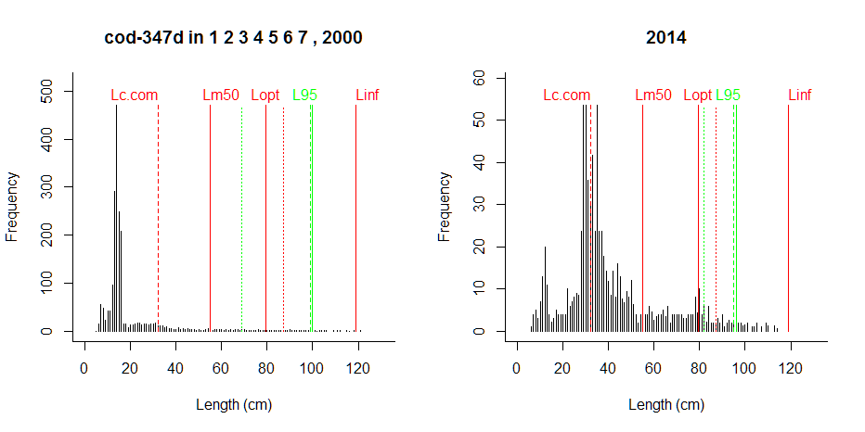
Comment: The commercial length frequency shows a healthy stock without much exploitation, which is not consistent with the current assessment of the stock. The survey data show a strongly depleted stock with truncated size structure, which is consistent with the current assessment.

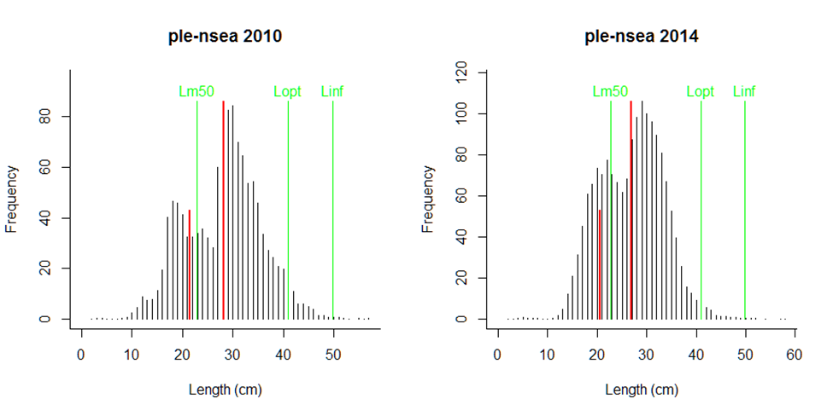
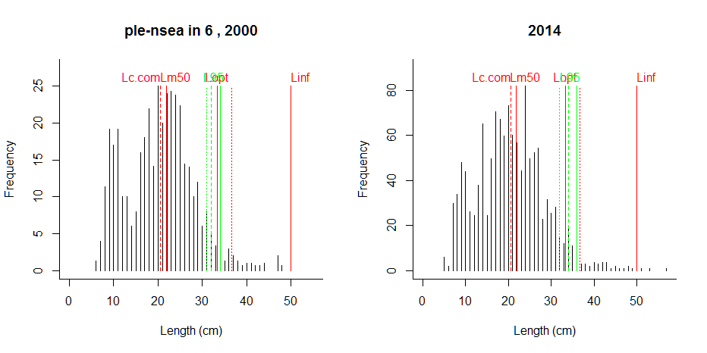
Comment: LFs agree reasonably well, but large individuals seem to be missing abruptly in the survey.

Apply proposed indicators across a variety of stocks
Table 1 summarizes the application of the selected size-based indicators to 17 stocks in the North Sea and the Baltic Sea. The standard gears used in BITS and NS-IBTS surveys are designed to catch gadoids. They tend to not retain representatively large flatfish and maybe also large herring in deeper waters, such as the Central Baltic. This needs to be checked against other surveys and against data from the commercial fishery.
For small species such as sprat and Norway pout, small differences in length may represent different year classes, and the time of capture within the year may influence the assessment, as individuals are larger in autumn and thus closer to the fixed reference points. For herring and sprat the control catches of acoustic surveys may be more suitable than BITS and NS-IBTS. However, these data were not available to WKIND3.3ii (not in DATRAS).
The indicators for proportion of mature individuals in the survey and for large individuals (Mega-spawners) among mature individuals appeared to work well in that they reflected the proportion of these groups visible in the length-frequency graphs. The variability in the indicators caused by recruitment peaks or troughs could be smoothed by e.g. a 3-year moving average, so that the average signal becomes more visible.
Of the three indicators for the 95th percentile in length, the one across all length classes (L95) was more responsive to changes in length composition than the ones that looked only at mature (L95.mat) or larger (L95.5) individuals. Because of the inclusion of small length classes, L95 showed variability caused by recruitment peaks or troughs, but these could be smoothed by e.g. a 3-year moving average, so that the average signal becomes more visible.

Table 1. Summary of applying size-based indicators to altogether 17 stocks in the North Sea (NS_IBTS survey) and Baltic Sea (BITS survey). Stocks are sorted by taxonomic group to highlight similarities. ppmat is the proportion of mature individuals in the survey; ppmega is the proportion of mega-spawners (L > 1.1 Lopt) among spawners; L95 is the 95th percentile across all length classes; L95.mat is the 95th percentile above Lm50 and L95.5 above half of Linf, each relative to Linf. The page in the report where the full assessment of a stock can be found is indicated.
Species | Stock | pp_{mat} | pp_{mega} | L95 | L95.mat | L95.5 | Page | Comment
Clupea harengus | her-47d3 | 0.17 | 0.78 | 0.81 | 0.83 | 0.83 | 7 | Indicators seem to be working okay.
 | her-3a22 | 0.04 | 0.01 | 0.55 | 0.76 | 0.59 | 36 | L95.mat too optimistic
 | her-2532-gor | 0.33 | 0.01 | 0.63 | 0.65 | 0.65 | 38 | Large individuals are missing
Sprattus sprattus | spr-2232 | 0.27 | 0.52 | 0.77 | 0.77 | 0.77 | 40 | Gear may not be suitable
Gadus morhua | cod-347d | 0.35 | 0.08 | 0.65 | 0.77 | 0.79 | 9 | L95 better than L95.mat and L95.5
 | cod-2224 | 0.55 | 0.00 | 0.44 | 0.46 | 0.64 | 24 | L95.5 misses truncated age structure
 | cod-2532 | 0.34 | 0.00 | 0.37 | 0.42 | 0.53 | 26 | L95.5 misses truncated age structure
Scomber scombrus | mac-nea | 0.48 | 0.24 | 0.77 | 0.82 | 0.80 | 22 | Indicators work well. Variability in pp.mat could be reduced by moving average.
Melanogrammus aeglefinus | had-346a | 0.26 | 0.01 | 0.53 |  | 0.66 | 11 | L95 better than L95.mat and L95.5; high variability in pp.mat could be reduced by moving average
Merlangius merlangus | whg-47d | 0.26 | 0.00 | 0.49 | 0.58 | 0.68 | 13 | Indicators work well; high variability in pp.mat could be reduced by moving average
Pollachius virens | sai-3a46 | 0.33 | 0.03 | 0.56 | 0.59 | 0.62 | 17 | Trends in indicators seem to work well despite few data; variability could be reduced by moving average
Trisopterus esmarkii | nop-34 | 0.21 | 0.09 | 0.63 | 0.71 | 0.71 | 15 | Recruitment variability introduces noise in all indicators, but trends seem to work well.
Pleuronectes platessa | ple-nsea | 0.61 | 0.07 | 0.70 | 0.72 | 0.74 | 20 | Large individuals are apparently not retained by the gear. Compare with commercial data.
 | ple-2123 | 0.87 | 0.03 | 0.69 | 0.69 | 0.71 | 28 | Large individuals apparently not retained
 | ple-2432 | 0.79 | 0.01 | 0.61 | 0.61 | 0.67 | 30 | Large individuals apparently not retained
Platichthys flesus | fle-2223 | 0.96 | 0.07 | 0.72 | 0.73 | 0.75 | 32 | Large individuals apparently not retained
 | fle-2425 | 0.95 | 0.01 | 0.61 | 0.61 | 0.65 | 34 | Large ones missing

Present possible indicators with thresholds and with pros and cons
95th percentile
The 95th percentile of lengths across all length classes in the survey reflected well the presence (e.g. in North Sea herring) or absence (e.g. in Eastern Baltic cod) of large individuals. Using the 95th percentile of lengths above maturity (L95.mat) or above half of Linf (L95.5) led to wrong signals in severely truncated size structures, because then the assessment was done mostly or only within the tail of the length distribution (see e.g North Sea cod). The down-side of using all length classes is the influence of recruitment on the indicator. This influence can, however, be reduced by e.g. using a moving average, basically using average recruitment over the past years as is often done in stock assessment.
Potential lower reference points for L95 are Lopt and 1.1 Lopt, with L95 in healthy size structures falling above 1.1 Lopt (e.g. North Sea herring, mackerel and Baltic sprat) and severely truncated size structures falling below Lopt (e.g. in Baltic cod and North Sea whiting).

Table 2. Evaluation of the indicators examined in this report.
Indicator | Data needed | Pot. thresholds | Pro | Con
L95 | only LF | Lopt; 1.1 Lopt | No assumptions; broad applicability across species | sensitive to recruitment; arbitrary; may be difficult to communicate
L95.mat | LF, Lm50 | Lopt; 1.1 Lopt | less sensitive to recruitment | underestimates strong truncation; different results depending on Lm50/Lopt ratio
L95.5 | Lf, Linf | Lopt; 1.1 Lopt | less sensitive to recruitment | underestimates strong truncation
pp.mat | LF & maturity ogive; at least numbers & Lm50 | long-term simulations | broadly applicable, easy to communicate | sensitive to recruitment; different thresholds needed for different Linf/Lm50 ratios
pp.mega | LF & maturity ogive; at least numbers & Lm50 | long-term simulations | broadly applicable, easy to communicate | arbitrary definition; different thresholds needed for different Lm50/Linf ratios

Proportion of mature individuals
The number of mature individuals relative to all individuals in the survey for a given year (pp.mat) is an easy to obtain indicator. It is most accurately determined from representative length-frequencies and a robust maturity-at-length ogive. However, it can also be approximated from number of individuals larger than Lm50 relative to number of all individuals. Given that surveys such as NS-IBTS and BITS will always catch juveniles for most species, the proportion is a function of how many large fish are present. However, the proportion of mature fish is also a function of recruitment, with many recruits reducing the value of the indicator even if the number of mature fish has not changed. This effect can be reduced by using a moving average on the indicator.
There are no broadly applicable thresholds available for this indicator, because the number of small individuals depends on the selectivity of the survey gear. Simulations of long-term values based on assumptions about average fishing pressure (F/Fmsy) and selectivity (Lc/Linf) can be used to derive thresholds. However, different Lm50/Linf ratios, such as found in gadoids (about half of Lopt) versus small pelagics (near Lopt) would lead to different proportions of mature individuals in otherwise identical length frequency distributions. Therefore such simulations need to be stock specific.

Porportion of mega-spawners
The number of large individuals (L >= 1.1 Lopt) relative to all mature individuals in the survey for a given year (pp.mega) is an easy to obtain indicator. Note, however, that the definition of mega-spawners is arbitrary and not easy to communicate. Also, for the same length-frequency sample and the same number of mega-spawners, the proportion will change if the relative length at maturity (Lm50/Linf) is different, such as such as in gadoids (about half of Lopt) versus small pelagics (near Lopt). Therefore, simulations to derive long-term thresholds need to be stock specific.
APPENDIX
Details of assessed stocks
Legends for subsequent graphs:

Legend for upper graph:
The two panels in this graph show length frequencies for first and last year in CPUE-by-length-by-area surveys for the North Sea (NS-IBTS) and the Baltic (IBITS). Lc.com is the length at which 50% of the specimen are retained by the commercial gears, derived from commercial LF or from 90% of minimum landing sizes. Lm50 is the length where 50% of the larger sex have reached maturity. Lopt is the theoretical length where cohort biomass reaches a maximum in the unexploited stock. The dotted vertical line at 1.1 Lopt indicates the length above which specimens are considered to be mega-spawners. Linf is the asymptotic length. The green lines indicate the weighted 95th percentile of lengths, with the dotted line using all length classes in the sample, the dashed line using lengths above Lm50, and the solid line using lengths above half of Linf.

Legend for lower left graph:
Maturity ogive, i.e., the proportion of mature individuals by length class for the indicated sex. The red circles indicate the lengths at 10%, 50% and 90% maturity, respectively. Lc.com indicates the length where 50% of the specimens are retained by the commercial gears.

Legend for lower right graph:
The upper panel of the lower right graph shows the weighted 95% percentile of length in the survey relative to Linf (green curves). The dotted green curve uses all length classes in the sample, the dashed line uses lengths above Lm50, and the solid line uses lengths above half of Linf. The solid red line indicates Lopt/Linf and the dotted red line indicates the length above which specimens are considered to be mega-spawners. The solid green curve in the lower panel shows the proportion of mature individuals in the LF sample (Nmat / N). The dashed green curve shows the proportion of mega-spawners (>= 1.1 Lopt) among spawners (Nmega / Nmat).

North Sea herring
----------------------------------------------
Results of SMALK and CPUE analysis, Fri Nov 04 13:41:00 2016
----------------------------------------------
SMALK_File = SMALK_NS-IBTS_2016-10-31.csv CPUE_File = NSCPUE per length per subarea_2016-11-02 16_43_26.csv
Survey = NS-IBTS
Species = Clupea harengus Stock = her-47d3
Sex SMALK = F
Years = 1991 - 2015
Quarter = 3
Areas = 1 2 3 4 5 6 7
Lc.com = 18 cm (length where 50% are retained by commercial gear)
----------------------------------------------
Summary stats of weighted F W~L regression
----------------------------------------------
27 outliers (beyond 4 SD) were removed.
Number of remaining observations = 15035
Length range = 8 - 37.5 cm
Weight range = 3 - 477 g
log10(a) = -2.45 , SE = 0.00652
Geometric mean a = 0.00352 , 95% CL = 0.00342 - 0.00362
b = 3.28 , 95% CL = 3.28 - 3.29
Standard deviation of estimated log10(W) = 0.0568
Coefficient of determination (r2) = 0.975
--------------------------------------------------------------
Maturity analysis from proportion-mature-at-length data
--------------------------------------------------------------
Available maturity codes = 1 2 4 3
Number of observations = 24147
Largest immature = 33.5 cm
Smallest mature = 7.5 cm
Ogive length at 50% maturity = 23 cm
Ogive length at 10% and 90% maturity 19.3 - 26.6 cm
-------------------------------------------------
Estimation of Linf
-------------------------------------------------
Observed maximum length SMALK = 37.5 cm
Median of annual maximum lengths = 35.5 cm
Whetherall Linf based on SMALK = 34 cm
Observed maximum length CPUE = 55 cm
Median annual maximum lengths CPUE = 36.5 cm
Chosen Linf = 36 cm
Length at max cohort biomass Lopt = 24 cm (assuming b~3 and M/K~1.5)

Stock Year Lmax.obs N N.mat N.mega pp.mat pp.mega L95 L95mat L95.5 L95Linf L95matLinf L95.5Linf
1 her-47d3 1990 32.5 291050 47763 14815 0.1641 0.310 26.5 27.5 27.0 0.736 0.764 0.750
2 her-47d3 1991 37.0 1511577 150408 NA 0.0995 NA 27.0 29.0 28.0 0.750 0.806 0.778
3 her-47d3 1992 36.5 1753652 141578 61544 0.0807 0.435 27.0 30.5 29.5 0.750 0.847 0.819
4 her-47d3 1993 36.0 1100725 104594 33872 0.0950 0.324 26.0 29.0 28.0 0.722 0.806 0.778
5 her-47d3 1994 37.0 1969634 208131 63655 0.1057 0.306 26.5 29.5 27.5 0.736 0.819 0.764
6 her-47d3 1995 44.0 2060301 245892 NA 0.1193 NA 26.5 28.5 27.5 0.736 0.792 0.764
7 her-47d3 1996 37.0 922631 71980 26043 0.0780 0.362 26.0 29.5 28.5 0.722 0.819 0.792
8 her-47d3 1997 36.0 1293342 81533 32812 0.0630 0.402 25.5 28.5 28.0 0.708 0.792 0.778
9 her-47d3 1998 34.5 349653 34353 9198 0.0982 0.268 25.5 28.0 27.0 0.708 0.778 0.750
10 her-47d3 1999 33.0 264700 54048 13228 0.2042 0.245 26.5 27.5 27.0 0.736 0.764 0.750
11 her-47d3 2000 55.0 901697 74426 36020 0.0825 0.484 26.5 31.0 28.5 0.736 0.861 0.792
12 her-47d3 2001 36.0 859147 84910 26711 0.0988 0.315 26.0 28.5 27.5 0.722 0.792 0.764
13 her-47d3 2002 52.0 560681 27902 NA 0.0498 NA 24.0 27.5 26.0 0.667 0.764 0.722
14 her-47d3 2003 36.5 948747 163181 70286 0.1720 0.431 27.0 28.0 27.5 0.750 0.778 0.764
15 her-47d3 2004 36.0 1010089 189707 83932 0.1878 0.442 27.5 28.5 28.0 0.764 0.792 0.778
16 her-47d3 2005 36.5 648400 125169 84029 0.1930 0.671 27.5 28.5 28.0 0.764 0.792 0.778
17 her-47d3 2006 37.5 733063 127336 92259 0.1737 0.725 28.0 29.0 28.5 0.778 0.806 0.792
18 her-47d3 2007 35.0 555420 63039 44264 0.1135 0.702 27.5 29.5 29.5 0.764 0.819 0.819
19 her-47d3 2008 38.0 618777 87205 48241 0.1409 0.553 27.5 29.5 29.0 0.764 0.819 0.806
20 her-47d3 2009 36.5 511849 31814 31805 0.0622 1.000 28.5 31.0 30.5 0.792 0.861 0.847
21 her-47d3 2010 37.0 576799 53701 38436 0.0931 0.716 29.0 31.5 30.5 0.806 0.875 0.847
22 her-47d3 2011 36.0 1220441 259526 NA 0.2126 NA 29.0 30.0 30.0 0.806 0.833 0.833
23 her-47d3 2012 35.5 359404 57283 43490 0.1594 0.759 29.0 30.5 30.5 0.806 0.847 0.847
24 her-47d3 2013 36.5 1313563 130126 100063 0.0991 0.769 28.5 30.5 30.0 0.792 0.847 0.833
25 her-47d3 2014 34.5 558242 14617 4644 0.0262 0.318 22.0 30.5 28.5 0.611 0.847 0.792
26 her-47d3 2015 38.5 489985 84619 59879 0.1727 0.708 29.0 30.0 30.0 0.806 0.833 0.833

Comment: 90% of minimum landing size used as proxy for Lc.com. It seems like larger specimens are not retained by the gear.

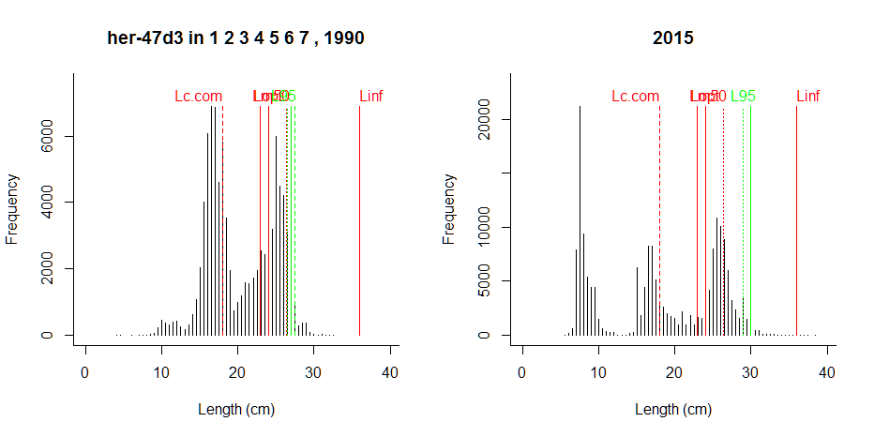
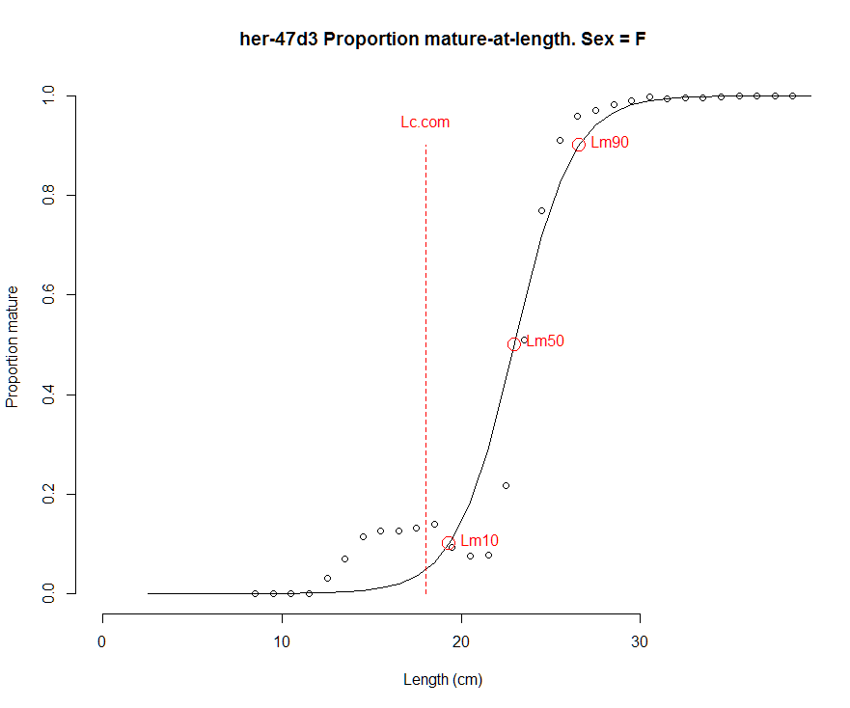 | 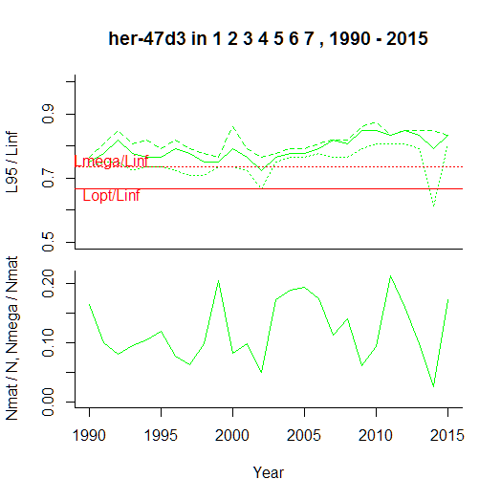

Comment: Indicators seem to be working okay. It needs to be checked whether large individuals are missing from the population or are not retained by the gear.

North Sea cod
----------------------------------------------
Results of SMALK and CPUE analysis, Fri Nov 04 13:44:16 2016
----------------------------------------------
SMALK_File = SMALK_NS-IBTS_2016-10-31.csv CPUE_File = NSCPUE per length per subarea_2016-11-02 16_43_26.csv
Survey = NS-IBTS
Species = Gadus morhua Stock = cod-347d
Sex SMALK = F
Years = 1990 - 2015
Quarter = 1
Areas = 1 2 3 4 5 6 7
Lc.com = 32.2 cm (length where 50% are retained by commercial gear)
----------------------------------------------
Summary stats of weighted F W~L regression
----------------------------------------------
23 outliers (beyond 4 SD) were removed.
Number of remaining observations = 6069
Length range = 9.3 - 133 cm
Weight range = 6 - 25000 g
log10(a) = -2.25 , SE = 0.00492
Geometric mean a = 0.00563 , 95% CL = 0.00551 - 0.00576
b = 3.15 , 95% CL = 3.15 - 3.16
Standard deviation of estimated log10(W) = 0.0581
Coefficient of determination (r2) = 0.995
--------------------------------------------------------------
Maturity analysis from proportion-mature-at-length data
--------------------------------------------------------------
Available maturity codes = 1 2 4 3
Number of observations = 13373
Largest immature = 88 cm
Smallest mature = 9 cm
Ogive length at 50% maturity = 52.2 cm
Ogive length at 10% and 90% maturity 29.6 - 74.7 cm
-------------------------------------------------
Estimation of Linf
-------------------------------------------------
Observed maximum length SMALK = 133 cm
Median of annual maximum lengths = 119 cm
Whetherall Linf based on SMALK = 117 cm
Observed maximum length CPUE = 140 cm
Median annual maximum lengths CPUE = 120 cm
Chosen Linf = 119 cm
Length at max cohort biomass Lopt = 79.3 cm (assuming b~3 and M/K~1.5)

Stock Year Lmax.obs N N.mat N.mega pp.mat pp.mega L95 L95mat L95.5 L95Linf L95matLinf L95.5Linf
1 cod-347d 1990 138 3444 865 138.7 0.2511 0.1604 75 97.0 101.0 0.630 0.815 0.849
2 cod-347d 1991 138 23231 2684 223.0 0.1155 0.0831 55 94.0 98.9 0.462 0.790 0.831
3 cod-347d 1992 125 34024 3700 236.2 0.1087 0.0638 48 95.0 99.3 0.403 0.798 0.834
4 cod-347d 1993 131 21043 3079 224.0 0.1463 0.0727 59 96.0 100.0 0.496 0.807 0.840
5 cod-347d 1994 120 28528 3136 215.1 0.1099 0.0686 50 97.0 100.0 0.420 0.815 0.840
6 cod-347d 1995 125 23407 4304 163.1 0.1839 0.0379 58 92.0 100.0 0.487 0.773 0.840
7 cod-347d 1996 140 16481 2460 198.5 0.1493 0.0807 62 97.0 101.0 0.521 0.815 0.849
8 cod-347d 1997 115 26900 2554 149.2 0.0949 0.0584 50 95.0 98.1 0.420 0.798 0.824
9 cod-347d 1998 121 19750 1854 111.8 0.0939 0.0603 47 94.0 97.9 0.395 0.790 0.823
10 cod-347d 1999 140 10595 1216 93.5 0.1148 0.0769 57 97.9 100.0 0.479 0.823 0.840
11 cod-347d 2000 121 5970 997 104.5 0.1671 0.1048 69 99.0 100.0 0.580 0.832 0.840
12 cod-347d 2001 114 28023 1288 60.9 0.0460 0.0473 34 92.7 98.7 0.286 0.779 0.829
13 cod-347d 2002 117 4015 839 51.6 0.2090 0.0615 65 91.7 97.7 0.546 0.771 0.821
14 cod-347d 2003 119 2516 748 86.6 0.2973 0.1157 83 95.0 98.0 0.697 0.798 0.824
15 cod-347d 2004 133 3510 621 59.4 0.1770 0.0956 71 95.9 98.9 0.597 0.806 0.832
16 cod-347d 2005 115 3085 448 62.5 0.1453 0.1394 67 96.6 97.0 0.563 0.812 0.815
17 cod-347d 2006 118 4235 559 45.4 0.1319 0.0813 59 100.0 101.0 0.496 0.840 0.849
18 cod-347d 2007 113 4795 838 65.4 0.1747 0.0780 63 98.2 101.5 0.529 0.826 0.853
19 cod-347d 2008 130 3794 1112 76.2 0.2932 0.0685 72 90.0 93.0 0.605 0.756 0.782
20 cod-347d 2009 123 2463 858 65.3 0.3482 0.0761 80 90.0 93.4 0.672 0.756 0.785
21 cod-347d 2010 114 3725 1139 82.7 0.3058 0.0726 76 90.0 93.0 0.639 0.756 0.782
22 cod-347d 2011 120 5038 2387 339.0 0.4738 0.1420 89 93.0 94.5 0.748 0.782 0.794
23 cod-347d 2012 109 3688 1569 125.7 0.4254 0.0801 83 91.0 94.0 0.697 0.765 0.790
24 cod-347d 2013 126 3209 1349 101.5 0.4202 0.0753 84 91.0 93.0 0.706 0.765 0.782
25 cod-347d 2014 114 4123 1307 129.3 0.3170 0.0990 82 93.6 96.1 0.689 0.787 0.808
26 cod-347d 2015 113 5210 1819 142.3 0.3492 0.0782 78 92.0 94.0 0.655 0.773 0.790

Comment: Lc.com from analysis of commercial catch

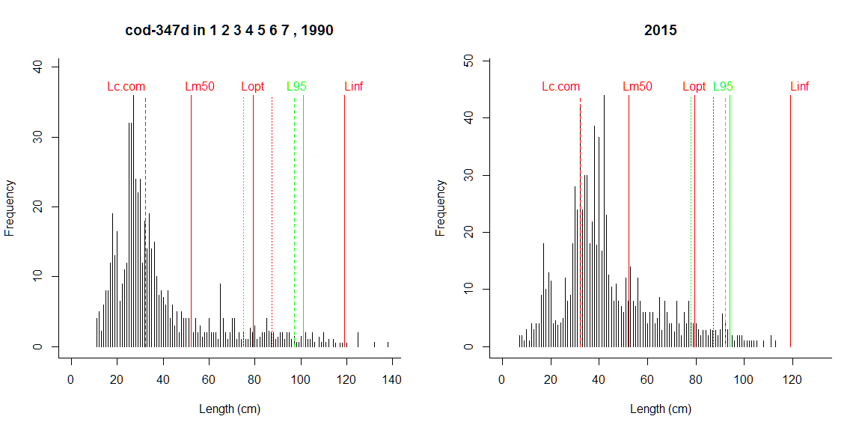

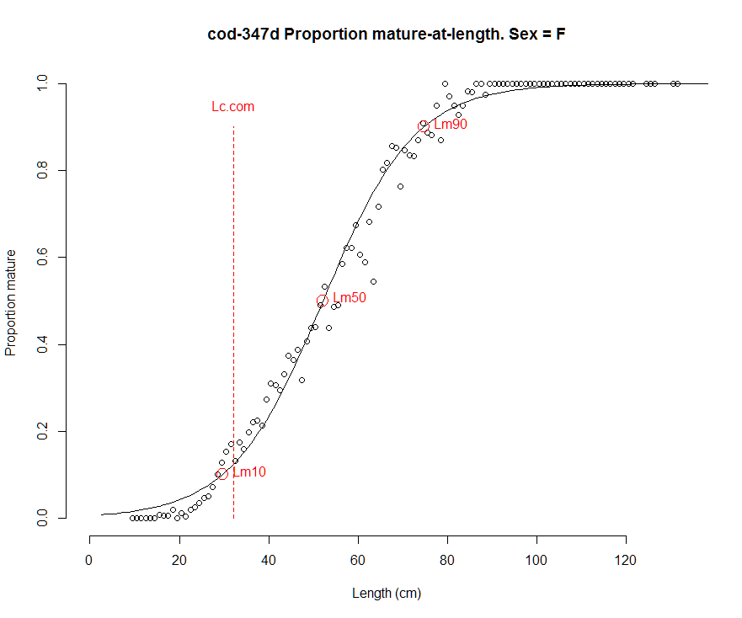 | 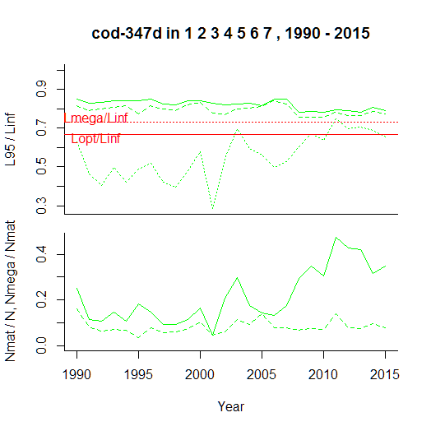

Comment: L95 based on whole survey (dotted green line in the upper panel of the lower right graph) is sensitive to recruitment (e.g. in 2001), but reflects the initial lack of large individuals and the slight recovery better than L95 above 0.5 Linf (solid line) or above Lm50 (dashed green line). A 3-years moving average could correct the sensitivity to fluctuations in recruitment. Proportion of spawners and proportion of mega spawners work well as indicators of a stock where Lc/Lmat=32.2/52.2=0.62 is low and the size structure is clearly truncated.

North Sea haddock
----------------------------------------------
Results of SMALK and CPUE analysis, Fri Nov 04 13:48:56 2016
----------------------------------------------
SMALK_File = SMALK_NS-IBTS_2016-10-31.csv CPUE_File = NSCPUE per length per subarea_2016-11-02 16_43_26.csv
Survey = NS-IBTS
Species = Melanogrammus aeglefinus Stock = had-346a
Sex SMALK = F
Years = 1990 - 2015
Quarter = 1
Areas = 1 2 3 4 6 7 5
Lc.com = 27 cm (length where 50% are retained by commercial gear)
----------------------------------------------
Summary stats of weighted F W~L regression
----------------------------------------------
25 outliers (beyond 4 SD) were removed.
Number of remaining observations = 14072
Length range = 10 - 81 cm
Weight range = 10 - 4935 g
log10(a) = -2.25 , SE = 0.00478
Geometric mean a = 0.00556 , 95% CL = 0.00544 - 0.00568
b = 3.15 , 95% CL = 3.15 - 3.16
Standard deviation of estimated log10(W) = 0.0553
Coefficient of determination (r2) = 0.987
--------------------------------------------------------------
Maturity analysis from proportion-mature-at-length data
--------------------------------------------------------------
Available maturity codes = 1 2 4 3
Number of observations = 26327
Largest immature = 47 cm
Smallest mature = 10 cm
Ogive length at 50% maturity = 26 cm
Ogive length at 10% and 90% maturity 20.7 - 31.4 cm
-------------------------------------------------
Estimation of Linf
-------------------------------------------------
Observed maximum length SMALK = 81 cm
Median of annual maximum lengths = 67.5 cm
Whetherall Linf based on SMALK = NA cm
Observed maximum length CPUE = 87 cm
Median annual maximum lengths CPUE = 69.5 cm
Chosen Linf = 69.5 cm
Length at max cohort biomass Lopt = 46.3 cm (assuming b~3 and M/K~1.5)

Stock Year Lmax.obs N N.mat N.mega pp.mat pp.mega L95 L95mat L95.5 L95Linf L95matLinf L95.5Linf
1 had-346a 1990 71 49000 19089 96.1 0.3896 0.005033 36 40 46 0.518 0.576 0.662
2 had-346a 1991 82 425741 79844 439.9 0.1875 0.005509 30 39 50 0.432 0.561 0.719
3 had-346a 1992 70 1000579 153609 296.0 0.1535 0.001927 31 37 44 0.446 0.532 0.633
4 had-346a 1993 76 654777 155029 290.3 0.2368 0.001873 33 38 44 0.475 0.547 0.633
5 had-346a 1994 87 789447 120559 225.7 0.1527 0.001872 30 37 44 0.432 0.532 0.633
6 had-346a 1995 72 832794 193448 256.8 0.2323 0.001328 32 37 44 0.460 0.532 0.633
7 had-346a 1996 68 496324 162645 221.7 0.3277 0.001363 33 37 44 0.475 0.532 0.633
8 had-346a 1997 72 396030 135348 125.3 0.3418 0.000926 34 37 44 0.489 0.532 0.633
9 had-346a 1998 67 197435 70302 96.2 0.3561 0.001368 35 38 42 0.504 0.547 0.604
10 had-346a 1999 67 871381 57424 109.7 0.0659 0.001910 28 38 43 0.403 0.547 0.619
11 had-346a 2000 70 822391 85621 84.2 0.1041 0.000983 26 39 44 0.374 0.561 0.633
12 had-346a 2001 68 513140 170058 98.1 0.3314 0.000577 30 34 45 0.432 0.489 0.647
13 had-346a 2002 70 314935 189743 95.2 0.6025 0.000502 34 35 42 0.489 0.504 0.604
14 had-346a 2003 67 210497 154524 139.8 0.7341 0.000905 36 36 41 0.518 0.518 0.590
15 had-346a 2004 74 140169 97159 126.1 0.6932 0.001298 37 38 40 0.532 0.547 0.576
16 had-346a 2005 67 197740 43536 136.8 0.2202 0.003143 36 39 42 0.518 0.561 0.604
17 had-346a 2006 69 219043 40375 120.0 0.1843 0.002972 33 41 44 0.475 0.590 0.633
18 had-346a 2007 67 200529 92757 88.9 0.4626 0.000959 32 36 44 0.460 0.518 0.633
19 had-346a 2008 67 98625 55127 168.1 0.5590 0.003049 35 36 46 0.504 0.518 0.662
20 had-346a 2009 68 173576 54514 76.7 0.3141 0.001408 34 37 43 0.489 0.532 0.619
21 had-346a 2010 68 200130 67174 93.8 0.3357 0.001396 35 38 42 0.504 0.547 0.604
22 had-346a 2011 68 183013 111502 126.5 0.6093 0.001135 37 38 42 0.532 0.547 0.604
23 had-346a 2012 67 95067 73054 137.8 0.7684 0.001887 38 39 43 0.547 0.561 0.619
24 had-346a 2013 72 53800 34061 310.3 0.6331 0.009109 41 43 45 0.590 0.619 0.647
25 had-346a 2014 70 159766 49410 304.8 0.3093 0.006169 38 42 44 0.547 0.604 0.633
26 had-346a 2015 81 130483 34157 234.5 0.2618 0.006866 37 43 46 0.532 0.619 0.662

Comment: No mega-spawners; 90% of minimum landing size assumed as proxy for Lc.com

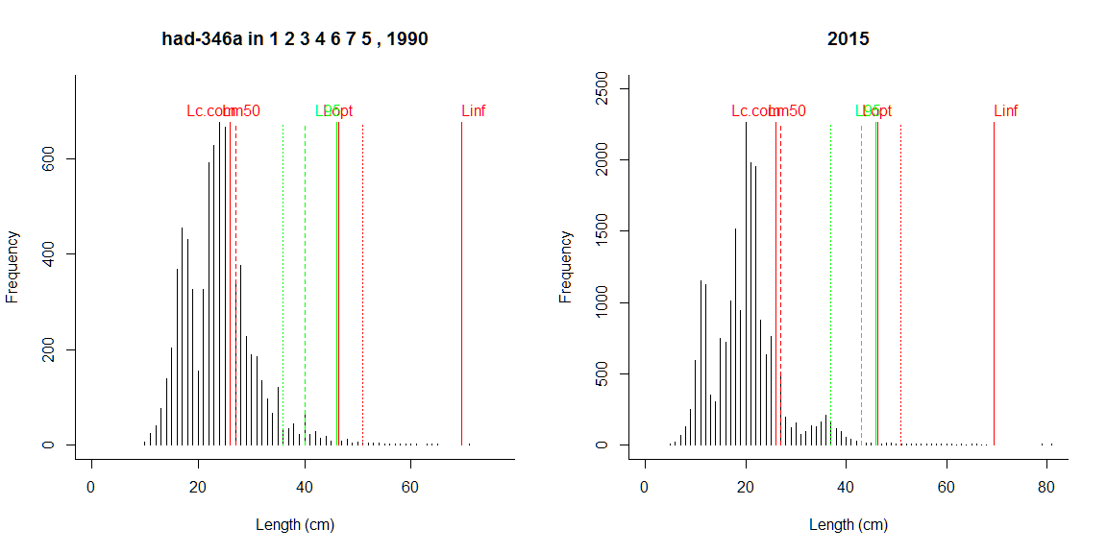

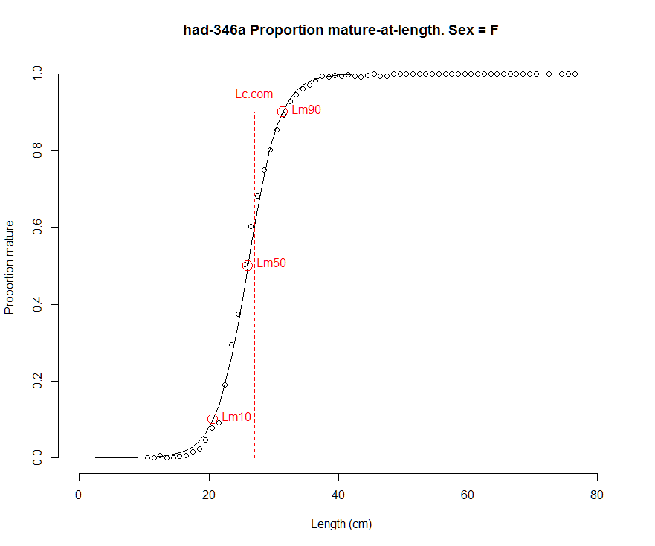 | 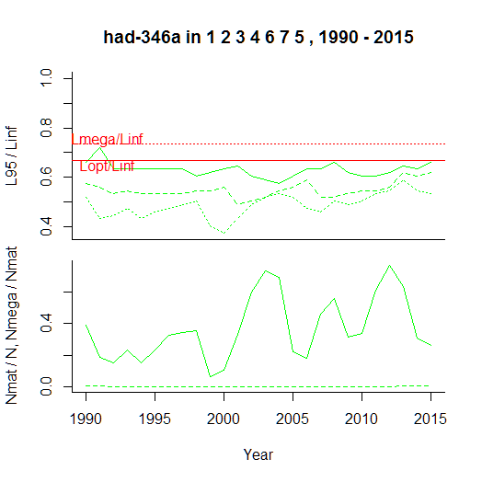

Comment: Severely truncated size structure and absence of mega-spawners. L95 across all sizes works better than L95 restricted to larger sizes, suggesting slight improvement in size structure at very low level. This is also visible in number of spawners.

North Sea whiting
----------------------------------------------
Results of SMALK and CPUE analysis, Fri Nov 04 13:30:08 2016
----------------------------------------------
SMALK_File = SMALK_NS-IBTS_2016-10-31.csv CPUE_File = NSCPUE per length per subarea_2016-11-02 16_43_26.csv
Survey = NS-IBTS
Species = Merlangius merlangus Stock = whg-47d
Sex SMALK = F
Years = 1990 - 2015
Quarter = 1
Areas = 1 2 3 4 5 6 7
Lc.com = 24.3 cm (length where 50% are retained by commercial gear)
----------------------------------------------
Summary stats of weighted F W~L regression
----------------------------------------------
53 outliers (beyond 4 SD) were removed.
Number of remaining observations = 19431
Length range = 7 - 57.8 cm
Weight range = 2 - 1966 g
log10(a) = -2.36 , SE = 0.00353
Geometric mean a = 0.00432 , 95% CL = 0.00426 - 0.00439
b = 3.19 , 95% CL = 3.19 - 3.2
Standard deviation of estimated log10(W) = 0.0565
Coefficient of determination (r2) = 0.989
--------------------------------------------------------------
Maturity analysis from proportion-mature-at-length data
--------------------------------------------------------------
Available maturity codes = 1 2 3 4
Number of observations = 32380
Largest immature = 49 cm
Smallest mature = 7 cm
Ogive length at 50% maturity = 21.1 cm
Ogive length at 10% and 90% maturity 17 - 25.1 cm
-------------------------------------------------
Estimation of Linf
-------------------------------------------------
Observed maximum length SMALK = 57.8 cm
Median of annual maximum lengths = 51.5 cm
Whetherall Linf based on SMALK = 58.9 cm
Observed maximum length CPUE = 69 cm
Median annual maximum lengths CPUE = 56 cm
Chosen Linf = 58.9 cm
Length at max cohort biomass Lopt = 39.3 cm (assuming b~3 and M/K~1.5)

Stock Year Lmax.obs N N.mat N.mega pp.mat pp.mega L95 L95mat L95.5 L95Linf L95matLinf L95.5Linf
1 whg-47d 1990 56 239879 124637 82.8 0.520 0.000665 29 32 37 0.492 0.543 0.628
2 whg-47d 1991 54 1063441 504150 164.6 0.474 0.000326 29 31 36 0.492 0.526 0.611
3 whg-47d 1992 50 1186150 510939 177.4 0.431 0.000347 30 32 36 0.509 0.543 0.611
4 whg-47d 1993 54 1040973 406856 538.5 0.391 0.001324 30 33 37 0.509 0.560 0.628
5 whg-47d 1994 52 986085 418401 233.9 0.424 0.000559 29 31 37 0.492 0.526 0.628
6 whg-47d 1995 57 1174044 492876 291.2 0.420 0.000591 29 31 37 0.492 0.526 0.628
7 whg-47d 1996 56 636144 340117 194.4 0.535 0.000572 30 32 37 0.509 0.543 0.628
8 whg-47d 1997 48 231331 132070 71.7 0.571 0.000543 30 32 36 0.509 0.543 0.611
9 whg-47d 1998 56 554787 105297 78.0 0.190 0.000741 27 32 37 0.458 0.543 0.628
10 whg-47d 1999 59 705237 166565 74.7 0.236 0.000448 27 31 37 0.458 0.526 0.628
11 whg-47d 2000 59 697651 221355 71.8 0.317 0.000325 28 31 36 0.475 0.526 0.611
12 whg-47d 2001 54 891597 210879 81.2 0.237 0.000385 27 31 37 0.458 0.526 0.628
13 whg-47d 2002 54 372549 190310 85.3 0.511 0.000448 30 32 37 0.509 0.543 0.628
14 whg-47d 2003 69 315561 195005 117.2 0.618 0.000601 31 32 36 0.526 0.543 0.611
15 whg-47d 2004 55 258664 109461 74.0 0.423 0.000676 30 32 37 0.509 0.543 0.628
16 whg-47d 2005 53 134110 74586 74.2 0.556 0.000995 31 33 36 0.526 0.560 0.611
17 whg-47d 2006 59 134772 66197 84.6 0.491 0.001279 32 33 36 0.543 0.560 0.611
18 whg-47d 2007 65 230301 68990 110.8 0.300 0.001605 30 33 37 0.509 0.560 0.628
19 whg-47d 2008 60 291796 98459 125.0 0.337 0.001269 30 33 38 0.509 0.560 0.645
20 whg-47d 2009 54 341310 153868 159.1 0.451 0.001034 29 31 38 0.492 0.526 0.645
21 whg-47d 2010 56 263072 133448 248.8 0.507 0.001864 32 34 37 0.543 0.577 0.628
22 whg-47d 2011 58 270043 144451 628.3 0.535 0.004349 32 35 40 0.543 0.594 0.679
23 whg-47d 2012 61 286154 138729 686.3 0.485 0.004947 31 35 41 0.526 0.594 0.696
24 whg-47d 2013 56 179738 103730 665.9 0.577 0.006420 34 36 40 0.577 0.611 0.679
25 whg-47d 2014 58 494809 114288 804.7 0.231 0.007041 30 35 40 0.509 0.594 0.679
26 whg-47d 2015 57 542136 142413 538.2 0.263 0.003779 29 34 40 0.492 0.577 0.679

Comment: No mega-spawners; 90% of minimum landing size assumed as proxy for Lc.com, but may be too high

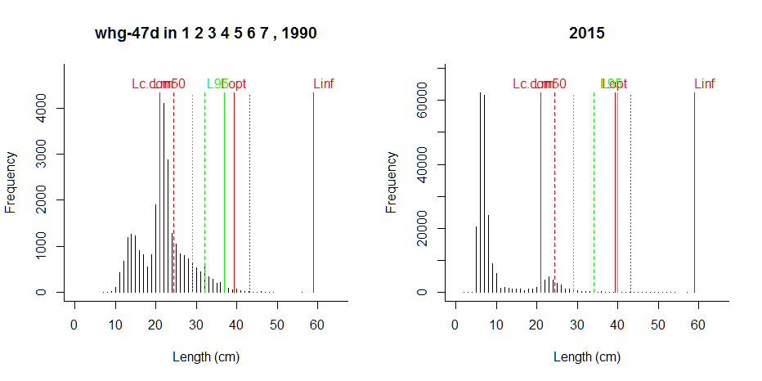

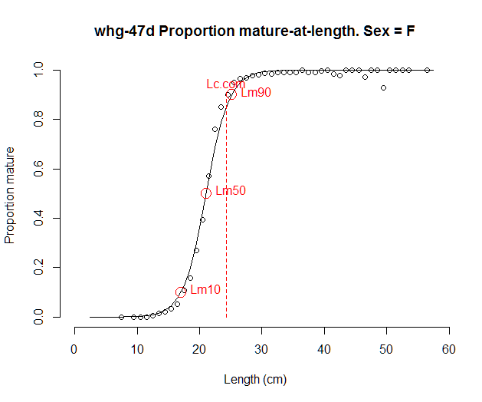 | 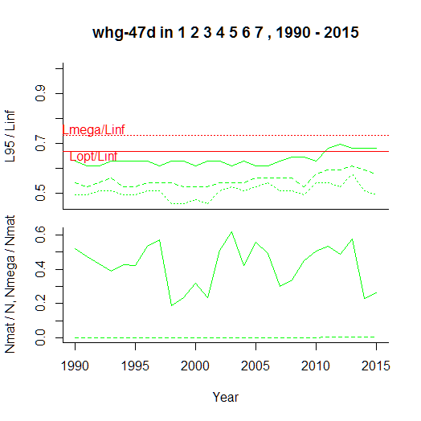

Comment: L95 indicators show similar trends, but L95 above half of Linf seems too high. No mega-spawners; truncated age structure consistent with past F >> Fmsy in assessment. Lc.com assumed as 90% MLS, may still be too high (= above Lm50).

Norway pout in the North Sea
----------------------------------------------
Results of SMALK and CPUE analysis, Fri Nov 04 13:53:43 2016
----------------------------------------------
SMALK_File = SMALK_NS-IBTS_2016-10-31.csv CPUE_File = NSCPUE per length per subarea_2016-11-02 16_43_26.csv
Survey = NS-IBTS
Species = Trisopterus esmarkii Stock = nop-34
Sex SMALK = F
Years = 1990 - 2015
Quarter = 1
Areas = 1 2 3 4 7 6 5
Lc.com = 13 cm (length where 50% are retained by commercial gear)
----------------------------------------------
Summary stats of weighted F W~L regression
----------------------------------------------
14 outliers (beyond 4 SD) were removed.
Number of remaining observations = 4487
Length range = 8 - 25.2 cm
Weight range = 3 - 126 g
log10(a) = -2.28 , SE = 0.0122
Geometric mean a = 0.00524 , 95% CL = 0.00496 - 0.00554
b = 3.11 , 95% CL = 3.09 - 3.14
Standard deviation of estimated log10(W) = 0.0667
Coefficient of determination (r2) = 0.962
--------------------------------------------------------------
Maturity analysis from proportion-mature-at-length data
--------------------------------------------------------------
Available maturity codes = 1 2 3 4
Number of observations = 6417
Largest immature = 21 cm
Smallest mature = 8 cm
Ogive length at 50% maturity = 13.5 cm
Ogive length at 10% and 90% maturity 11.2 - 15.8 cm
-------------------------------------------------
Estimation of Linf
-------------------------------------------------
Observed maximum length SMALK = 25.2 cm
Median of annual maximum lengths = 23 cm
Whetherall Linf based on SMALK = 25.6 cm
Observed maximum length CPUE = 30 cm
Median annual maximum lengths CPUE = 24 cm
Chosen Linf = 24 cm
Length at max cohort biomass Lopt = 16 cm (assuming b~3 and M/K~1.5)

Stock Year Lmax.obs N N.mat N.mega pp.mat pp.mega L95 L95mat L95.5 L95Linf L95matLinf L95.5Linf
1 nop-34 1990 22 189588 71419 16783 0.377 0.2350 17 18 18 0.708 0.750 0.750
2 nop-34 1991 26 1427520 362045 61737 0.254 0.1705 16 18 17 0.667 0.750 0.708
3 nop-34 1992 30 2985659 1302296 296701 0.436 0.2278 17 18 18 0.708 0.750 0.750
4 nop-34 1993 23 1458936 670781 216538 0.460 0.3228 18 18 18 0.750 0.750 0.750
5 nop-34 1994 25 2638033 447301 111937 0.170 0.2503 16 18 18 0.667 0.750 0.750
6 nop-34 1995 27 2276154 790526 92196 0.347 0.1166 16 17 17 0.667 0.708 0.708
7 nop-34 1996 25 1336447 449513 80306 0.336 0.1787 17 18 18 0.708 0.750 0.750
8 nop-34 1997 24 2385631 622020 98899 0.261 0.1590 16 18 17 0.667 0.750 0.708
9 nop-34 1998 22 440974 104109 18586 0.236 0.1785 16 17 17 0.667 0.708 0.708
10 nop-34 1999 23 451560 125338 39008 0.278 0.3112 17 18 18 0.708 0.750 0.750
11 nop-34 2000 23 1838486 686347 41235 0.373 0.0601 16 17 16 0.667 0.708 0.667
12 nop-34 2001 23 775308 399647 69879 0.515 0.1749 17 17 17 0.708 0.708 0.708
13 nop-34 2002 27 743542 250053 102863 0.336 0.4114 18 18 18 0.750 0.750 0.750
14 nop-34 2003 29 499442 177076 49134 0.355 0.2775 18 19 18 0.750 0.792 0.750
15 nop-34 2004 24 277548 116417 33691 0.419 0.2894 18 19 18 0.750 0.792 0.750
16 nop-34 2005 22 388954 73032 27582 0.188 0.3777 17 19 18 0.708 0.792 0.750
17 nop-34 2006 24 660720 202347 27750 0.306 0.1371 16 18 17 0.667 0.750 0.708
18 nop-34 2007 22 764738 207337 52405 0.271 0.2528 17 18 18 0.708 0.750 0.750
19 nop-34 2008 23 803780 227689 61095 0.283 0.2683 17 19 18 0.708 0.792 0.750
20 nop-34 2009 24 1644811 407414 70474 0.248 0.1730 16 18 17 0.667 0.750 0.708
21 nop-34 2010 25 1335967 627237 142342 0.470 0.2269 17 18 18 0.708 0.750 0.750
22 nop-34 2011 28 689120 384732 159619 0.558 0.4149 18 19 19 0.750 0.792 0.792
23 nop-34 2012 24 229532 115431 48481 0.503 0.4200 18 19 18 0.750 0.792 0.750
24 nop-34 2013 23 966295 269577 58575 0.279 0.2173 17 19 18 0.708 0.792 0.750
25 nop-34 2014 22 582291 258679 20356 0.444 0.0787 16 17 17 0.667 0.708 0.708
26 nop-34 2015 25 1907314 405913 36289 0.213 0.0894 15 17 17 0.625 0.708 0.708

Comment: Indicators seem to work reasonably well; but Lc.com was just guessed

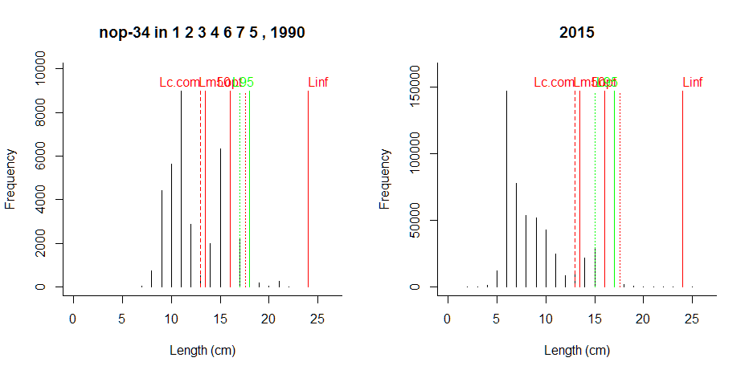

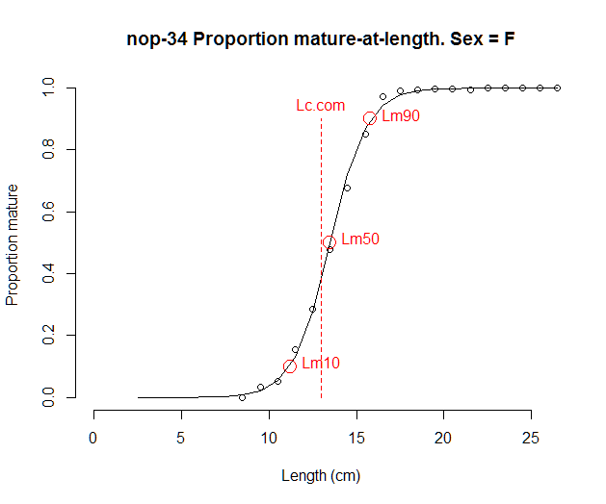 | 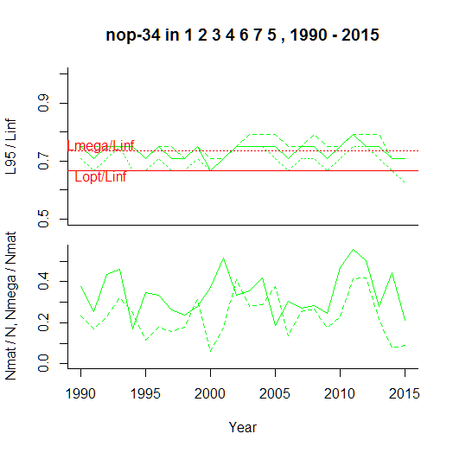

Comment: Recruitment variability introduces noise in all indicators; this could be reduced e.g. by a 3-years moving average. This is a small species that grows relatively much throughout the year, so ratio of indicators to fixed reference points depends on season. But on average indicators seem to be working well.

Saithe in the North Sea
----------------------------------------------
Results of SMALK and CPUE analysis, Fri Nov 04 14:02:38 2016
----------------------------------------------
SMALK_File = SMALK_NS-IBTS_2016-10-31.csv CPUE_File = NSCPUE per length per subarea_2016-11-02 16_43_26.csv
Survey = NS-IBTS
Species = Pollachius virens Stock = sai-3a46
Sex SMALK = F
Years = 1990 - 2015
Quarter = 1
Areas = 2 3
Lc.com = 31.5 cm (length where 50% are retained by commercial gear)
----------------------------------------------
Summary stats of weighted F W~L regression
----------------------------------------------
0 outliers (beyond 4 SD) were removed.
Number of remaining observations = 114
Length range = 13 - 103 cm
Weight range = 16 - 11380 g
log10(a) = -2.37 , SE = 0.0345
Geometric mean a = 0.00426 , 95% CL = 0.00364 - 0.00499
b = 3.2 , 95% CL = 3.16 - 3.25
Standard deviation of estimated log10(W) = 0.0501
Coefficient of determination (r2) = 0.995
--------------------------------------------------------------
Maturity analysis from proportion-mature-at-length data
--------------------------------------------------------------
Available maturity codes = 62 61 63 64
Number of observations = 103
Largest immature = 50 cm
Smallest mature = 39 cm
Ogive length at 50% maturity = 46.2 cm
Ogive length at 10% and 90% maturity 39.6 - 52.8 cm
-------------------------------------------------
Estimation of Linf
-------------------------------------------------
Observed maximum length SMALK = 103 cm
Median of annual maximum lengths = 72.5 cm
Whetherall Linf based on SMALK = 102 cm
Observed maximum length CPUE = 118 cm
Median annual maximum lengths CPUE = 100 cm
Chosen Linf = 102 cm
Length at max cohort biomass Lopt = 68.3 cm (assuming b~3 and M/K~1.5)

Stock Year Lmax.obs N N.mat N.mega pp.mat pp.mega L95 L95mat L95.5 L95Linf L95matLinf L95.5Linf
1 sai-3a46 1990 82 3.33 1.28 0.50 0.3833 0.3914 45.2 NA NA 0.441 NA NA
2 sai-3a46 1991 118 120.84 42.56 15.00 0.3522 0.3524 68.5 88.7 97.5 0.669 0.867 0.952
3 sai-3a46 1992 110 109.00 91.79 34.50 0.8421 0.3759 99.9 100.0 100.0 0.976 0.977 0.977
4 sai-3a46 1993 110 176.33 107.76 22.83 0.6111 0.2119 99.9 100.0 100.3 0.976 0.977 0.980
5 sai-3a46 1994 112 65.67 38.37 17.33 0.5844 0.4517 100.0 100.0 101.8 0.977 0.977 0.994
6 sai-3a46 1995 113 318.33 67.78 16.00 0.2129 0.2360 65.0 104.0 104.0 0.635 1.016 1.016
7 sai-3a46 1996 110 89.92 32.72 10.92 0.3638 0.3337 95.0 110.0 110.0 0.928 1.074 1.074
8 sai-3a46 1997 103 56.00 34.62 5.67 0.6182 0.1637 85.6 95.9 96.4 0.836 0.937 0.942
9 sai-3a46 1998 103 21.67 6.54 2.67 0.3020 0.4076 85.0 98.5 99.2 0.830 0.962 0.969
10 sai-3a46 1999 101 6.00 4.13 1.00 0.6886 0.2421 92.2 97.5 97.5 0.901 0.952 0.952
11 sai-3a46 2000 100 64.67 33.61 2.33 0.5198 0.0694 61.0 63.2 77.0 0.596 0.617 0.752
12 sai-3a46 2001 108 247.25 35.26 9.00 0.1426 0.2553 46.5 105.0 105.2 0.455 1.026 1.028
13 sai-3a46 2002 70 52.17 17.90 NA 0.3432 NA 52.5 69.0 69.0 0.513 0.674 0.674
14 sai-3a46 2003 103 340.00 82.78 7.00 0.2435 0.0846 49.0 101.0 102.0 0.479 0.986 0.996
15 sai-3a46 2004 112 34.20 18.51 1.00 0.5413 0.0540 57.0 70.8 90.0 0.557 0.691 0.879
16 sai-3a46 2005 68 35.00 9.49 NA 0.2712 NA 64.3 66.9 67.4 0.628 0.654 0.658
17 sai-3a46 2006 59 58.37 20.91 NA 0.3583 NA 52.8 57.5 58.6 0.516 0.562 0.572
18 sai-3a46 2007 61 112.50 36.13 NA 0.3212 NA 52.4 55.0 58.3 0.512 0.537 0.569
19 sai-3a46 2008 78 24.00 13.76 1.00 0.5733 0.0727 72.5 75.0 75.5 0.709 0.733 0.737
20 sai-3a46 2009 68 16.67 1.04 NA 0.0625 NA 44.0 68.0 68.0 0.430 0.664 0.664
21 sai-3a46 2010 76 153.33 11.54 1.00 0.0753 0.0867 45.2 72.0 75.2 0.441 0.703 0.734
22 sai-3a46 2011 95 726.84 25.38 2.00 0.0349 0.0788 39.0 86.0 89.0 0.381 0.840 0.869
23 sai-3a46 2012 103 107.00 61.82 37.00 0.5777 0.5986 94.8 96.7 98.0 0.925 0.944 0.957
24 sai-3a46 2013 81 109.09 46.60 1.00 0.4272 0.0215 55.0 69.0 71.4 0.537 0.674 0.697
25 sai-3a46 2014 63 31.12 13.03 NA 0.4187 NA 55.1 58.1 60.8 0.538 0.567 0.594
26 sai-3a46 2015 83 139.70 47.00 1.20 0.3364 0.0255 57.0 60.8 63.5 0.557 0.594 0.620

Comment: High variability because of few data; 90% of MLS assumed as Lc.com

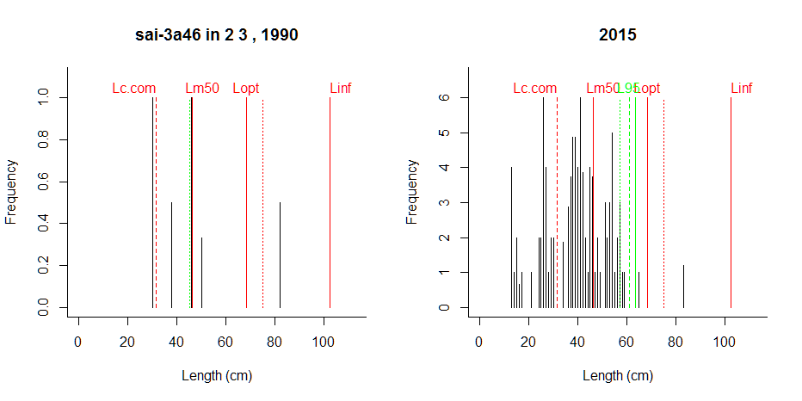

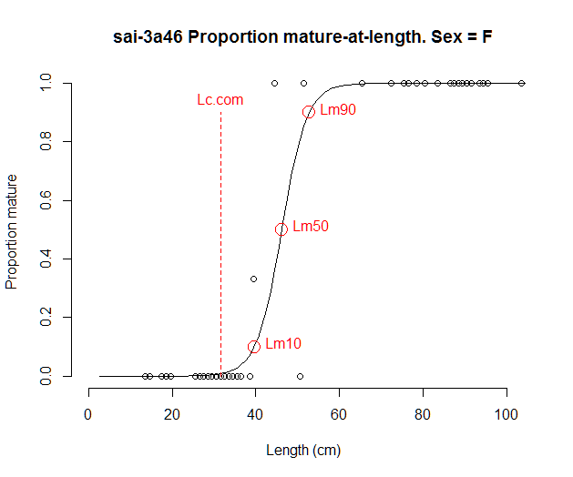 | 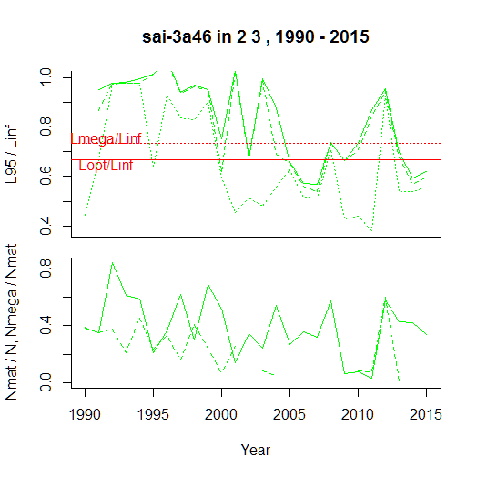

Comment: Few data (catches only in round fish areas 2 and 3) cause variability, but indicators correctly suggest that size structure is getting more truncated. Again, a 3-year moving average could reduce variability and strengthen the average signal.

Plaice in the North Sea
----------------------------------------------
Results of SMALK and CPUE analysis, Fri Nov 04 19:07:24 2016
----------------------------------------------
SMALK_File = SMALK_NS-IBTS_2016-10-31.csv CPUE_File = NSCPUE per length per subarea_2016-11-02 16_43_26.csv
Survey = NS-IBTS
Species = Pleuronectes platessa Stock = ple-nsea
Sex SMALK = F
Years = 1992 - 2015
Quarter = 1
Areas = 4 5 6 7 2 3 1
Lc.com = 20.5 cm (length where 50% are retained by commercial gear)
----------------------------------------------
Summary stats of weighted F W~L regression
----------------------------------------------
20 outliers (beyond 4 SD) were removed.
Number of remaining observations = 7107
Length range = 7.6 - 55 cm
Weight range = 4 - 1784 g
log10(a) = -2 , SE = 0.0063
Geometric mean a = 0.00995 , 95% CL = 0.00967 - 0.0102
b = 2.98 , 95% CL = 2.97 - 2.99
Standard deviation of estimated log10(W) = 0.052
Coefficient of determination (r2) = 0.986
--------------------------------------------------------------
Maturity analysis from proportion-mature-at-length data
--------------------------------------------------------------
Available maturity codes = 62 61 63 64
Number of observations = 4609
Largest immature = 41 cm
Smallest mature = 10 cm
Ogive length at 50% maturity = 22.6 cm
Ogive length at 10% and 90% maturity 14.8 - 30.4 cm
-------------------------------------------------
Estimation of Linf
-------------------------------------------------
Observed maximum length SMALK = 55 cm
Median of annual maximum lengths = 50.7 cm
Whetherall Linf based on SMALK = 59.7 cm
Observed maximum length CPUE = 67 cm
Median annual maximum lengths CPUE = 56 cm
Chosen Linf = 50 cm
Length at max cohort biomass Lopt = 33.3 cm (assuming b~3 and M/K~1.5)

Stock Year Lmax.obs N N.mat N.mega pp.mat pp.mega L95 L95mat L95.5 L95Linf L95matLinf L95.5Linf
1 ple-nsea 1990 56 5183 3222 272 0.622 0.0845 35 36.0 37.0 0.70 0.720 0.740
2 ple-nsea 1991 62 34098 14362 716 0.421 0.0498 32 35.0 36.0 0.64 0.700 0.720
3 ple-nsea 1992 57 26439 12516 627 0.473 0.0501 32 35.0 36.0 0.64 0.700 0.720
4 ple-nsea 1993 61 13174 6629 411 0.503 0.0619 34 36.0 37.0 0.68 0.720 0.740
5 ple-nsea 1994 60 10490 5848 344 0.558 0.0588 34 35.0 36.0 0.68 0.700 0.720
6 ple-nsea 1995 55 7819 4564 439 0.584 0.0962 36 37.0 37.0 0.72 0.740 0.740
7 ple-nsea 1996 56 10283 6042 385 0.588 0.0636 34 36.0 37.0 0.68 0.720 0.740
8 ple-nsea 1997 56 14564 6169 385 0.424 0.0624 33 37.0 38.0 0.66 0.740 0.760
9 ple-nsea 1998 54 10973 4887 267 0.445 0.0546 32 36.0 37.0 0.64 0.720 0.740
10 ple-nsea 1999 54 9323 5025 202 0.539 0.0402 32 34.0 35.3 0.64 0.680 0.706
11 ple-nsea 2000 63 6024 3534 185 0.587 0.0524 33 35.0 36.0 0.66 0.700 0.720
12 ple-nsea 2001 57 7677 4157 188 0.542 0.0451 33 35.0 35.0 0.66 0.700 0.700
13 ple-nsea 2002 54 8834 3808 213 0.431 0.0560 33 35.3 36.0 0.66 0.707 0.720
14 ple-nsea 2003 54 10167 4919 232 0.484 0.0472 32 35.0 36.0 0.64 0.700 0.720
15 ple-nsea 2004 49 6588 3594 179 0.546 0.0498 33 35.0 35.0 0.66 0.700 0.700
16 ple-nsea 2005 53 8199 4106 211 0.501 0.0513 33 35.0 36.0 0.66 0.700 0.720
17 ple-nsea 2006 52 9502 5137 258 0.541 0.0502 33 35.0 36.0 0.66 0.700 0.720
18 ple-nsea 2007 55 14370 7470 431 0.520 0.0576 34 36.0 37.0 0.68 0.720 0.740
19 ple-nsea 2008 56 20173 10072 682 0.499 0.0678 34 36.0 37.0 0.68 0.720 0.740
20 ple-nsea 2009 67 19075 10535 699 0.552 0.0663 34 36.0 37.0 0.68 0.720 0.740
21 ple-nsea 2010 56 21411 12171 834 0.568 0.0685 35 36.0 37.0 0.70 0.720 0.740
22 ple-nsea 2011 56 27118 15954 1073 0.588 0.0672 35 36.0 37.0 0.70 0.720 0.740
23 ple-nsea 2012 57 30458 17833 1553 0.585 0.0871 36 37.0 38.0 0.72 0.740 0.760
24 ple-nsea 2013 56 21950 13754 1174 0.627 0.0853 36 37.0 38.0 0.72 0.740 0.760
25 ple-nsea 2014 58 27972 16096 1021 0.575 0.0634 34 36.0 37.0 0.68 0.720 0.740
26 ple-nsea 2015 57 29175 17885 1298 0.613 0.0726 35 36.0 37.0 0.70 0.720 0.740

Comment: Large individuals are apparently not retained by the gear

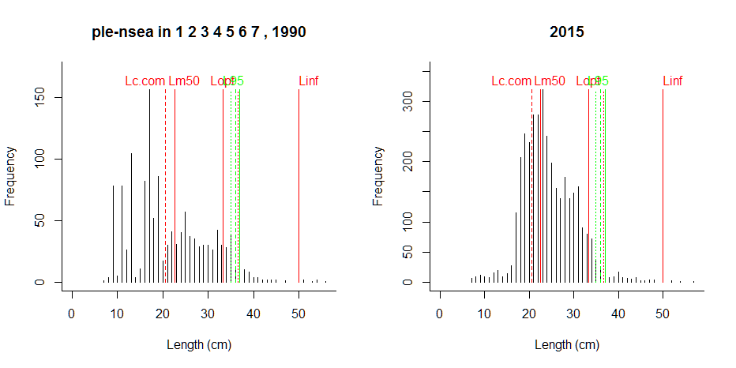

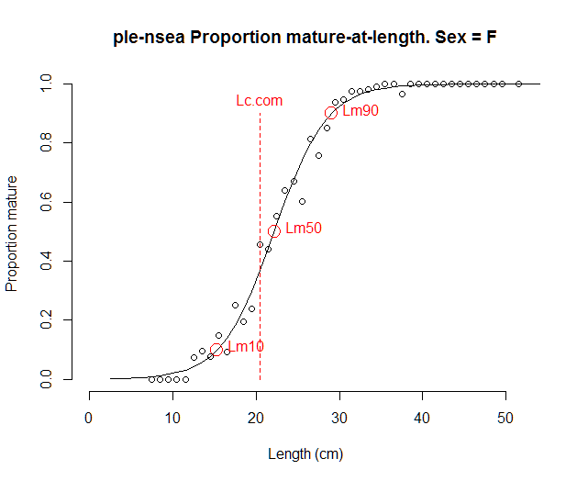 | 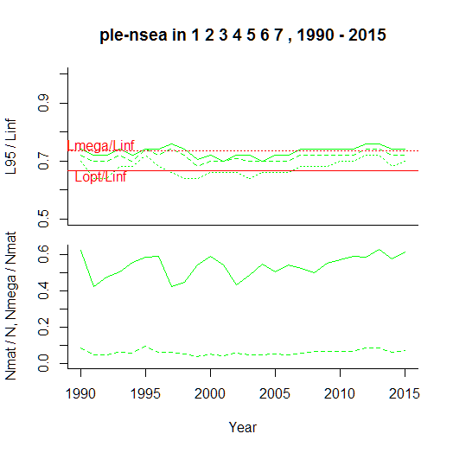

Comment: The SG was of the opinion that large flatfish are not sampled representatively by the survey gear, as correctly shown by the indicators. Thus, commercial data should be used instead.

Mackerel in the Northeast Atlantic (here: North Sea)
----------------------------------------------
Results of SMALK and CPUE analysis, Fri Nov 04 15:46:51 2016
----------------------------------------------
SMALK_File = SMALK_NS-IBTS_2016-10-31.csv CPUE_File = NSCPUE per length per subarea_2016-11-02 16_43_26.csv
Survey = NS-IBTS
Species = Scomber scombrus Stock = mac-nea
Sex SMALK = F
Years = 1996 - 2015
Quarter = 1
Areas = 1 2 3 7 4 6 5
Lc.com = 27 cm (length where 50% are retained by commercial gear)
----------------------------------------------
Summary stats of weighted F W~L regression
----------------------------------------------
1 outliers (beyond 4 SD) were removed.
Number of remaining observations = 1818
Length range = 14 - 44 cm
Weight range = 19 - 743 g
log10(a) = -2.56 , SE = 0.0174
Geometric mean a = 0.00274 , 95% CL = 0.00253 - 0.00297
b = 3.3 , 95% CL = 3.28 - 3.33
Standard deviation of estimated log10(W) = 0.0472
Coefficient of determination (r2) = 0.978
--------------------------------------------------------------
Maturity analysis from proportion-mature-at-length data
--------------------------------------------------------------
Available maturity codes = 1 2 3 4
Number of observations = 2410
Largest immature = 30 cm
Smallest mature = 14 cm
Ogive length at 50% maturity = 25.6 cm
Ogive length at 10% and 90% maturity 22.7 - 28.5 cm
-------------------------------------------------
Estimation of Linf
-------------------------------------------------
Observed maximum length SMALK = 44 cm
Median of annual maximum lengths = 39 cm
Whetherall Linf based on SMALK = 40.6 cm
Observed maximum length CPUE = 56 cm
Median annual maximum lengths CPUE = 44 cm
Chosen Linf = 44 cm
Length at max cohort biomass Lopt = 29.3 cm (assuming b~3 and M/K~1.5)

Stock Year Lmax.obs N N.mat N.mega pp.mat pp.mega L95 L95mat L95.5 L95Linf L95matLinf L95.5Linf
1 mac-nea 1995 49 46059 40042 17096 0.869 0.4270 37 37 37 0.841 0.841 0.841
2 mac-nea 1996 50 28124 20652 6432 0.734 0.3115 36 36 36 0.818 0.818 0.818
3 mac-nea 1997 48 136028 19658 5786 0.145 0.2944 31 37 36 0.705 0.841 0.818
4 mac-nea 1998 44 44228 22304 3779 0.504 0.1695 33 34 33 0.750 0.773 0.750
5 mac-nea 1999 48 30703 20213 3668 0.658 0.1815 34 34 34 0.773 0.773 0.773
6 mac-nea 2000 44 75354 21268 3889 0.282 0.1829 32 34 33 0.727 0.773 0.750
7 mac-nea 2001 56 24515 16604 4792 0.677 0.2886 34 35 35 0.773 0.795 0.795
8 mac-nea 2002 45 33327 21258 9445 0.638 0.4443 36 36 36 0.818 0.818 0.818
9 mac-nea 2003 44 17624 11644 3706 0.661 0.3183 37 37 37 0.841 0.841 0.841
10 mac-nea 2004 43 25764 15288 3971 0.593 0.2598 34 35 34 0.773 0.795 0.773
11 mac-nea 2005 49 17508 14953 4008 0.854 0.2681 34 34 34 0.773 0.773 0.773
12 mac-nea 2006 41 84313 39058 3400 0.463 0.0870 31 33 31 0.705 0.750 0.705
13 mac-nea 2007 43 88638 44347 3591 0.500 0.0810 31 32 31 0.705 0.727 0.705
14 mac-nea 2008 43 97981 63825 4316 0.651 0.0676 31 32 31 0.705 0.727 0.705
15 mac-nea 2009 42 36072 28349 3976 0.786 0.1402 33 33 33 0.750 0.750 0.750
16 mac-nea 2010 48 40102 32606 10536 0.813 0.3231 35 35 35 0.795 0.795 0.795
17 mac-nea 2011 43 73327 29335 7421 0.400 0.2530 33 35 33 0.750 0.795 0.750
18 mac-nea 2012 46 111502 38636 3528 0.347 0.0913 30 34 31 0.682 0.773 0.705
19 mac-nea 2013 44 33324 27451 12080 0.824 0.4401 36 36 36 0.818 0.818 0.818
20 mac-nea 2014 43 32393 23587 7289 0.728 0.3090 35 35 35 0.795 0.795 0.795
21 mac-nea 2015 44 83504 39913 9497 0.478 0.2379 34 36 35 0.773 0.818 0.795

Comment: Assuming 90% of minimum landing size for Lc.com

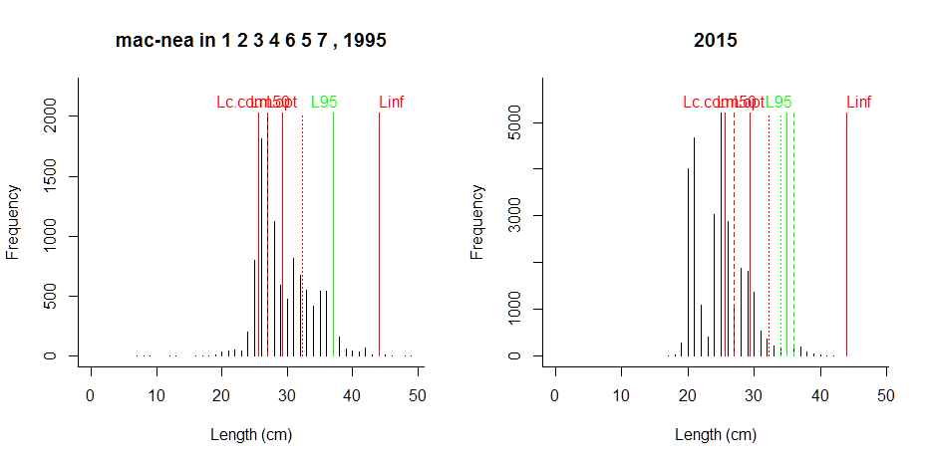
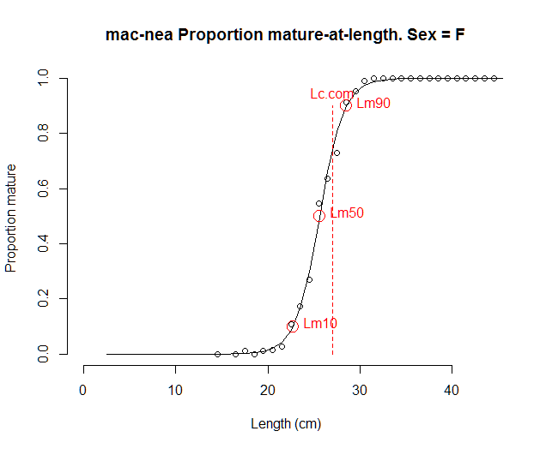 | 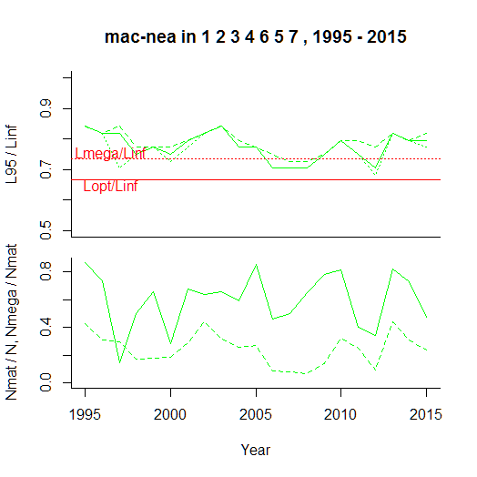

Comment: Species seems to be well represented by the gear and indicators seem to work well. High proportion of mature individuals is confirmed by reasonably high biomass. High variability in proportion of mature individuals (solid green line in lower right graph and panel) is caused by closeness of Lc.com and Lm50 (see maturity ogive). This could be reduced by a 3-year moving average.

Western Baltic cod
----------------------------------------------
Results of SMALK and CPUE analysis, Fri Nov 04 15:59:58 2016
----------------------------------------------
SMALK_File = SMALK_BITS_2016-10-31.csv CPUE_File = BalticCPUE per length per subarea_2016-11-01 15_32_54.csv
Survey = BITS
Species = Gadus morhua Stock = cod-2224
Sex SMALK = F
Years = 1994 - 2015
Quarter = 1
Areas = 22 24 23
Lc.com = 32 cm (length where 50% are retained by commercial gear)
----------------------------------------------
Summary stats of weighted F W~L regression
----------------------------------------------
43 outliers (beyond 4 SD) were removed.
Number of remaining observations = 17649
Length range = 8 - 119 cm
Weight range = 5 - 25220 g
log10(a) = -2.18 , SE = 0.00339
Geometric mean a = 0.0066 , 95% CL = 0.0065 - 0.0067
b = 3.11 , 95% CL = 3.11 - 3.11
Standard deviation of estimated log10(W) = 0.0533
Coefficient of determination (r2) = 0.993
--------------------------------------------------------------
Maturity analysis from proportion-mature-at-length data
--------------------------------------------------------------
Available maturity codes = 1 2 3 4
Number of observations = 7787
Largest immature = 78 cm
Smallest mature = 9 cm
Ogive length at 50% maturity = 34 cm
Ogive length at 10% and 90% maturity 23.7 - 44.2 cm
-------------------------------------------------
Estimation of Linf
-------------------------------------------------
Observed maximum length SMALK = 119 cm
Median of annual maximum lengths = 99.5 cm
Whetherall Linf based on SMALK = NA cm
Observed maximum length CPUE = 119 cm
Median annual maximum lengths CPUE = 102 cm
Chosen Linf = 110 cm
Length at max cohort biomass Lopt = 73.3 cm (assuming b~3 and M/K~1.5)

Stock Year Lmax.obs N N.mat N.mega pp.mat pp.mega L95 L95mat L95.5 L95Linf L95matLinf L95.5Linf
1 cod-2224 1994 111 6296 1763 2.53 0.280 0.001437 47 52.0 60.0 0.427 0.473 0.545
2 cod-2224 1995 96 22991 6570 14.80 0.286 0.002253 49 63.0 76.0 0.445 0.573 0.691
3 cod-2224 1996 103 8087 3048 5.83 0.377 0.001914 48 53.0 68.0 0.436 0.482 0.618
4 cod-2224 1997 99 16022 3410 25.43 0.213 0.007456 49 60.0 83.0 0.445 0.545 0.755
5 cod-2224 1998 107 10294 3396 20.47 0.330 0.006029 46 54.0 86.0 0.418 0.491 0.782
6 cod-2224 1999 100 7965 2479 9.76 0.311 0.003936 46 55.0 80.0 0.418 0.500 0.727
7 cod-2224 2000 116 6020 2234 2.10 0.371 0.000940 47 55.0 75.3 0.427 0.500 0.685
8 cod-2224 2001 111 8377 2585 19.81 0.309 0.007663 49 62.7 81.0 0.445 0.570 0.736
9 cod-2224 2002 99 7987 2250 3.28 0.282 0.001458 42 49.0 74.5 0.382 0.445 0.677
10 cod-2224 2003 101 8736 2908 1.68 0.333 0.000577 44 50.0 77.0 0.400 0.455 0.700
11 cod-2224 2004 104 13918 2428 4.39 0.174 0.001809 40 52.5 78.2 0.364 0.478 0.711
12 cod-2224 2005 105 13633 4761 11.28 0.349 0.002369 44 50.0 81.0 0.400 0.455 0.736
13 cod-2224 2006 102 6278 2795 2.05 0.445 0.000733 46 49.0 70.0 0.418 0.445 0.636
14 cod-2224 2007 101 6791 2783 12.60 0.410 0.004529 47 54.8 80.0 0.427 0.498 0.727
15 cod-2224 2008 119 9146 3748 12.31 0.410 0.003284 45 51.0 76.4 0.409 0.464 0.695
16 cod-2224 2009 108 5064 1861 11.94 0.367 0.006416 47 53.0 80.0 0.427 0.482 0.727
17 cod-2224 2010 104 9192 3531 8.43 0.384 0.002388 46 50.0 80.0 0.418 0.455 0.727
18 cod-2224 2011 92 12255 7354 6.37 0.600 0.000867 52 54.0 73.0 0.473 0.491 0.664
19 cod-2224 2012 88 6441 3045 4.05 0.473 0.001331 49 52.0 68.0 0.445 0.473 0.618
20 cod-2224 2013 89 6568 2263 1.88 0.345 0.000829 47 52.0 72.0 0.427 0.473 0.655
21 cod-2224 2014 98 8167 3000 1.29 0.367 0.000430 44 52.0 70.0 0.400 0.473 0.636
22 cod-2224 2015 82 8555 4732 1.44 0.553 0.000304 48 51.0 70.6 0.436 0.464 0.642

Comment: L95 falls outside of area of mega-spawners, which could be a potential threshold

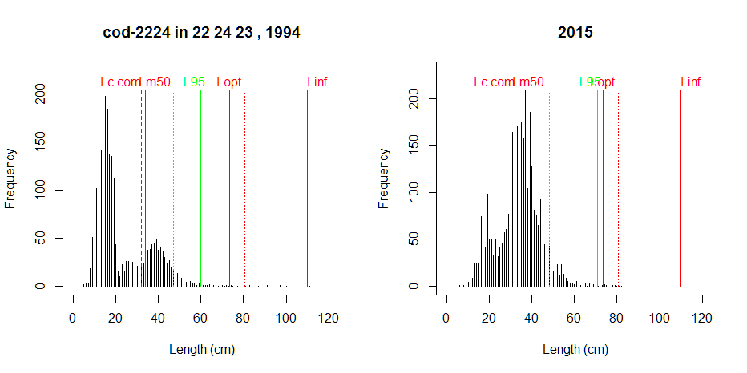

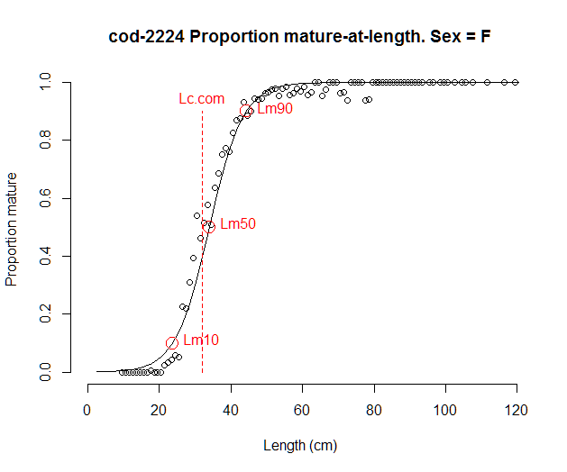 | 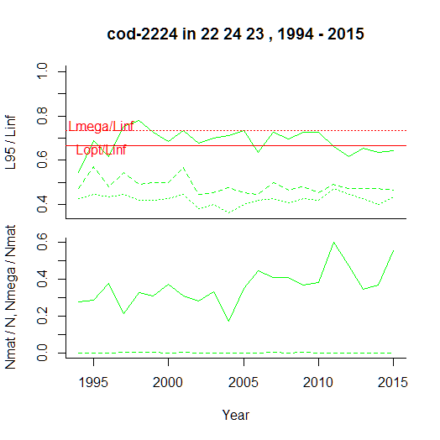

Comment: Age structure in stock is severely truncated with close to zero mega-spawners. L95 for lengths above ½ Lopt misses that. Other indicators work well.

Eastern Baltic cod
----------------------------------------------
Results of SMALK and CPUE analysis, Fri Nov 04 16:12:07 2016
----------------------------------------------
SMALK_File = SMALK_BITS_2016-10-31.csv CPUE_File = BalticCPUE per length per subarea_2016-11-01 15_32_54.csv
Survey = BITS
Species = Gadus morhua Stock = cod-2532
Sex SMALK = F
Years = 1991 - 2015
Quarter = 1
Areas = 26 28 25 27
Lc.com = 32 cm (length where 50% are retained by commercial gear)
----------------------------------------------
Summary stats of weighted F W~L regression
----------------------------------------------
162 outliers (beyond 4 SD) were removed.
Number of remaining observations = 46015
Length range = 6 - 127 cm
Weight range = 2 - 20400 g
log10(a) = -2.15 , SE = 0.00228
Geometric mean a = 0.0071 , 95% CL = 0.00703 - 0.00717
b = 3.08 , 95% CL = 3.08 - 3.08
Standard deviation of estimated log10(W) = 0.0577
Coefficient of determination (r2) = 0.991
--------------------------------------------------------------
Maturity analysis from proportion-mature-at-length data
--------------------------------------------------------------
Available maturity codes = 2 3 1 4
Number of observations = 23369
Largest immature = 98 cm
Smallest mature = 6 cm
Ogive length at 50% maturity = 35.4 cm
Ogive length at 10% and 90% maturity 26.2 - 44.6 cm
-------------------------------------------------
Estimation of Linf
-------------------------------------------------
Observed maximum length SMALK = 127 cm
Median of annual maximum lengths = 106 cm
Whetherall Linf based on SMALK = 135 cm
Observed maximum length CPUE = 136 cm
Median annual maximum lengths CPUE = 113 cm
Chosen Linf = 110 cm
Length at max cohort biomass Lopt = 73.3 cm (assuming b~3 and M/K~1.5)

Stock Year Lmax.obs N N.mat N.mega pp.mat pp.mega L95 L95mat L95.5 L95Linf L95matLinf L95.5Linf
1 cod-2532 1991 120 2641 1890 25.57 0.716 0.013530 66.9 69.0 75.0 0.608 0.627 0.682
2 cod-2532 1992 109 5963 780 23.18 0.131 0.029719 37.0 71.4 80.0 0.336 0.649 0.727
3 cod-2532 1993 127 11667 5545 21.89 0.475 0.003948 49.0 52.0 65.4 0.445 0.473 0.595
4 cod-2532 1994 127 8510 3744 16.37 0.440 0.004372 53.8 60.0 72.0 0.489 0.545 0.655
5 cod-2532 1995 110 7755 3318 34.14 0.428 0.010290 56.0 63.0 74.0 0.509 0.573 0.673
6 cod-2532 1996 136 5264 2956 38.67 0.562 0.013080 59.0 64.0 80.0 0.536 0.582 0.727
7 cod-2532 1997 105 3211 1895 11.48 0.590 0.006059 53.0 55.0 70.0 0.482 0.500 0.636
8 cod-2532 1998 121 6022 1755 18.55 0.291 0.010566 48.0 56.0 73.4 0.436 0.509 0.667
9 cod-2532 1999 113 6207 2234 11.99 0.360 0.005368 46.0 51.0 76.0 0.418 0.464 0.691
10 cod-2532 2000 118 7625 2574 12.19 0.338 0.004735 45.0 49.0 72.0 0.409 0.445 0.655
11 cod-2532 2001 104 11076 2040 6.38 0.184 0.003129 42.0 49.0 80.4 0.382 0.445 0.731
12 cod-2532 2002 118 13668 5111 7.43 0.374 0.001454 46.0 52.0 72.3 0.418 0.473 0.657
13 cod-2532 2003 121 6413 2544 8.61 0.397 0.003385 46.0 50.0 73.2 0.418 0.455 0.665
14 cod-2532 2004 110 10719 2472 6.32 0.231 0.002555 44.0 52.0 71.0 0.400 0.473 0.645
15 cod-2532 2005 115 12095 3659 8.32 0.303 0.002274 43.0 49.0 69.7 0.391 0.445 0.634
16 cod-2532 2006 118 9981 3477 7.91 0.348 0.002275 44.0 48.0 68.6 0.400 0.436 0.624
17 cod-2532 2007 102 14295 4386 13.41 0.307 0.003057 44.0 49.0 84.2 0.400 0.445 0.766
18 cod-2532 2008 116 19204 6870 16.49 0.358 0.002401 45.0 49.0 65.0 0.409 0.445 0.591
19 cod-2532 2009 113 18411 7018 18.18 0.381 0.002591 46.0 51.0 65.0 0.418 0.464 0.591
20 cod-2532 2010 113 24482 11052 27.85 0.451 0.002520 49.0 53.0 71.0 0.445 0.482 0.645
21 cod-2532 2011 110 15307 5850 7.76 0.382 0.001326 44.0 48.0 64.0 0.400 0.436 0.582
22 cod-2532 2012 97 23153 7685 5.23 0.332 0.000680 43.0 47.0 68.0 0.391 0.427 0.618
23 cod-2532 2013 91 21176 5111 1.74 0.241 0.000341 40.0 45.0 NA 0.364 0.409 NA
24 cod-2532 2014 98 17230 4486 1.37 0.260 0.000305 39.0 45.0 93.1 0.355 0.409 0.846
25 cod-2532 2015 77 16075 5459 NA 0.340 NA 41.0 46.0 58.7 0.373 0.418 0.534

Comment: L95 falls outside of area of mega-spawners and even below Lopt; missing of mega-spawners confirmed in commercial data.

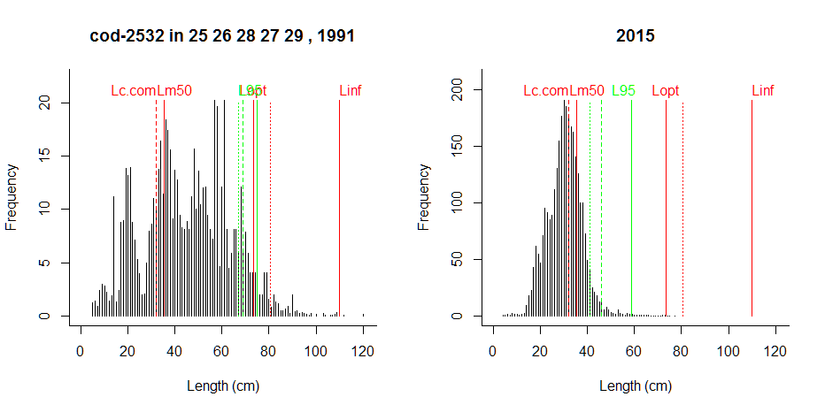
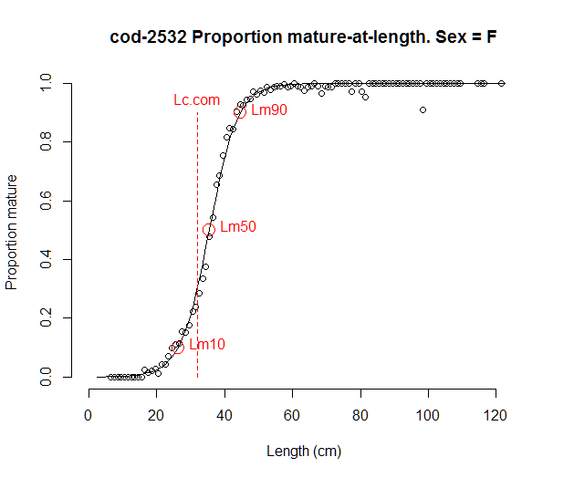 | 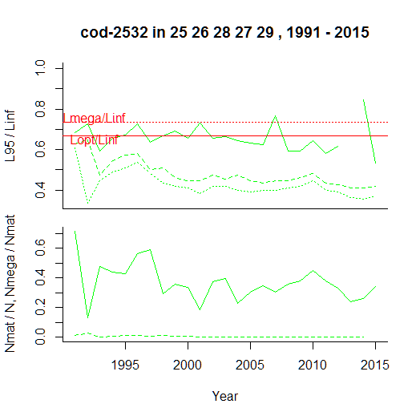

Comment: Size structure has become severely truncated in recent years, mega-spawners are absent. All indicators pick that up, but L95 above ½ Lopt is too high.

Western Baltic plaice
----------------------------------------------
Results of SMALK and CPUE analysis, Fri Nov 04 16:27:04 2016
----------------------------------------------
SMALK_File = SMALK_BITS_2016-10-31.csv CPUE_File = BalticCPUE per length per subarea_2016-11-01 15_32_54.csv
Survey = BITS
Species = Pleuronectes platessa Stock = ple-2123
Sex SMALK = F
Years = 1999 - 2015
Quarter = 1
Areas = 21 22 23
Lc.com = 22.5 cm (length where 50% are retained by commercial gear)
----------------------------------------------
Summary stats of weighted F W~L regression
----------------------------------------------
5 outliers (beyond 4 SD) were removed.
Number of remaining observations = 5972
Length range = 7 - 53 cm
Weight range = 4 - 2130 g
log10(a) = -2.03 , SE = 0.00989
Geometric mean a = 0.00942 , 95% CL = 0.00901 - 0.00985
b = 3.04 , 95% CL = 3.02 - 3.05
Standard deviation of estimated log10(W) = 0.0655
Coefficient of determination (r2) = 0.974
--------------------------------------------------------------
Maturity analysis from proportion-mature-at-length data
--------------------------------------------------------------
Available maturity codes = 61 62 64 63
Number of observations = 1274
Largest immature = 43 cm
Smallest mature = 14 cm
Ogive length at 50% maturity = 16.4 cm
Ogive length at 10% and 90% maturity 7.57 - 25.2 cm
-------------------------------------------------
Estimation of Linf
-------------------------------------------------
Observed maximum length SMALK = 53 cm
Median of annual maximum lengths = 47 cm
Whetherall Linf based on SMALK = 50.5 cm
Observed maximum length CPUE = 62 cm
Median annual maximum lengths CPUE = 48 cm
Chosen Linf = 50.5 cm
Length at max cohort biomass Lopt = 33.7 cm (assuming b~3 and M/K~1.5)

Stock Year Lmax.obs N N.mat N.mega pp.mat pp.mega L95 L95mat L95.5 L95Linf L95matLinf L95.5Linf
1 ple-2123 1999 62 1037 734 13.77 0.708 0.01876 33 34 37.0 0.653 0.673 0.732
2 ple-2123 2000 48 1998 1363 15.82 0.682 0.01160 29 30 35.0 0.574 0.594 0.693
3 ple-2123 2001 53 3232 2511 43.46 0.777 0.01730 33 34 36.0 0.653 0.673 0.713
4 ple-2123 2002 62 916 686 23.74 0.749 0.03462 34 35 38.0 0.673 0.693 0.752
5 ple-2123 2003 45 2457 1902 9.11 0.774 0.00479 30 30 33.0 0.594 0.594 0.653
6 ple-2123 2004 42 2700 2078 11.87 0.770 0.00571 30 31 33.0 0.594 0.614 0.653
7 ple-2123 2005 56 2013 1464 21.51 0.727 0.01469 32 33 36.0 0.633 0.653 0.713
8 ple-2123 2006 48 2245 1708 30.47 0.761 0.01784 33 33 35.0 0.653 0.653 0.693
9 ple-2123 2007 47 2520 1984 19.81 0.787 0.00998 33 34 35.0 0.653 0.673 0.693
10 ple-2123 2008 48 2402 1910 49.47 0.795 0.02591 33 33 36.1 0.653 0.653 0.714
11 ple-2123 2009 47 1621 1280 20.46 0.789 0.01599 33 33 35.0 0.653 0.653 0.693
12 ple-2123 2010 49 1742 1409 32.21 0.809 0.02285 34 34 36.0 0.673 0.673 0.713
13 ple-2123 2011 48 5560 4309 27.47 0.775 0.00638 32 32 34.0 0.633 0.633 0.673
14 ple-2123 2012 47 3912 3362 30.79 0.859 0.00916 34 34 34.0 0.673 0.673 0.673
15 ple-2123 2013 47 4979 4214 68.68 0.846 0.01630 34 34 35.0 0.673 0.673 0.693
16 ple-2123 2014 49 5296 4224 128.01 0.798 0.03030 34 34 37.0 0.673 0.673 0.732
17 ple-2123 2015 51 3959 3462 87.58 0.874 0.02530 35 35 36.0 0.693 0.693 0.713

Comment: 90% of minimum landing size assumed for Lc.com. Missing of large plaice could be real or gear effect

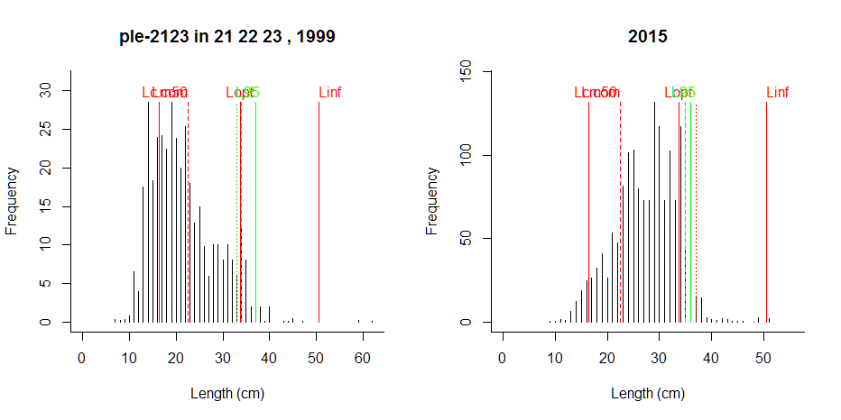
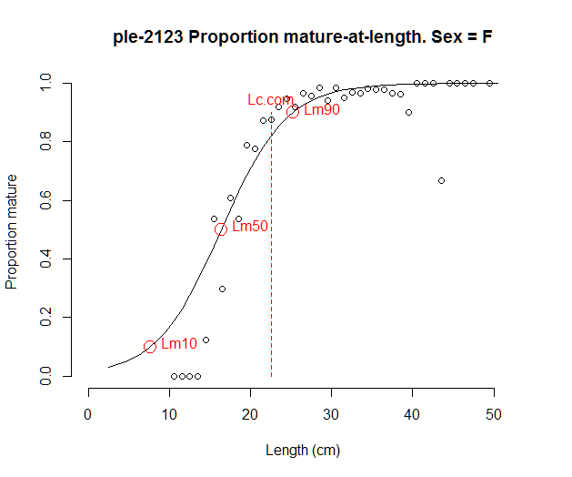 | 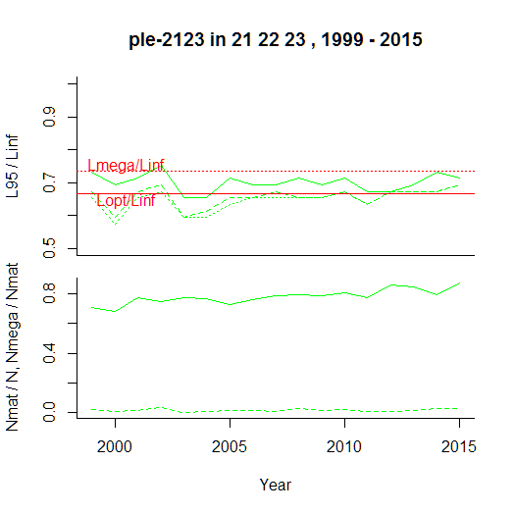

Comment: Plaice has recovered in recent years, with high numbers of mature individuals, and thus one would expect more large individuals; abrupt decline in large individuals is strange, these may not be caught by the survey gear, same as in the North Sea. A comparison with commercial data is needed.

Plaice in the central and eastern Baltic
----------------------------------------------
Results of SMALK and CPUE analysis, Fri Nov 04 16:35:27 2016
----------------------------------------------
SMALK_File = SMALK_BITS_2016-10-31.csv CPUE_File = BalticCPUE per length per subarea_2016-11-01 15_32_54.csv
Survey = BITS
Species = Pleuronectes platessa Stock = ple-2432
Sex SMALK = F
Years = 2002 - 2015
Quarter = 1
Areas = 24 25 26
Lc.com = 22.5 cm (length where 50% are retained by commercial gear)
----------------------------------------------
Summary stats of weighted F W~L regression
----------------------------------------------
5 outliers (beyond 4 SD) were removed.
Number of remaining observations = 4401
Length range = 10 - 57 cm
Weight range = 11 - 2590 g
log10(a) = -1.85 , SE = 0.0124
Geometric mean a = 0.0142 , 95% CL = 0.0135 - 0.0151
b = 2.9 , 95% CL = 2.88 - 2.91
Standard deviation of estimated log10(W) = 0.131
Coefficient of determination (r2) = 0.968
--------------------------------------------------------------
Maturity analysis from proportion-mature-at-length data
--------------------------------------------------------------
Available maturity codes = 1 3 2 4
Number of observations = 627
Largest immature = 26 cm
Smallest mature = 13 cm
Ogive length at 50% maturity = 20.7 cm
Ogive length at 10% and 90% maturity 17.2 - 24.2 cm
-------------------------------------------------
Estimation of Linf
-------------------------------------------------
Observed maximum length SMALK = 57 cm
Median of annual maximum lengths = 49 cm
Whetherall Linf based on SMALK = 59.4 cm
Observed maximum length CPUE = 63 cm
Median annual maximum lengths CPUE = 52.5 cm
Chosen Linf = 54 cm
Length at max cohort biomass Lopt = 36 cm (assuming b~3 and M/K~1.5)

Stock Year Lmax.obs N N.mat N.mega pp.mat pp.mega L95 L95mat L95.5 L95Linf L95matLinf L95.5Linf
1 ple-2432 2002 63 556 449 5.25 0.808 0.01171 32.0 32 33.0 0.593 0.593 0.611
2 ple-2432 2003 57 269 238 4.59 0.885 0.01925 33.9 34 34.2 0.629 0.630 0.634
3 ple-2432 2004 57 290 199 5.20 0.688 0.02613 32.3 34 35.6 0.599 0.630 0.659
4 ple-2432 2005 51 460 361 5.25 0.786 0.01453 30.0 30 31.6 0.556 0.556 0.586
5 ple-2432 2006 49 533 465 5.17 0.872 0.01113 32.0 32 33.0 0.593 0.593 0.611
6 ple-2432 2007 53 494 453 6.38 0.916 0.01410 35.0 35 35.0 0.648 0.648 0.648
7 ple-2432 2008 47 639 541 13.36 0.846 0.02471 36.0 36 37.0 0.667 0.667 0.685
8 ple-2432 2009 52 757 685 22.86 0.905 0.03337 36.0 36 36.7 0.667 0.667 0.680
9 ple-2432 2010 59 946 660 22.76 0.698 0.03449 34.0 35 36.0 0.630 0.648 0.667
10 ple-2432 2011 54 1095 807 13.70 0.737 0.01698 31.8 32 35.0 0.589 0.593 0.648
11 ple-2432 2012 51 1113 936 8.09 0.841 0.00865 32.0 32 33.0 0.593 0.593 0.611
12 ple-2432 2013 51 1003 818 9.66 0.816 0.01181 33.0 33 34.0 0.611 0.611 0.630
13 ple-2432 2014 50 1891 1314 10.87 0.695 0.00827 32.0 32 35.0 0.593 0.593 0.648
14 ple-2432 2015 57 1699 1341 18.76 0.789 0.01399 33.0 33 36.0 0.611 0.611 0.667

Comment: 90% of minimum landing size assumed for Lc.com. Missing mega spawners could be a gear problem.

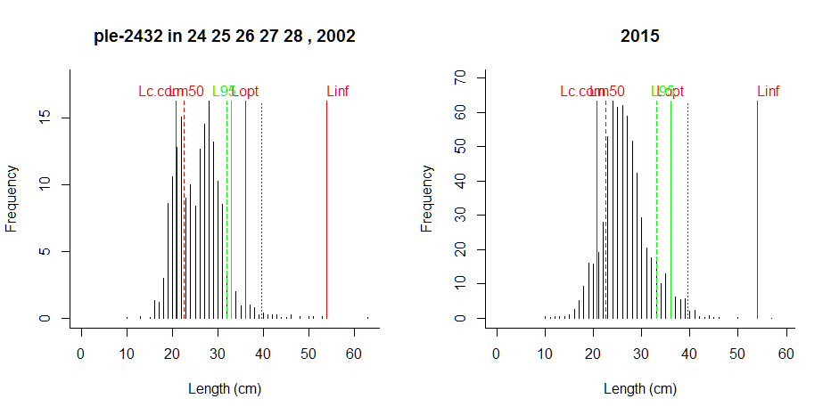
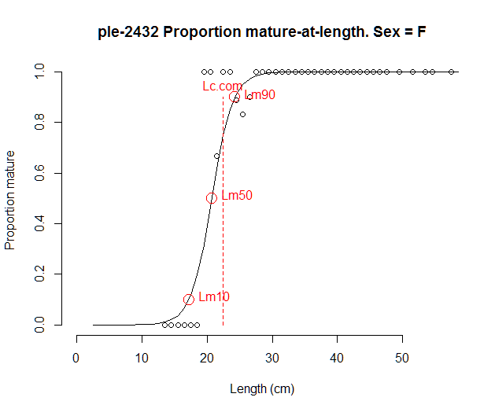 | 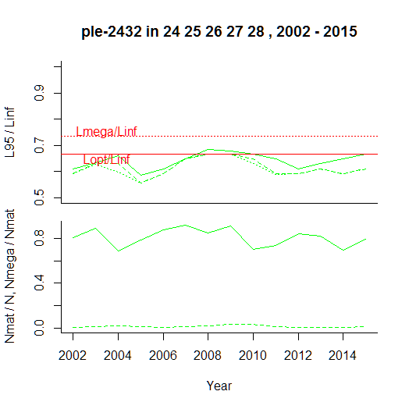

Comment: The plaice stocks have recovered in recent years. One would expect this to be reflected in more large individuals. Maybe these are missed by the gear, same as in North Sea. Comparison with commercial data is needed.

Flounder in Sound and Belt Sea
----------------------------------------------
Results of SMALK and CPUE analysis, Fri Nov 04 16:45:37 2016
----------------------------------------------
SMALK_File = SMALK_BITS_2016-10-31.csv CPUE_File = BalticCPUE per length per subarea_2016-11-01 15_32_54.csv
Survey = BITS
Species = Platichthys flesus Stock = fle-2223
Sex SMALK = F
Years = 2002 - 2015
Quarter = 1
Areas = 22
Lc.com = 20.7 cm (length where 50% are retained by commercial gear)
----------------------------------------------
Summary stats of weighted F W~L regression
----------------------------------------------
4 outliers (beyond 4 SD) were removed.
Number of remaining observations = 1447
Length range = 10 - 51 cm
Weight range = 13 - 2114 g
log10(a) = -2.23 , SE = 0.0263
Geometric mean a = 0.00595 , 95% CL = 0.00528 - 0.0067
b = 3.23 , 95% CL = 3.2 - 3.27
Standard deviation of estimated log10(W) = 0.0555
Coefficient of determination (r2) = 0.967
--------------------------------------------------------------
Maturity analysis from proportion-mature-at-length data
--------------------------------------------------------------
Available maturity codes = 2 3 4 1
Number of observations = 475
Largest immature = 10 cm
Smallest mature = 10 cm
Ogive length at 50% maturity = 13 cm
Ogive length at 10% and 90% maturity 12.7 - 13.3 cm
Chosen length at 50% maturity Lm50 = 19 cm
-------------------------------------------------
Estimation of Linf
-------------------------------------------------
Observed maximum length SMALK = 51 cm
Median of annual maximum lengths = 48 cm
Whetherall Linf based on SMALK = NA cm
Observed maximum length CPUE = 51 cm
Median annual maximum lengths CPUE = 50 cm
Chosen Linf = 51 cm
Length at max cohort biomass Lopt = 34 cm (assuming b~3 and M/K~1.5)

Stock Year Lmax.obs N N.mat N.mega pp.mat pp.mega L95 L95mat L95.5 L95Linf L95matLinf L95.5Linf
1 fle-2223 2001 48 215 208 27.1 0.968 0.1305 39.0 39.0 39.0 0.765 0.765 0.765
2 fle-2223 2002 47 384 360 12.6 0.937 0.0349 34.0 34.0 36.0 0.667 0.667 0.706
3 fle-2223 2003 51 327 262 12.6 0.800 0.0480 34.0 34.5 35.0 0.667 0.677 0.686
4 fle-2223 2004 51 268 249 30.6 0.927 0.1232 39.0 39.0 39.9 0.765 0.765 0.783
5 fle-2223 2005 51 255 251 41.5 0.982 0.1653 41.8 41.8 42.0 0.819 0.821 0.824
6 fle-2223 2006 49 475 465 29.4 0.979 0.0633 36.0 36.0 37.0 0.706 0.706 0.725
7 fle-2223 2007 50 595 551 30.1 0.927 0.0547 35.0 35.0 37.0 0.686 0.686 0.725
8 fle-2223 2008 50 1060 1024 57.9 0.966 0.0566 36.0 36.0 37.0 0.706 0.706 0.725
9 fle-2223 2009 49 533 440 29.6 0.826 0.0674 36.0 36.0 38.0 0.706 0.706 0.745
10 fle-2223 2010 51 670 648 45.6 0.967 0.0704 36.6 37.0 37.0 0.718 0.725 0.725
11 fle-2223 2011 50 1016 913 98.8 0.898 0.1082 39.0 39.0 40.0 0.765 0.765 0.784
12 fle-2223 2012 48 1673 1594 100.6 0.953 0.0631 37.0 37.0 38.0 0.725 0.725 0.745
13 fle-2223 2013 50 1220 1022 33.3 0.838 0.0326 35.0 35.1 36.0 0.686 0.689 0.706
14 fle-2223 2014 47 1589 1497 56.5 0.942 0.0377 36.0 36.0 36.0 0.706 0.706 0.706
15 fle-2223 2015 46 1152 1104 79.7 0.958 0.0722 37.0 37.0 38.0 0.725 0.725 0.745

Comment: Maturity ogive too few data; Lm50 from fle-2425; Lc.com assumed as 90% of minimum landing size

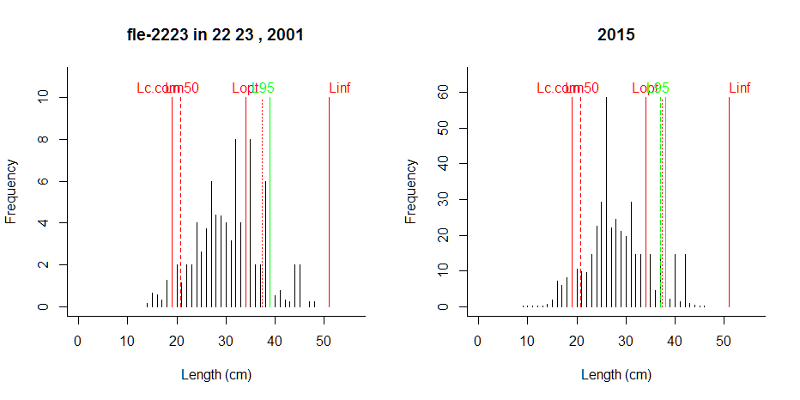
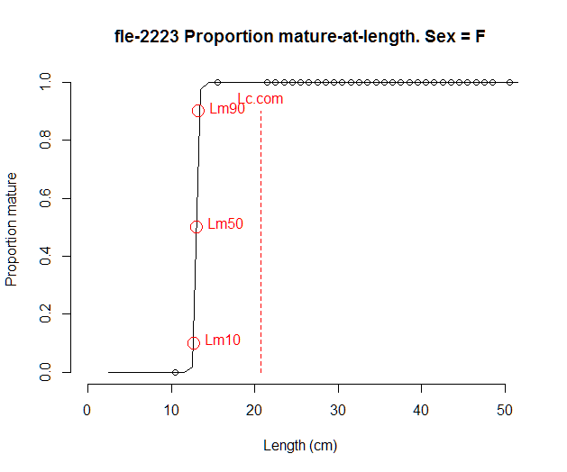 | 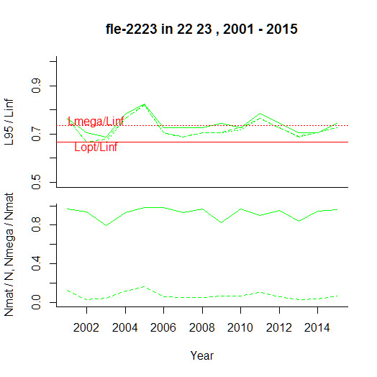

Comment: Size structure of flounder looks more or less okay, but large individuals are missing, probably not retained by the gear, as with the other flatfish. Comparison with commercial data is needed. Also, there are too few maturity data to fit an ogive.

Flounder in the central Baltic
----------------------------------------------
Results of SMALK and CPUE analysis, Fri Nov 04 16:58:57 2016
----------------------------------------------
SMALK_File = SMALK_BITS_2016-10-31.csv CPUE_File = BalticCPUE per length per subarea_2016-11-01 15_32_54.csv
Survey = BITS
Species = Platichthys flesus Stock = fle-2425
Sex SMALK = F
Years = 2001 - 2015
Quarter = 1
Areas = 24 25
Lc.com = 20.7 cm (length where 50% are retained by commercial gear)
----------------------------------------------
Summary stats of weighted F W~L regression
----------------------------------------------
20 outliers (beyond 4 SD) were removed.
Number of remaining observations = 8517
Length range = 9 - 53 cm
Weight range = 7 - 1860 g
log10(a) = -2.06 , SE = 0.00823
Geometric mean a = 0.00877 , 95% CL = 0.00845 - 0.0091
b = 3.1 , 95% CL = 3.09 - 3.12
Standard deviation of estimated log10(W) = 0.059
Coefficient of determination (r2) = 0.976
--------------------------------------------------------------
Maturity analysis from proportion-mature-at-length data
--------------------------------------------------------------
Available maturity codes = 1 2 3 4
Number of observations = 2473
Largest immature = 26 cm
Smallest mature = 9 cm
Ogive length at 50% maturity = 19.1 cm
Ogive length at 10% and 90% maturity 16.7 - 21.4 cm
-------------------------------------------------
Estimation of Linf
-------------------------------------------------
Observed maximum length SMALK = 53 cm
Median of annual maximum lengths = 46 cm
Whetherall Linf based on SMALK = 48.1 cm
Observed maximum length CPUE = 60 cm
Median annual maximum lengths CPUE = 48 cm
Chosen Linf = 51 cm
Length at max cohort biomass Lopt = 34 cm (assuming b~3 and M/K~1.5)

Stock Year Lmax.obs N N.mat N.mega pp.mat pp.mega L95 L95mat L95.5 L95Linf L95matLinf L95.5Linf
1 fle-2425 2001 49 1075 1033 34.5 0.961 0.03340 34 34 35 0.667 0.667 0.686
2 fle-2425 2002 49 2535 2425 85.6 0.956 0.03529 35 35 36 0.686 0.686 0.706
3 fle-2425 2003 48 1784 1732 49.6 0.971 0.02863 34 34 35 0.667 0.667 0.686
4 fle-2425 2004 47 1390 1335 50.9 0.960 0.03812 34 34 36 0.667 0.667 0.706
5 fle-2425 2005 48 2073 1965 50.1 0.948 0.02548 34 34 35 0.667 0.667 0.686
6 fle-2425 2006 46 2245 2175 45.2 0.969 0.02079 34 34 35 0.667 0.667 0.686
7 fle-2425 2007 51 1845 1782 28.5 0.966 0.01597 32 32 34 0.627 0.627 0.667
8 fle-2425 2008 60 5053 4956 109.7 0.981 0.02214 34 34 35 0.667 0.667 0.686
9 fle-2425 2009 53 2853 2785 87.3 0.976 0.03134 35 35 36 0.686 0.686 0.706
10 fle-2425 2010 46 3545 3476 106.9 0.980 0.03077 35 35 36 0.686 0.686 0.706
11 fle-2425 2011 49 2186 2053 62.1 0.939 0.03026 35 35 35 0.686 0.686 0.686
12 fle-2425 2012 52 4189 3932 125.9 0.939 0.03203 35 35 36 0.686 0.686 0.706
13 fle-2425 2013 47 5277 4686 92.3 0.888 0.01969 33 33 35 0.647 0.647 0.686
14 fle-2425 2014 47 5864 5439 29.7 0.928 0.00546 31 31 33 0.608 0.608 0.647
15 fle-2425 2015 46 7314 6950 38.1 0.950 0.00549 31 31 33 0.608 0.608 0.647

Comment: Missing of mega spawners is probably a gear effect

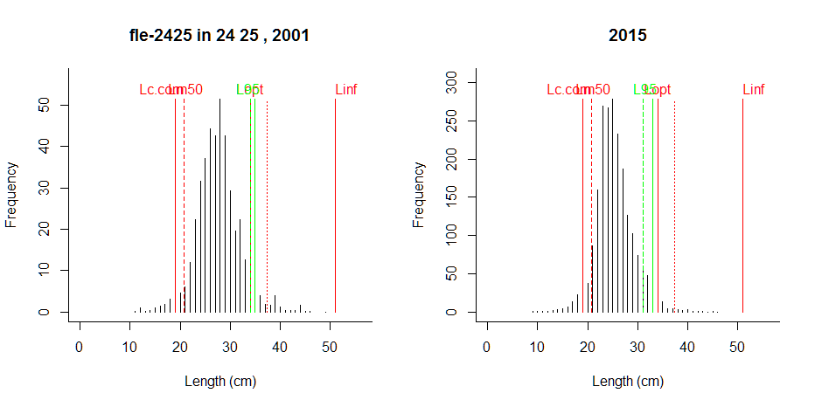
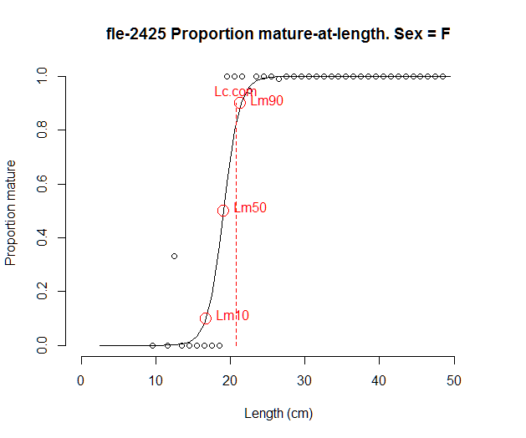 | 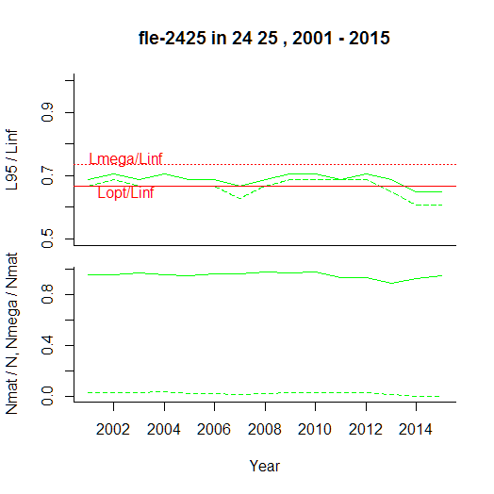

Comment: Large individuals are missing.

Western Baltic herring
----------------------------------------------
Results of SMALK and CPUE analysis, Fri Nov 04 17:06:36 2016
----------------------------------------------
SMALK_File = SMALK_BITS_2016-10-31.csv CPUE_File = BalticCPUE per length per subarea_2016-11-01 15_32_54.csv
Survey = BITS
Species = Clupea harengus Stock = her-3a22
Sex SMALK = F
Years = 1993 - 2012
Quarter = 1
Areas = 24 23
Lc.com = NA cm (length where 50% are retained by commercial gear)
----------------------------------------------
Summary stats of weighted F W~L regression
----------------------------------------------
1 outliers (beyond 4 SD) were removed.
Number of remaining observations = 310
Length range = 11 - 31 cm
Weight range = 7 - 250 g
log10(a) = -2.67 , SE = 0.035
Geometric mean a = 0.00214 , 95% CL = 0.00182 - 0.0025
b = 3.36 , 95% CL = 3.31 - 3.41
Standard deviation of estimated log10(W) = 0.0446
Coefficient of determination (r2) = 0.982
--------------------------------------------------------------
Maturity analysis from proportion-mature-at-length data
--------------------------------------------------------------
Available maturity codes = 2 1 3 4
Number of observations = 485
Largest immature = 28 cm
Smallest mature = 11 cm
Ogive length at 50% maturity = 20 cm
Ogive length at 10% and 90% maturity 15.6 - 24.4 cm
-------------------------------------------------
Estimation of Linf
-------------------------------------------------
Observed maximum length SMALK = 31 cm
Median of annual maximum lengths = 29.2 cm
Whetherall Linf based on SMALK = 29.5 cm
Observed maximum length CPUE = 46 cm
Median annual maximum lengths CPUE = 32.5 cm
Chosen Linf = 33 cm
Length at max cohort biomass Lopt = 22 cm (assuming b~3 and M/K~1.5)

Stock Year Lmax.obs N N.mat N.mega pp.mat pp.mega L95 L95mat L95.5 L95Linf L95matLinf L95.5Linf
1 her-3a22 1991 34.0 27881 5508 NA 0.1976 NA 25.0 26.5 25.5 0.758 0.803 0.773
2 her-3a22 1992 32.5 92776 27621 16381.8 0.2977 0.5931 26.5 27.0 27.0 0.803 0.818 0.818
3 her-3a22 1993 32.0 74578 14932 7131.9 0.2002 0.4776 26.5 28.5 27.5 0.803 0.864 0.833
4 her-3a22 1994 33.0 30201 4925 1813.2 0.1631 0.3682 26.0 28.5 27.5 0.788 0.864 0.833
5 her-3a22 1995 34.0 27461 3484 NA 0.1269 NA 27.0 29.0 28.5 0.818 0.879 0.864
6 her-3a22 1996 37.0 22498 2051 1070.3 0.0911 0.5219 26.5 31.0 30.0 0.803 0.939 0.909
7 her-3a22 1997 34.0 82674 2747 527.2 0.0332 0.1919 18.0 30.5 27.0 0.545 0.924 0.818
8 her-3a22 1998 34.5 63831 3174 430.6 0.0497 0.1357 20.5 27.0 24.0 0.621 0.818 0.727
9 her-3a22 1999 34.0 80154 4925 626.6 0.0614 0.1272 21.5 25.0 24.0 0.652 0.758 0.727
10 her-3a22 2000 31.5 94379 4902 542.0 0.0519 0.1106 20.0 26.0 24.0 0.606 0.788 0.727
11 her-3a22 2001 31.0 85287 8380 NA 0.0983 NA 22.0 25.5 24.0 0.667 0.773 0.727
12 her-3a22 2002 30.0 80207 4453 605.5 0.0555 0.1360 21.5 25.0 24.5 0.652 0.758 0.742
13 her-3a22 2003 32.0 62172 2902 207.6 0.0467 0.0715 18.5 26.1 22.0 0.561 0.790 0.667
14 her-3a22 2004 31.5 27273 1972 329.1 0.0723 0.1668 21.5 27.5 24.0 0.652 0.833 0.727
15 her-3a22 2005 31.5 23490 3040 478.7 0.1294 0.1575 23.5 27.0 24.5 0.712 0.818 0.742
16 her-3a22 2006 32.5 17033 1682 158.2 0.0987 0.0940 22.0 26.0 23.5 0.667 0.788 0.712
17 her-3a22 2007 32.5 32833 2491 137.0 0.0759 0.0550 21.0 24.5 22.5 0.636 0.742 0.682
18 her-3a22 2008 32.5 28122 2600 567.4 0.0925 0.2182 23.0 27.0 25.0 0.697 0.818 0.758
19 her-3a22 2009 33.0 35543 1850 181.3 0.0521 0.0980 19.5 27.0 23.5 0.591 0.818 0.712
20 her-3a22 2010 32.5 45529 3772 393.1 0.0829 0.1042 21.5 27.0 24.5 0.652 0.818 0.742
21 her-3a22 2011 33.5 27338 2416 527.8 0.0884 0.2184 23.0 28.0 27.0 0.697 0.848 0.818
22 her-3a22 2012 39.0 48528 3681 344.1 0.0759 0.0935 21.5 25.5 24.0 0.652 0.773 0.727
23 her-3a22 2013 46.0 40696 4721 NA 0.1160 NA 22.5 25.0 23.5 0.682 0.758 0.712
24 her-3a22 2014 34.5 134683 3538 98.5 0.0263 0.0278 17.0 24.5 22.5 0.515 0.742 0.682
25 her-3a22 2015 31.5 143732 6097 68.0 0.0424 0.0112 18.0 25.0 19.5 0.545 0.758 0.591

Comment: Proportion of mega-spawners works ok; L95 shows the decline. No Lc.com or MCRL available.

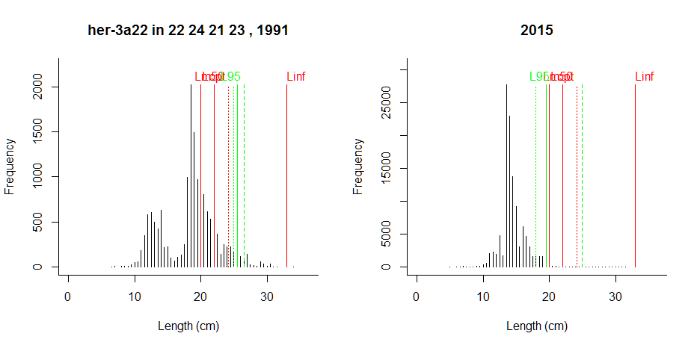
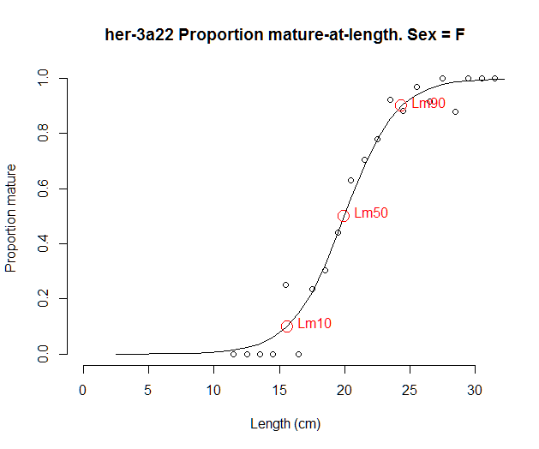 | 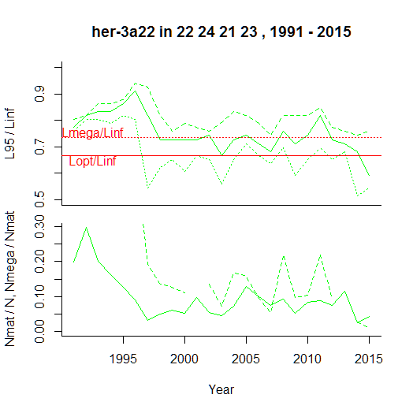

Comment: This stock has been overfished. The decline in size structure is reflected in the indicators. The very low proportion of mature fish is alarming. L95 for lengths above Lm50 is too optimistic, due to high Lm50/Linf ratio in small pelagics. Variability in all indicators due to recruitment could be reduced by moving average.

Herring in the Central Baltic
----------------------------------------------
Results of SMALK and CPUE analysis, Fri Nov 04 17:16:57 2016
----------------------------------------------
SMALK_File = SMALK_BITS_2016-10-31.csv CPUE_File = BalticCPUE per length per subarea_2016-11-01 15_32_54.csv
Survey = BITS
Species = Clupea harengus Stock = her-2532-gor
Sex SMALK = F
Years = 1993 - 2015
Quarter = 1
Areas = 25 26 28
Lc.com = NA cm (length where 50% are retained by commercial gear)
----------------------------------------------
Summary stats of weighted F W~L regression
----------------------------------------------
16 outliers (beyond 4 SD) were removed.
Number of remaining observations = 11805
Length range = 8 - 35 cm
Weight range = 3 - 278 g
log10(a) = -2.45 , SE = 0.00718
Geometric mean a = 0.00354 , 95% CL = 0.00342 - 0.00365
b = 3.19 , 95% CL = 3.18 - 3.2
Standard deviation of estimated log10(W) = 0.0599
Coefficient of determination (r2) = 0.971
--------------------------------------------------------------
Maturity analysis from proportion-mature-at-length data
--------------------------------------------------------------
Available maturity codes = 2 1 3 4
Number of observations = 9891
Largest immature = 27.5 cm
Smallest mature = 2 cm
Ogive length at 50% maturity = 14 cm
Ogive length at 10% and 90% maturity 9.46 - 18.5 cm
Chosen length at 50% maturity Lm50 = 15 cm
-------------------------------------------------
Estimation of Linf
-------------------------------------------------
Observed maximum length SMALK = 35 cm
Median of annual maximum lengths = 31.5 cm
Whetherall Linf based on SMALK = 33.9 cm
Observed maximum length CPUE = 40 cm
Median annual maximum lengths CPUE = 33 cm
Chosen Linf = 33.9 cm
Length at max cohort biomass Lopt = 22.6 cm (assuming b~3 and M/K~1.5)

Stock Year Lmax.obs N N.mat N.mega pp.mat pp.mega L95 L95mat L95.5 L95Linf L95matLinf L95.5Linf
1 her-3532-gor 1991 32.5 48905 19178 3223 0.392 0.16808 25.0 25.5 25.5 0.736 0.751 0.751
2 her-3532-gor 1992 33.0 336065 114769 NA 0.342 NA 23.0 23.5 24.0 0.678 0.692 0.707
3 her-3532-gor 1993 37.5 360874 139980 6919 0.388 0.04943 23.0 23.0 23.5 0.678 0.678 0.692
4 her-3532-gor 1994 32.5 62095 22093 1195 0.356 0.05408 23.0 23.0 23.5 0.678 0.678 0.692
5 her-3532-gor 1995 40.0 138349 50566 NA 0.365 NA 21.5 21.5 22.5 0.633 0.633 0.663
6 her-3532-gor 1996 35.0 37470 12226 NA 0.326 NA 23.0 23.5 24.0 0.678 0.692 0.707
7 her-3532-gor 1997 33.5 28923 8828 329 0.305 0.03730 22.0 22.5 23.5 0.648 0.663 0.692
8 her-3532-gor 1998 38.0 414559 132899 723 0.321 0.00544 20.5 21.0 21.5 0.604 0.619 0.633
9 her-3532-gor 1999 36.5 226351 60309 530 0.266 0.00879 20.0 20.5 21.5 0.589 0.604 0.633
10 her-3532-gor 2000 33.0 195449 58601 730 0.300 0.01246 20.5 21.0 21.5 0.604 0.619 0.633
11 her-3532-gor 2001 32.0 216343 68096 NA 0.315 NA 20.5 21.0 21.5 0.604 0.619 0.633
12 her-3532-gor 2002 35.0 408684 110698 NA 0.271 NA 20.5 21.0 22.0 0.604 0.619 0.648
13 her-3532-gor 2003 33.0 266569 69449 905 0.261 0.01302 21.0 22.0 22.5 0.619 0.648 0.663
14 her-3532-gor 2004 36.0 260865 74052 1636 0.284 0.02210 22.0 22.5 23.0 0.648 0.663 0.678
15 her-3532-gor 2005 32.5 506593 120466 1222 0.238 0.01014 20.0 21.5 22.5 0.589 0.633 0.663
16 her-3532-gor 2006 32.5 747451 172103 1214 0.230 0.00705 20.0 21.0 21.5 0.589 0.619 0.633
17 her-3532-gor 2007 32.0 297864 95928 NA 0.322 NA 21.0 21.5 22.0 0.619 0.633 0.648
18 her-3532-gor 2008 34.0 334585 103678 NA 0.310 NA 21.5 22.0 22.5 0.633 0.648 0.663
19 her-3532-gor 2009 34.5 545231 172196 1078 0.316 0.00626 20.0 20.5 21.0 0.589 0.604 0.619
20 her-3532-gor 2010 32.5 559528 189631 1946 0.339 0.01026 21.0 21.5 22.0 0.619 0.633 0.648
21 her-3532-gor 2011 32.0 516019 156471 NA 0.303 NA 21.0 21.5 22.0 0.619 0.633 0.648
22 her-3532-gor 2012 32.5 487939 156087 1496 0.320 0.00958 21.0 21.5 22.0 0.619 0.633 0.648
23 her-3532-gor 2013 34.5 506052 157753 2155 0.312 0.01366 21.5 22.0 22.5 0.633 0.648 0.663
24 her-3532-gor 2014 35.5 234082 93266 1528 0.398 0.01638 22.0 22.0 22.5 0.648 0.648 0.663
25 her-3532-gor 2015 31.5 413257 139315 1708 0.337 0.01226 21.5 22.0 22.0 0.633 0.648 0.648

Comment: Proportion of mega-spawners works ok; L95 shows the decline

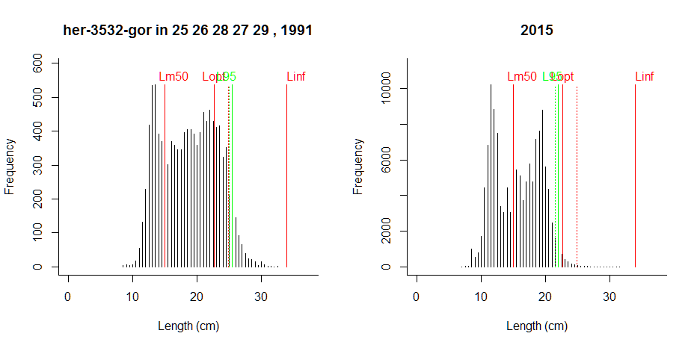
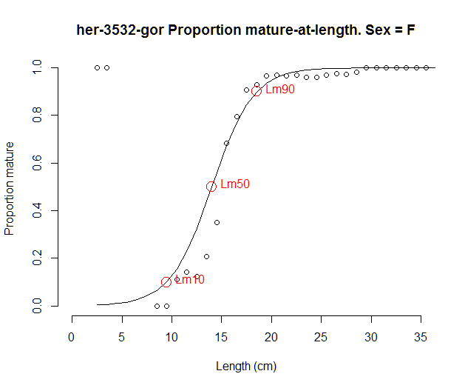 | 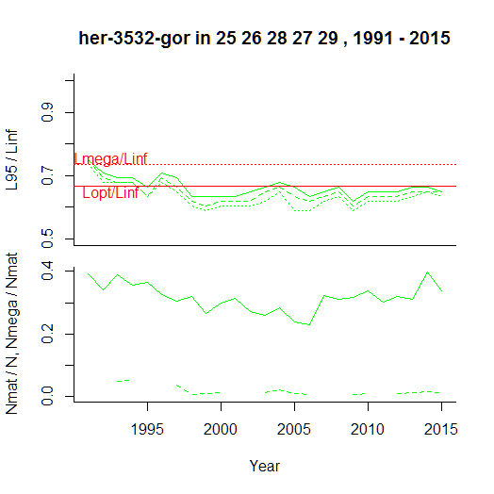

Comment: Large individuals are missing, but decline looks smooth, could be real. Needs to be checked against commercial LF data. No Lc.com or MCRS is available.

Baltic sprat
----------------------------------------------
Results of SMALK and CPUE analysis, Fri Nov 04 17:31:41 2016
----------------------------------------------
SMALK_File = SMALK_BITS_2016-10-31.csv CPUE_File = BalticCPUE per length per subarea_2016-11-01 15_32_54.csv
Survey = BITS
Species = Sprattus sprattus Stock = spr-2232
Sex SMALK = F
Years = 1999 - 2015
Quarter = 1
Areas = 25 26
Lc.com = NA cm (length where 50% are retained by commercial gear)
----------------------------------------------
Summary stats of weighted F W~L regression
----------------------------------------------
17 outliers (beyond 4 SD) were removed.
Number of remaining observations = 3504
Length range = 5.5 - 16 cm
Weight range = 1 - 26 g
log10(a) = -2.32 , SE = 0.015
Geometric mean a = 0.00478 , 95% CL = 0.00447 - 0.00512
b = 3.1 , 95% CL = 3.07 - 3.12
Standard deviation of estimated log10(W) = 0.11
Coefficient of determination (r2) = 0.955
--------------------------------------------------------------
Maturity analysis from proportion-mature-at-length data
--------------------------------------------------------------
Available maturity codes = 2 3 1 4
Number of observations = 1112
Largest immature = 14.5 cm
Smallest mature = 5.5 cm
Ogive length at 50% maturity = 7.99 cm
Ogive length at 10% and 90% maturity 3.15 - 12.8 cm
Chosen length at 50% maturity Lm50 = 10 cm
-------------------------------------------------
Estimation of Linf
-------------------------------------------------
Observed maximum length SMALK = 16 cm
Median of annual maximum lengths = 15.5 cm
Whetherall Linf based on SMALK = 14.5 cm
Observed maximum length CPUE = 18.5 cm
Median annual maximum lengths CPUE = 16.5 cm
Chosen Linf = 17.5 cm
Length at max cohort biomass Lopt = 11.7 cm (assuming b~3 and M/K~1.5)

Stock Year Lmax.obs N N.mat N.mega pp.mat pp.mega L95 L95mat L95.5 L95Linf L95matLinf L95.5Linf
1 spr-2232 1991 17.0 34721 11274 8785 0.325 0.779 14.5 14.5 14.5 0.829 0.829 0.829
2 spr-2232 1992 17.0 241229 94460 NA 0.392 NA 15.0 15.0 15.0 0.857 0.857 0.857
3 spr-2232 1993 17.0 59318 24171 NA 0.407 NA 15.0 15.0 15.0 0.857 0.857 0.857
4 spr-2232 1994 17.0 27499 9213 NA 0.335 NA 14.0 14.5 14.5 0.800 0.829 0.829
5 spr-2232 1995 16.5 93199 39510 35401 0.424 0.896 14.5 14.5 14.5 0.829 0.829 0.829
6 spr-2232 1996 17.0 101181 35125 NA 0.347 NA 14.5 14.5 14.5 0.829 0.829 0.829
7 spr-2232 1997 16.5 77809 26268 13691 0.338 0.521 14.0 14.0 14.0 0.800 0.800 0.800
8 spr-2232 1998 16.0 851247 271024 NA 0.318 NA 13.5 13.5 13.5 0.771 0.771 0.771
9 spr-2232 1999 17.5 489174 152464 93208 0.312 0.611 13.5 13.5 13.5 0.771 0.771 0.771
10 spr-2232 2000 17.5 398821 121358 68393 0.304 0.564 13.5 13.5 13.5 0.771 0.771 0.771
11 spr-2232 2001 17.0 393079 125267 NA 0.319 NA 13.5 13.5 13.5 0.771 0.771 0.771
12 spr-2232 2002 16.5 1126170 335475 197624 0.298 0.589 13.0 13.0 13.0 0.743 0.743 0.743
13 spr-2232 2003 17.5 457247 138722 103308 0.303 0.745 13.5 13.5 13.5 0.771 0.771 0.771
14 spr-2232 2004 16.0 520774 140453 NA 0.270 NA 13.0 13.5 13.0 0.743 0.771 0.743
15 spr-2232 2005 16.0 949775 267208 NA 0.281 NA 13.0 13.0 13.0 0.743 0.743 0.743
16 spr-2232 2006 16.5 1165944 331752 137843 0.285 0.416 13.0 13.5 13.0 0.743 0.771 0.743
17 spr-2232 2007 17.5 517559 137299 31427 0.265 0.229 12.5 13.0 13.0 0.714 0.743 0.743
18 spr-2232 2008 16.0 533112 170200 88329 0.319 0.519 13.5 13.5 13.5 0.771 0.771 0.771
19 spr-2232 2009 18.5 587545 179080 103034 0.305 0.575 13.0 13.5 13.0 0.743 0.771 0.743
20 spr-2232 2010 16.5 689673 168072 56431 0.244 0.336 12.5 13.0 13.0 0.714 0.743 0.743
21 spr-2232 2011 16.0 639644 213639 102527 0.334 0.480 13.0 13.0 13.0 0.743 0.743 0.743
22 spr-2232 2012 16.0 591248 170978 102191 0.289 0.598 13.0 13.5 13.5 0.743 0.771 0.771
23 spr-2232 2013 16.0 1435943 283771 45295 0.198 0.160 12.5 13.0 13.0 0.714 0.743 0.743
24 spr-2232 2014 15.5 322747 93297 54478 0.289 0.584 13.5 14.0 13.5 0.771 0.800 0.771
25 spr-2232 2015 16.5 634957 172973 89263 0.272 0.516 13.5 13.5 13.5 0.771 0.771 0.771

Comment: Concept of mega-spawners may not apply to sprat.

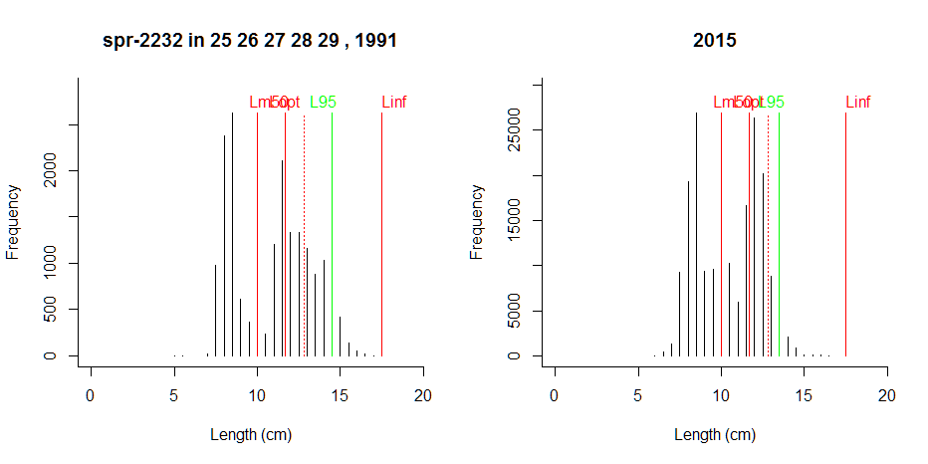
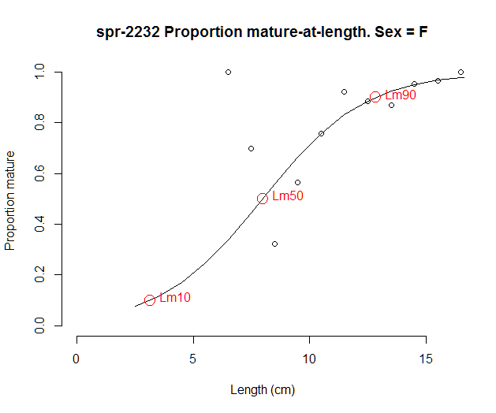 | 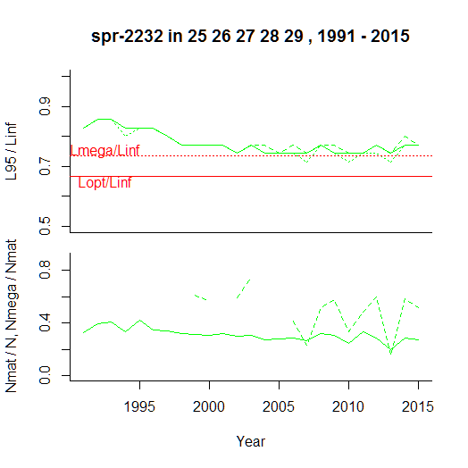

Comment: More maturity data are needed. Bottom trawl may not adequately reflect length distribution of this species. Commercial data or data from control catches in acoustic surveys are needed for comparison.

