Applying Length-Frequency Analysis to 10 Stocks with Suitable Data from Commercial Catches
Appendix with Results of Subgroup I on Selectivity in WKIND3.3i
Prepared by Rainer Froese in March 2016
This Appendix shows the results of the analyses of 10 stocks, shown in Table 1 below, performed by Subgroup 1 during the WKIND3.3i workshop at ICES HQ in Copenhagen, 13-16 March 2016. Members of the Subgroup were Chris Darby, Gerjan Piet, Henrik Svedäng, Jurgen Bastleer, Paz Sampedro, and Rainer Froese. The Subgroup was chaired by Rainer Froese.
Summary of results
The purpose of the subgroup was to identify and recommend suitable indicators for size (and age) structure of exploited stocks, with suitable reference points (benchmarks).
The group considered four potential indicators:
- Length at first capture (L_{c})
- Mean length in the catch (L_{mean})
- Mode length (= length class with highest number of individuals) (L_{peak})
- Maximum length (= length of largest individual) (L_{max})
The group considered five potential reference levels or benchmarks:
- Asymptotic length L_{inf} from the von Bertalanffy growth function
$$L_{t}=L_{inf}(1-e^{-K\left(t-t_{0}\right)})$$
- Length where cohort biomass is maximum without fishing L_{opt}
$L_{opt}=L_{inf}\frac{3}{3+M/K}$ or for M/K ~ 1.5 $L_{opt}=\frac{2}{3}L_{inf}$
- Length at first capture L_{c_opt} that, for a given F, results in a mean length of L_{opt}
$L_{c_opt}=L_{inf}\frac{2+3 F/M}{\left(1+F/M\right) (3+M/K}$ or for F ~ M $L_{c_opt}=0.52 L_{inf}$
- Length where 50% of females have reached maturity L_{m50}
- Length where 90% of females have reached maturity L_{m90}

Length frequencies from commercial catch data (landings and discards) were available and were analyzed for the stocks shown in Table 1.
After evaluating the performance of the indicators and reference points against the selected stocks, the group agreed that, of the four indicators, L_{c} and L_{mean} were firmly based in fisheries science and were more representative of the length frequency distribution than L_{peak} and L_{max}. L_{c} and L_{mean} were thus chosen and proposed as suitable indicators for length structure.
Of the five potential reference levels or benchmarks, asymptotic length L_{inf} itself was not needed because L_{inf} is contained in the equations of L_{opt} and L_{c_opt}. The group agreed that the remaining four

Table 1. Overview of stocks analyzed by subgroup 1 at WKIND3.3i
Name | Species | Stock | Area | Life history source | Comment
Eastern Baltic cod | Gadus morhua | cod-2532 | 25 - 32 | DATRAS SMALK BITS | Low L_{inf} of 90 cm assumed
North Sea cod | Gadus morhua | cod-347d | 1 - 7 | DATRAS SMALK IBTS
North Sea plaice | Pleuronectes platessa | ple-nsea | 1 - 7 | DATRAS SMALK IBTS
Northern hake | Merluccius merluccius | hke-nrtn | Biscay and north | DATRAS SMALK EVHOE & IGFS
Mediterranean hake | Merluccius merluccius | hke-med | GSA 9 |  | Unclear if LF in GSA 9 is representative of the stock
Mediterranean anchovy | Engraulis encrasicolus | anc-GSA1718 | GSA 17, 18  Adriatic Sea | Literature
Giant red shrimp | Aristaeomorpha foliacea | GRShrimp11 | GSA 11 | Literature | Carapace length
Roundnose grenadier | Coryphaenoides rupestris | rng-5b67 | 5b, 6, 7 | Literature | Length type is pre-anal fin length
Spurdog, Males | Squalus acanthias | dgs-nea | NEA | Exchange CA, across surveys
Spurdog, females | Squalus acanthias | dgs-nea | NEA | Exchange CA, across surveys

benchmarks were well established in fisheries science, provided useful guidance for managers, showed different results depending on the life history of the respective species, and should therefore all be kept.
The group agreed that L_{opt} was a suitable benchmark for L_{mean} and that L_{c_opt} was a suitable benchmark for L_{c}. The group differed in its opinion about the usefulness of the benchmarks for the purpose of GES evaluation.
One opinion was that these indicators and their reference points were very useful for management and should become part of regular assessments. But they were not needed and should not be used for GES (see also Discussion document by Chris Darby).
An alternative opinion, expressed in the subgroup and in the plenary, was that L_{c_opt} could be used as a target for L_{c} and that L_{m50} could be used as a lower limit for L_{c}. Similarly, L_{opt} could be used as a target for L_{mean} and L_{m90} could be used as a lower limit for L_{mean}. In other words, L_{c} near L_{c_opt} and L_{mean} near L_{opt} would indicate a healthy size structure and L_{c} below L_{m50} or L_{mean} below L_{m90} would indicate a truncated size structure.

Software
Two pieces of software in R were available to and used by the group:
SMALK_Analysis_28c.r analyses SMALK-type of data as downloaded from DATRAS. The software first identifies and removes outliers and then provides length-weight relationship, an estimate of asymptotic length L_{inf} based on the Wetherall method, estimation of von Bertalanffy growth parameters K and t₀, length at maturity (L_{m50} and L_{m90}), proportion mature by age class, and L_{c} and L_{mean} of the survey gear. Quarter, area, time-period, species, and sex can be selected by the user.
LFCOM_10.r analyzes time series of length frequency data from a user-created csv file with mandatory headers: Stock, Year, Length, CatchNo, with lengths in mm. As output it produces a csv file with headers Stock, Year, Lc, Lmean, Lpeak, Lmax and a time series of the respective indicators. Users can determine StartYear and EndYear of the analysis. Another required input is an estimate of Linf. Optional inputs are K, M, Lm50, Lm90. These life history parameters are used to calculate benchmarks which are then shown on screen and in graphs.
Both pieces of R code are available from the Software folder of the WKIND3.3i share point. The respective data files are available either in the Software folder or under the respective stocks in the Data folder.
In the detailed analysis below, the output from SMALK_Analysis_28c.r is shown only for North Sea cod.

Detailed Results for the Analyzed Stocks
Baltic cod (I)
---------------------------------------------
Results of LFCOM analysis, Fri Mar 18 15:48:02 2016
Species = Gadus morhua , stock = cod-2532

External estimates of Linf, K, Lm50, Lm90, M, F
---------------------------------------------
Asymptotic length Linf = 90 cm
Growth parameter K = 0.3 1/year
Length at 50% maturity Lm50 = 32.9 cm
Length at 90% maturity Lm90 = 42.2 cm
Natural mortality of adults M = 0.3 1/y
Commercial fishing mortality F = NA 1/y
M/K (expected 1.0-2.0) M/K = 1
Comment: Low Linf enforced

----------------------------------------------
Lopt, Lc_opt and L(F=M) based on Linf
----------------------------------------------
Length at max cohort biomass Lopt = 60 cm, assuming b ~ 3 and M/K ~ 1.5
Lc resulting in Lopt Lc_opt = 45 cm, if F ~ M
Lc resulting in Lopt Lc_opt = 49.5 cm, if F ~ 2 M
Mean length in catch if F=M L(F=M) = 46.5 cm

---------------------------------------------
Observed Lc and Lmean in 2014
---------------------------------------------
Mean length at first capture Lc = 32 cm
Mean length in catch Lmean = 38.6 cm

Time series
---------------------------------------------
Stock Year Lc Lmean Lpeak Lmax
1 cod-2532 2000 35.5 43.0 44.0 122
2 cod-2532 2001 36.0 43.3 43.0 115
3 cod-2532 2002 34.0 42.2 43.0 118
4 cod-2532 2003 36.5 44.0 42.7 132
5 cod-2532 2004 39.0 45.7 44.0 128
6 cod-2532 2005 34.9 43.1 44.0 129
7 cod-2532 2006 35.0 42.4 40.0 122
8 cod-2532 2007 35.5 42.9 42.0 118
9 cod-2532 2008 36.0 43.2 42.0 122
10 cod-2532 2009 35.5 43.4 42.0 132
11 cod-2532 2010 35.5 43.6 43.0 126
12 cod-2532 2011 34.0 42.6 41.0 119
13 cod-2532 2012 34.0 41.5 39.7 113
14 cod-2532 2013 34.0 39.6 40.0 104
15 cod-2532 2014 32.0 38.6 39.0 105

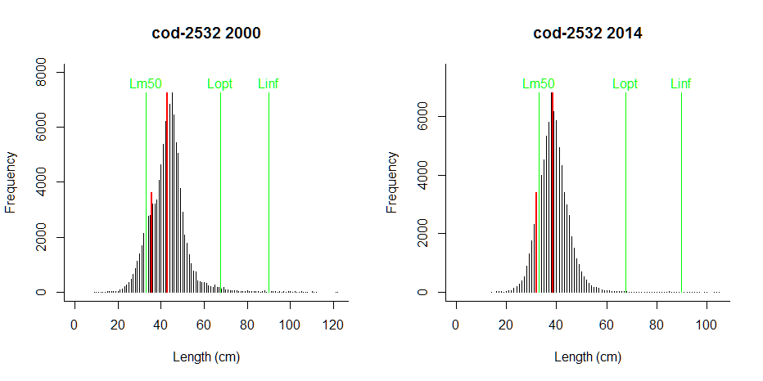
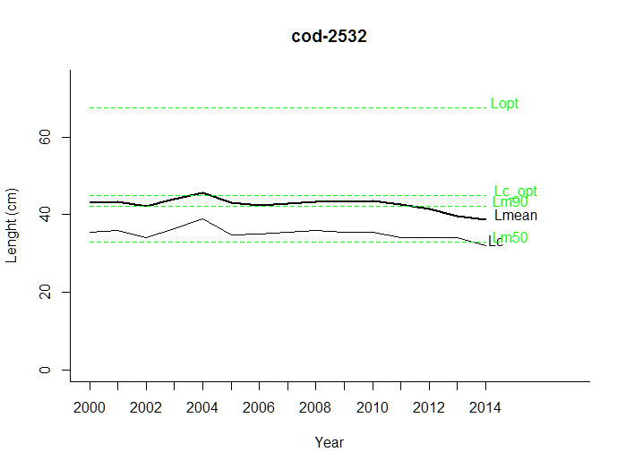

NORTH SEA COD (I)
----------------------------------------------
Results of SMALK analysis, Fri Mar 18 15:20:33 2016
----------------------------------------------
File = SMALK_NS-IBTS_2016-02-19_Q1.csv
Survey = NS-IBTS
Species = Gadus morhua
Sex = F
Years = 2000 - 2015
Quarter = 1
Areas = 1 2 3 4 5 6 7
----------------------------------------------
Summary stats of weighted mixed W~L regression
----------------------------------------------
21 outliers (beyond 4 SD) were removed.
Number of remaining observations = 5961
Length range = 10 - 133 cm
Weight range = 8 - 25000 g
log10(a) = -2.25 , SE = 0.00499
Geometric mean a = 0.00566 , 95% CL = 0.00554 - 0.00579
b = 3.15 , 95% CL = 3.15 - 3.16
Standard deviation of estimated log10(W) = 0.0578
Coefficient of determination (r2) = 0.995
Mean length = 45.7 cm, predicted weight = 970 g ( 747 - 1259 ) g
-------------------------------------------------
Wetherall estimation of Linf
-------------------------------------------------
Records used = 5647
Observed maximum length = 133 cm
Median of annual maximum lengths = 116 cm
Proposed Linf = 117 cm
-------------------------------------------------
Estimate of von Bertalanffy growth function
-------------------------------------------------
Number of observations = 5936
Observed maximum age = 12 years
Observed maximum length (including specimens without age)= 133 cm
Wetherall Linf = 117 cm, chosen Linf = 117
K = 0.205 , 95% CL = 0.202 - 0.208
t-zero = 0.154 , 95% CL = 0.134 - 0.174 (restricted to -3 and + 0.5 or Usert0)
SD of log(residuals) and of predicted log(length) = 0.205
--------------------------------------------------------------
Maturity analysis from proportion-mature-at-length data
--------------------------------------------------------------
Available maturity codes = 61 62 63 64
Number of observations = 4691
Largest immature = 83 cm
Smallest mature = 12 cm
Ogive length at 50% maturity = 53.4 cm
Ogive length at 10% and 90% maturity 26.8 - 79.9 cm
-----------------------------------------------------------
Maturity analysis from proportion-mature-at-age data
-----------------------------------------------------------
Number of observations = 4325
Youngest mature = 1 years
Oldest immature = 7 years
Proportion mature at ages 1-6 = 0.2 0.5 0.7 0.9 1.0 1.0
---------------------------------------------
Other LF results for this survey gear
---------------------------------------------
Fully selected length (peak+1) Lv = 33 cm
Length at first capture Lc = 15 cm
NORTH SEA COD (II)

Weighted mean length Lmean = 44.3
Length at max cohort biomass Lopt = 87.1
Lc resulting in Lopt Lc_opt = 77
Mean survey length if F=M L(F=M) = 48.4 cm
---------------------------------------------
External estimates of mortality
---------------------------------------------
Natural mortality of adults M = 0.21 1/y
Commercial fishing mortality F = 0.393 1/y

Comment:

Summary, formatted for pasting into other R-code
------------------------------------------------
Species <- Gadus morhua
Sex <- F
Area <- c( 1 2 3 4 5 6 7 )
a <- 0.00566
b <- 3.15
Linf <- 117
K <- 0.205
t0 <- 0.15
Lm50 <- 53.4
Lm90 <- 79.9
M <- 0.21
FM <- 0.393
Lopt <- 87.1
Lc_opt <- 77

NORTH SEA COD (III)
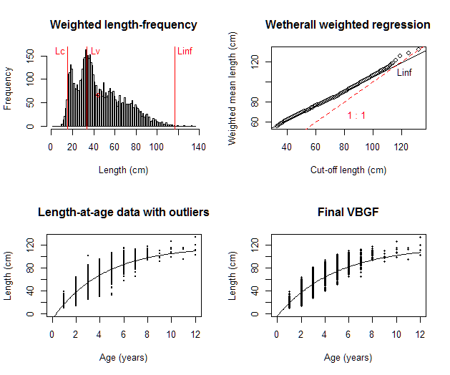
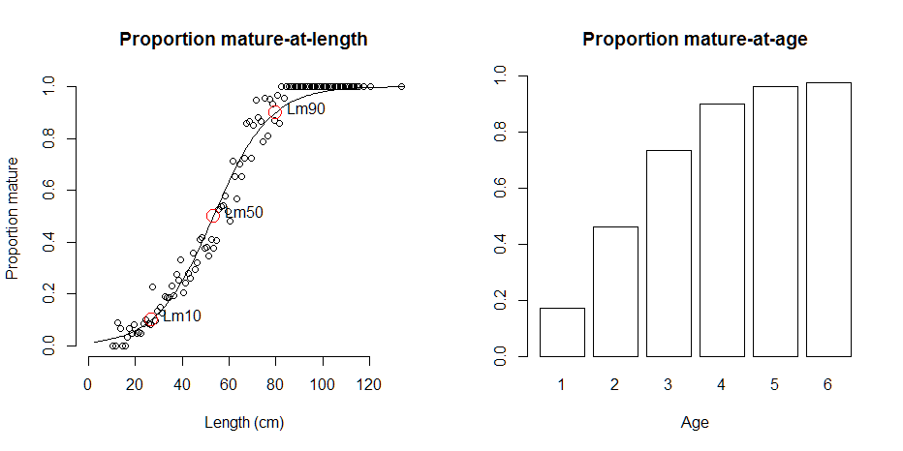
NORTH SEA COD (IV)
Results of LFCOM analysis, Fri Mar 18 15:51:03 2016
Species = Gadus morhua , stock = cod-347d

External estimates of Linf, K, Lm50, Lm90, M, F
---------------------------------------------
Asymptotic length Linf = 114 cm
Growth parameter K = 0.213 1/year
Length at 50% maturity Lm50 = 53.4 cm
Length at 90% maturity Lm90 = 79.9 cm
Natural mortality of adults M = 0.21 1/y
Commercial fishing mortality F = 0.393 1/y
M/K (expected 1.0-2.0) M/K = 0.986
Comment: Linf, K, Lopt, Lc_opt for combined sex; Lm50 and Lm90 for females

----------------------------------------------
Lopt, Lc_opt and L(F=M) based on Linf, M, K, F
----------------------------------------------
Length at max cohort biomass Lopt = 85.8
Lc resulting in Lopt Lc_opt = 75.8
Mean length in catch if F=M L(F=M) = 59.7 cm

----------------------------------------------
Lopt, Lc_opt and L(F=M) based on Linf
----------------------------------------------
Length at max cohort biomass Lopt = 76 cm, assuming b ~ 3 and M/K ~ 1.5
Lc resulting in Lopt Lc_opt = 57 cm, if F ~ M
Lc resulting in Lopt Lc_opt = 62.7 cm, if F ~ 2 M
Mean length in catch if F=M L(F=M) = 52.6 cm

---------------------------------------------
Observed Lc and Lmean in 2014
---------------------------------------------
Mean length at first capture Lc = 32.2 cm
Mean length in catch Lmean = 52 cm

Time series
---------------------------------------------
Stock Year Lc Lmean Lpeak Lmax
1 cod-347d 2010 34.9 57.9 51.7 110
2 cod-347d 2011 43.1 57.1 58.0 118
3 cod-347d 2012 39.3 59.1 56.7 121
4 cod-347d 2013 32.1 55.5 46.7 122
5 cod-347d 2014 32.2 52.0 43.7 120

NORTH SEA COD (V)
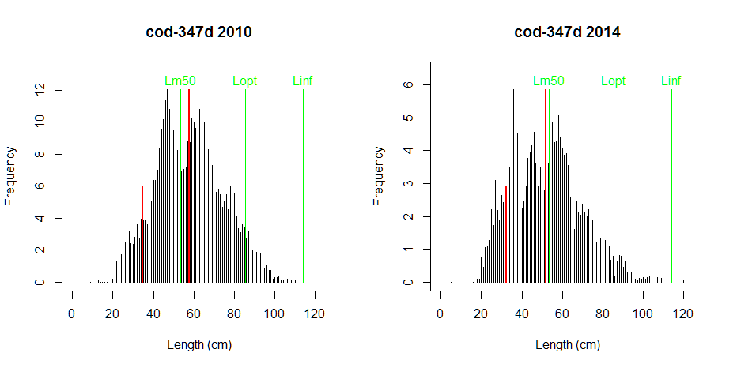
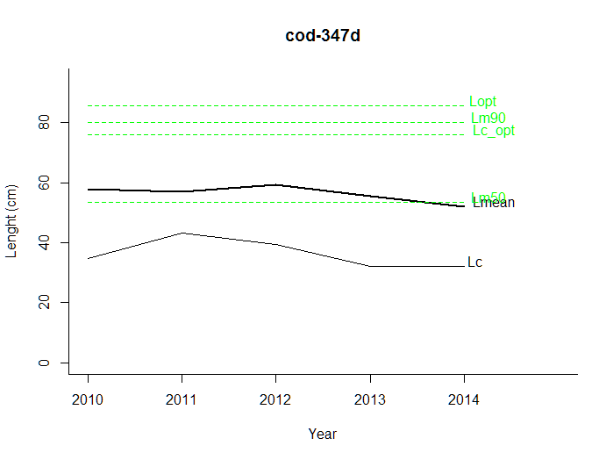
NORTH SEA PLAICE (I)
---------------------------------------------
Results of LFCOM analysis, Fri Mar 18 15:52:58 2016
Species = Pleuronectes platessa , stock = ple-nsea

External estimates of Linf, K, Lm50, Lm90, M, F
---------------------------------------------
Asymptotic length Linf = 49.9 cm
Growth parameter K = 0.153 1/year
Length at 50% maturity Lm50 = 22.8 cm
Length at 90% maturity Lm90 = 30.7 cm
Natural mortality of adults M = 0.1 1/y
Commercial fishing mortality F = 0.22 1/y
M/K (expected 1.0-2.0) M/K = 0.654
Comment: Linf, K, Lopt and Lc_opt for combined sex; Lm50 and Lm90 for females

----------------------------------------------
Lopt, Lc_opt and L(F=M) based on Linf, M, K, F
----------------------------------------------
Length at max cohort biomass Lopt = 41
Lc resulting in Lopt Lc_opt = 36.7
Mean length in catch if F=M L(F=M) = 33.2 cm

----------------------------------------------
Lopt, Lc_opt and L(F=M) based on Linf
----------------------------------------------
Length at max cohort biomass Lopt = 33.3 cm, assuming b ~ 3 and M/K ~ 1.5
Lc resulting in Lopt Lc_opt = 24.9 cm, if F ~ M
Lc resulting in Lopt Lc_opt = 27.4 cm, if F ~ 2 M
Mean length in catch if F=M L(F=M) = 27.9 cm

---------------------------------------------
Observed Lc and Lmean in 2014
---------------------------------------------
Mean length at first capture Lc = 20.5 cm
Mean length in catch Lmean = 26.9 cm

Time series
---------------------------------------------
Stock Year Lc Lmean Lpeak Lmax
1 ple-nsea 2010 21.5 28.2 29 57
2 ple-nsea 2011 21.5 27.2 28 62
3 ple-nsea 2012 22.0 28.0 28 60
4 ple-nsea 2013 24.5 27.6 28 52
5 ple-nsea 2014 20.5 26.9 29 58

NORTH SEA PLAICE (I)
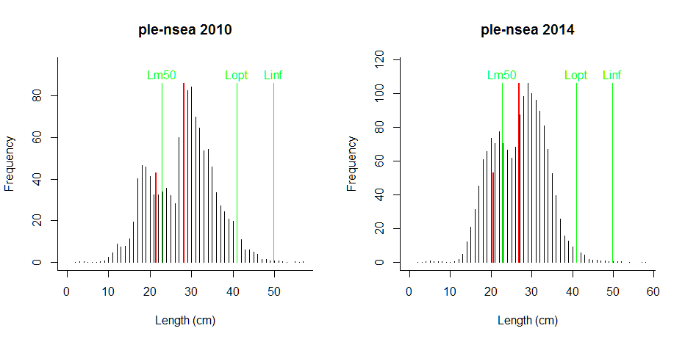
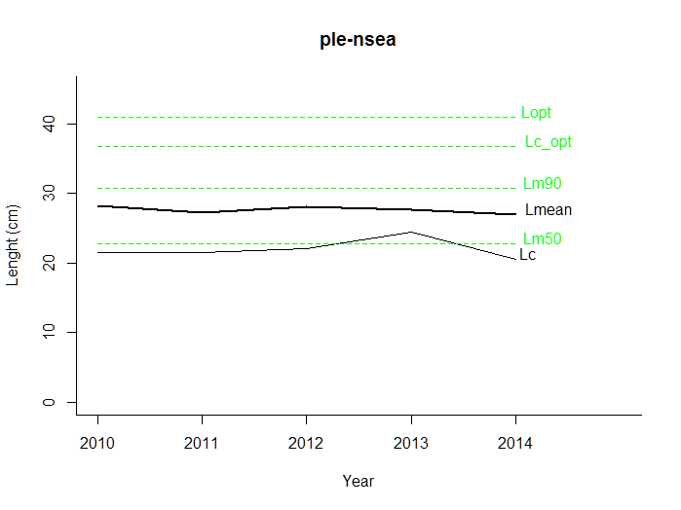

NORTHERN HAKE (I)
---------------------------------------------
Results of LFCOM analysis, Fri Mar 18 15:58:27 2016
Species = Merluccius merluccius , stock = hke-nrtn

External estimates of Linf, K, Lm50, Lm90, M, F
---------------------------------------------
Asymptotic length Linf = 130 cm
Growth parameter K = 0.177 1/year
Length at 50% maturity Lm50 = 42.9 cm
Length at 90% maturity Lm90 = 51.4 cm
Natural mortality of adults M = 0.4 1/y
Commercial fishing mortality F = 0.31 1/y
M/K (expected 1.0-2.0) M/K = 2.26
Comment: Linf, K, M, Lm50 from assessment; Lm90 assumed as 1.2*Lm50

----------------------------------------------
Lopt, Lc_opt and L(F=M) based on Linf, M, K, F
----------------------------------------------
Length at max cohort biomass Lopt = 74.1
Lc resulting in Lopt Lc_opt = 60.2
Mean length in catch if F=M L(F=M) = 48.9 cm

----------------------------------------------
Lopt, Lc_opt and L(F=M) based on Linf
----------------------------------------------
Length at max cohort biomass Lopt = 86.7 cm, assuming b ~ 3 and M/K ~ 1.5
Lc resulting in Lopt Lc_opt = 65 cm, if F ~ M
Lc resulting in Lopt Lc_opt = 71.5 cm, if F ~ 2 M
Mean length in catch if F=M L(F=M) = 55.8 cm

---------------------------------------------
Observed Lc and Lmean in 2013
---------------------------------------------
Mean length at first capture Lc = 31 cm
Mean length in catch Lmean = 40.6 cm

Time series
---------------------------------------------
Stock Year Lc Lmean Lpeak Lmax
1 hke-nrtn 2000 34.0 42.1 45.0 105
2 hke-nrtn 2001 33.0 42.2 42.0 125
3 hke-nrtn 2002 30.0 41.8 40.7 115
4 hke-nrtn 2003 32.0 41.8 40.0 113
5 hke-nrtn 2004 35.2 43.2 40.7 116
6 hke-nrtn 2005 32.5 41.9 37.0 118
7 hke-nrtn 2006 35.0 44.3 43.0 110
8 hke-nrtn 2007 34.5 45.2 42.7 113
9 hke-nrtn 2008 37.0 45.9 42.0 117
10 hke-nrtn 2009 35.0 44.0 42.7 119
11 hke-nrtn 2010 33.7 43.2 43.0 122
12 hke-nrtn 2011 35.9 43.7 45.0 122
13 hke-nrtn 2012 36.5 44.7 44.0 119
14 hke-nrtn 2013 31.0 40.6 38.0 104

NORTHERN HAKE (II)
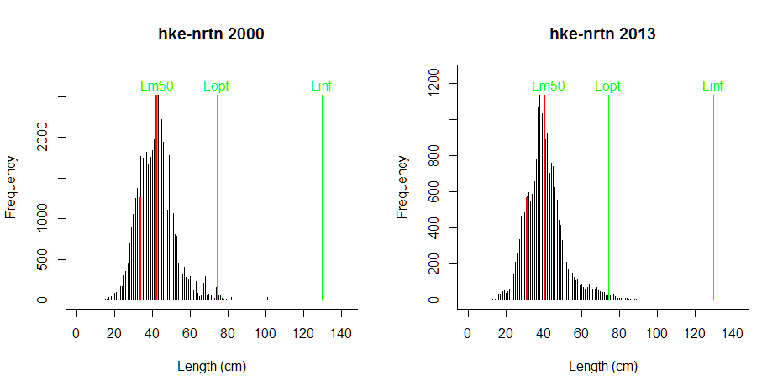
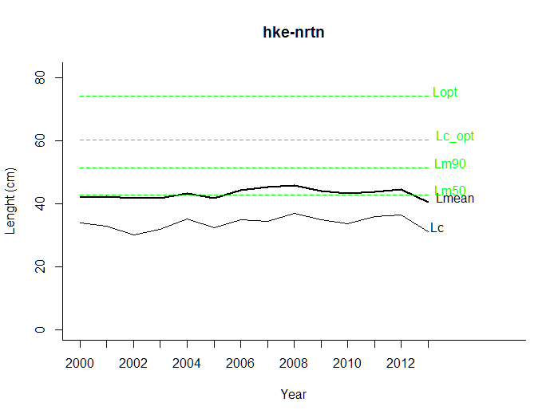

WESTERN MEDITERRANEAN HAKE (I)
---------------------------------------------
Results of LFCOM analysis, Fri Mar 18 16:07:59 2016
Species = Merluccius merluccius , stock = hke-med

External estimates of Linf, K, Lm50, Lm90, M, F
---------------------------------------------
Asymptotic length Linf = 96.8 cm
Growth parameter K = 0.08 1/year
Length at 50% maturity Lm50 = 32.5 cm
Length at 90% maturity Lm90 = 39 cm
Natural mortality of adults M = NA 1/y
Commercial fishing mortality F = NA 1/y
M/K (expected 1.0-2.0) M/K = NA
Comment: It is unclear whether this length frequency is representative of the whole stock

----------------------------------------------
Lopt, Lc_opt and L(F=M) based on Linf
----------------------------------------------
Length at max cohort biomass Lopt = 64.5 cm, assuming b ~ 3 and M/K ~ 1.5
Lc resulting in Lopt Lc_opt = 48.4 cm, if F ~ M
Lc resulting in Lopt Lc_opt = 53.2 cm, if F ~ 2 M
Mean length in catch if F=M L(F=M) = 28.4 cm

---------------------------------------------
Observed Lc and Lmean in 2014
---------------------------------------------
Mean length at first capture Lc = 5.67 cm
Mean length in catch Lmean = 12.5 cm

Time series
---------------------------------------------
Stock Year Lc Lmean Lpeak Lmax
1 hke-med 2006 12.00 17.8 14.3 73
2 hke-med 2007 16.50 20.4 19.0 86
3 hke-med 2008 14.00 20.1 16.7 81
4 hke-med 2009 7.50 13.4 13.0 81
5 hke-med 2010 11.00 18.5 17.0 97
6 hke-med 2011 9.00 14.2 14.0 85
7 hke-med 2012 7.71 16.4 11.3 80
8 hke-med 2013 13.00 19.2 17.0 80
9 hke-med 2014 5.67 12.5 9.0 80

WESTERN MEDITERRANEAN HAKE (II)

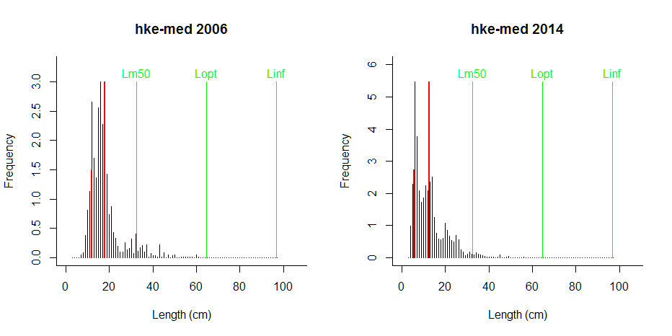
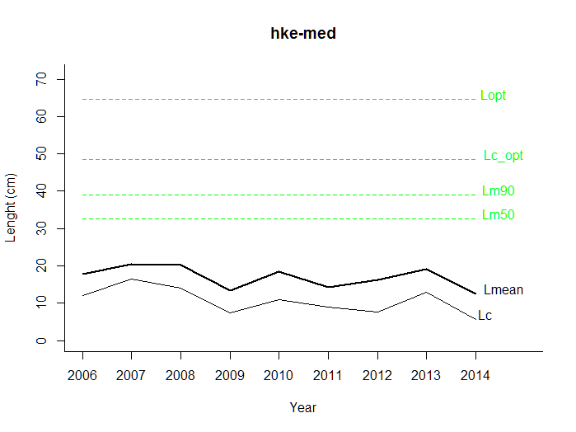
ADRIATIC ANCHOVY (I)
---------------------------------------------
Results of LFCOM analysis, Fri Mar 18 16:14:11 2016
Species = Engraulis encrasicolus , stock = anc-GSA1718

External estimates of Linf, K, Lm50, Lm90, M, F
---------------------------------------------
Asymptotic length Linf = 20 cm
Growth parameter K = 0.4 1/year
Length at 50% maturity Lm50 = 10.5 cm
Length at 90% maturity Lm90 = 14 cm
Natural mortality of adults M = NA 1/y
Commercial fishing mortality F = NA 1/y
M/K (expected 1.0-2.0) M/K = NA
Comment:

----------------------------------------------
Lopt, Lc_opt and L(F=M) based on Linf
----------------------------------------------
Length at max cohort biomass Lopt = 13.3 cm, assuming b ~ 3 and M/K ~ 1.5
Lc resulting in Lopt Lc_opt = 10 cm, if F ~ M
Lc resulting in Lopt Lc_opt = 11 cm, if F ~ 2 M
Mean length in catch if F=M L(F=M) = 13.1 cm

---------------------------------------------
Observed Lc and Lmean in 2014
---------------------------------------------
Mean length at first capture Lc = 10.8 cm
Mean length in catch Lmean = 12.1 cm

Time series
---------------------------------------------
Stock Year Lc Lmean Lpeak Lmax
1 anc-GSA1718 2002 11.5 12.9 13.0 17.0
2 anc-GSA1718 2003 10.5 12.2 12.5 18.0
3 anc-GSA1718 2004 10.7 12.2 13.0 18.0
4 anc-GSA1718 2005 11.5 12.7 13.0 16.5
5 anc-GSA1718 2006 11.5 12.9 13.0 18.0
6 anc-GSA1718 2007 11.2 12.9 13.0 18.5
7 anc-GSA1718 2008 11.0 12.8 12.5 18.0
8 anc-GSA1718 2009 10.8 12.3 13.0 17.5
9 anc-GSA1718 2010 11.0 12.3 12.5 18.0
10 anc-GSA1718 2011 10.8 12.4 12.7 18.0
11 anc-GSA1718 2012 10.8 11.9 12.0 18.0
12 anc-GSA1718 2013 10.8 12.2 12.5 17.0
13 anc-GSA1718 2014 10.8 12.1 12.0 17.0

ADRIATIC ANCHOVY (II)
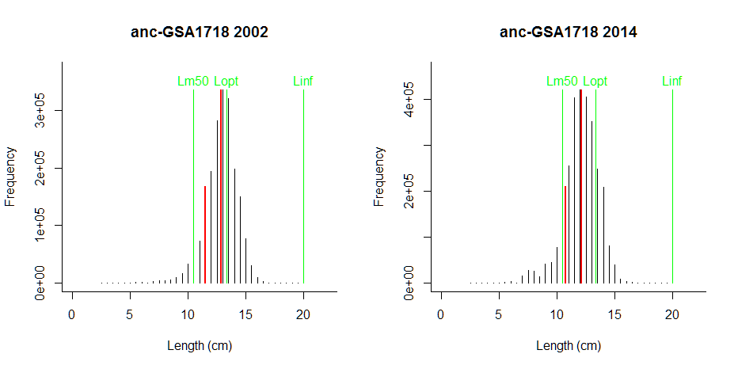
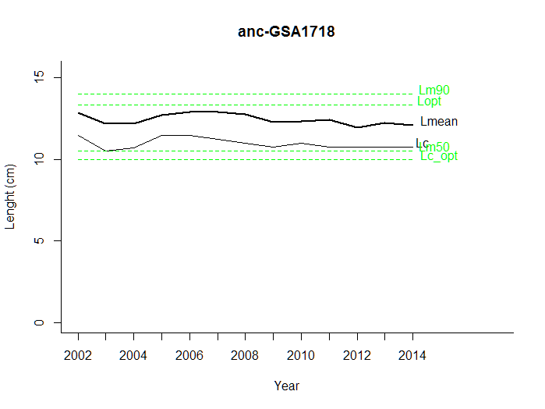

GIANT RED SHRIMP (I)
---------------------------------------------
Results of LFCOM analysis, Fri Mar 18 16:20:11 2016
Species = Aristaeomorpha foliacea , stock = GRShrimp11

External estimates of Linf, K, Lm50, Lm90, M, F
---------------------------------------------
Asymptotic length Linf = 7 cm
Growth parameter K = 0.45 1/year
Length at 50% maturity Lm50 = 3.05 cm
Length at 90% maturity Lm90 = 3.66 cm
Natural mortality of adults M = NA 1/y
Commercial fishing mortality F = NA 1/y
M/K (expected 1.0-2.0) M/K = NA
Comment: Carapace length

----------------------------------------------
Lopt, Lc_opt and L(F=M) based on Linf
----------------------------------------------
Length at max cohort biomass Lopt = 4.67 cm, assuming b ~ 3 and M/K ~ 1.5
Lc resulting in Lopt Lc_opt = 3.5 cm, if F ~ M
Lc resulting in Lopt Lc_opt = 3.85 cm, if F ~ 2 M
Mean length in catch if F=M L(F=M) = 3.78 cm

---------------------------------------------
Observed Lc and Lmean in 2014
---------------------------------------------
Mean length at first capture Lc = 2.7 cm
Mean length in catch Lmean = 3.4 cm

Time series
---------------------------------------------
Stock Year Lc Lmean Lpeak Lmax
1 GRShrimp11 2006 3.35 4.15 3.67 6.5
2 GRShrimp11 2007 3.20 4.13 3.73 6.6
3 GRShrimp11 2008 2.45 3.10 2.75 5.5
4 GRShrimp11 2009 2.48 3.25 3.03 6.8
5 GRShrimp11 2010 2.90 3.78 3.30 6.6
6 GRShrimp11 2011 2.62 3.17 3.13 6.5
7 GRShrimp11 2012 2.38 3.47 2.90 6.6
8 GRShrimp11 2013 3.10 3.93 3.40 6.9
9 GRShrimp11 2014 2.70 3.40 3.23 6.7

GIANT RED SHRIMP (II)
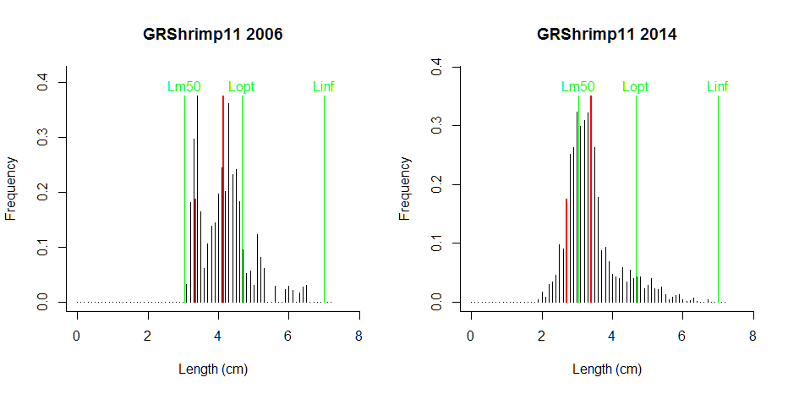

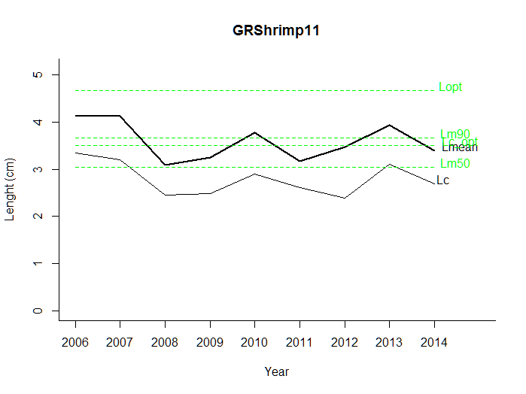
ROUNDNOSE GRENADIER (I)
---------------------------------------------
Results of LFCOM analysis, Fri Mar 18 16:47:39 2016
Species = Coyphaenoides rupestris , stock = rng-5b67

External estimates of Linf, K, Lm50, Lm90, M, F
---------------------------------------------
Asymptotic length Linf = 27 cm
Growth parameter K = 0.06 1/year
Length at 50% maturity Lm50 = 11.4 cm
Length at 90% maturity Lm90 = 13.7 cm
Natural mortality of adults M = NA 1/y
Commercial fishing mortality F = 0.037 1/y
M/K (expected 1.0-2.0) M/K = NA
Comment: Length type is preanal fin length, with PAFL = 0.196*TL+2.29; ref points were adjusted

----------------------------------------------
Lopt, Lc_opt and L(F=M) based on Linf
----------------------------------------------
Length at max cohort biomass Lopt = 18 cm, assuming b ~ 3 and M/K ~ 1.5
Lc resulting in Lopt Lc_opt = 13.5 cm, if F ~ M
Lc resulting in Lopt Lc_opt = 14.9 cm, if F ~ 2 M
Mean length in catch if F=M L(F=M) = 14.6 cm

---------------------------------------------
Observed Lc and Lmean in 2014
---------------------------------------------
Mean length at first capture Lc = 10.5 cm
Mean length in catch Lmean = 13.9 cm

Time series
---------------------------------------------
Stock Year Lc Lmean Lpeak Lmax
1 rng-5b67 1990 18.0 20.7 21.0 27
2 rng-5b67 1991 17.5 20.3 21.0 26
3 rng-5b67 1992 16.5 19.9 19.0 27
4 rng-5b67 1993 15.5 18.3 18.0 26
5 rng-5b67 1994 14.5 18.2 18.0 27
6 rng-5b67 1995 13.5 16.9 16.3 24
7 rng-5b67 1996 14.5 17.9 17.0 25
8 rng-5b67 1997 11.0 15.0 14.0 25
9 rng-5b67 1998 11.5 15.0 15.0 24
10 rng-5b67 1999 11.0 14.3 15.0 24
11 rng-5b67 2000 11.0 14.2 14.0 25
12 rng-5b67 2001 9.5 13.3 12.0 23
13 rng-5b67 2002 13.5 16.6 16.0 25
14 rng-5b67 2003 13.5 16.7 16.0 24
15 rng-5b67 2004 11.0 14.4 15.0 25
16 rng-5b67 2005 11.0 14.6 14.0 25
17 rng-5b67 2006 10.5 13.9 14.0 25
18 rng-5b67 2007 12.5 15.7 15.0 24
19 rng-5b67 2008 10.5 14.0 13.0 25
20 rng-5b67 2009 11.0 14.3 14.0 26
21 rng-5b67 2010 8.5 13.2 13.0 25
22 rng-5b67 2011 10.5 13.5 13.0 24
23 rng-5b67 2012 9.5 13.1 12.0 25
24 rng-5b67 2013 9.5 13.2 12.0 25
25 rng-5b67 2014 10.5 13.9 13.0 26

ROUNDNOSE GRENADIER (II)
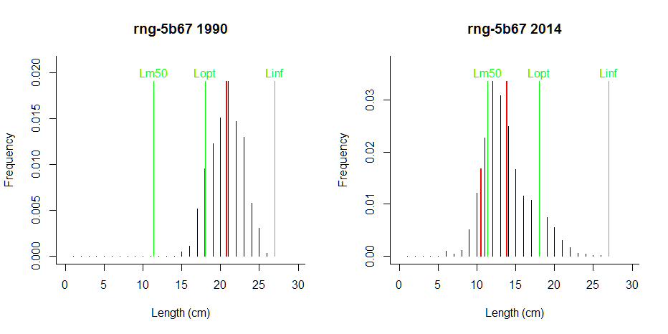
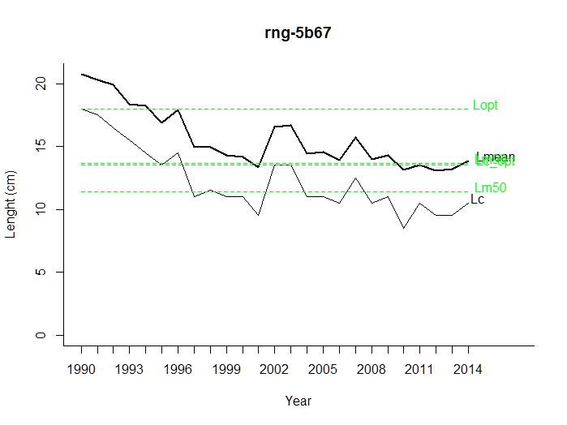

SPURDOG, MALES (I)
---------------------------------------------
Results of LFCOM analysis, Fri Mar 18 16:27:07 2016
Species = Squalus acanthias , stock = dgs_nea

External estimates of Linf, K, Lm50, Lm90, M, F
---------------------------------------------
Asymptotic length Linf = 116 cm
Growth parameter K = 0.1 1/year
Length at 50% maturity Lm50 = 64 cm
Length at 90% maturity Lm90 = 76.8 cm
Natural mortality of adults M = 0.1 1/y
Commercial fishing mortality F = 0.014 1/y
M/K (expected 1.0-2.0) M/K = 1
Comment: Data for males

----------------------------------------------
Lopt, Lc_opt and L(F=M) based on Linf, M, K, F
----------------------------------------------
Length at max cohort biomass Lopt = 87.2
Lc resulting in Lopt Lc_opt = 61.7
Mean length in catch if F=M L(F=M) = 84.2 cm

----------------------------------------------
Lopt, Lc_opt and L(F=M) based on Linf
----------------------------------------------
Length at max cohort biomass Lopt = 77.5 cm, assuming b ~ 3 and M/K ~ 1.5
Lc resulting in Lopt Lc_opt = 58.1 cm, if F ~ M
Lc resulting in Lopt Lc_opt = 64 cm, if F ~ 2 M
Mean length in catch if F=M L(F=M) = 80.2 cm

---------------------------------------------
Observed Lc and Lmean in 2004
---------------------------------------------
Mean length at first capture Lc = 68.2 cm
Mean length in catch Lmean = 73.2 cm

Time series
---------------------------------------------
Stock Year Lc Lmean Lpeak Lmax
1 dgs_nea 1991 66.5 70.9 73.0 88
2 dgs_nea 1992 70.5 74.0 74.7 92
3 dgs_nea 1993 68.5 73.0 73.0 88
4 dgs_nea 1994 66.9 71.6 73.0 96
5 dgs_nea 1995 65.4 72.1 73.3 87
6 dgs_nea 1996 66.8 70.5 72.7 88
7 dgs_nea 1997 66.0 71.6 72.3 91
8 dgs_nea 1998 64.3 70.2 73.0 100
9 dgs_nea 1999 65.7 71.7 73.0 108
10 dgs_nea 2000 70.3 74.1 75.0 100
11 dgs_nea 2001 68.5 72.8 74.0 94
12 dgs_nea 2002 65.0 70.8 74.0 94
13 dgs_nea 2003 68.4 73.6 73.3 97
14 dgs_nea 2004 68.2 73.2 74.0 99

SPURDOG, MALES (II)
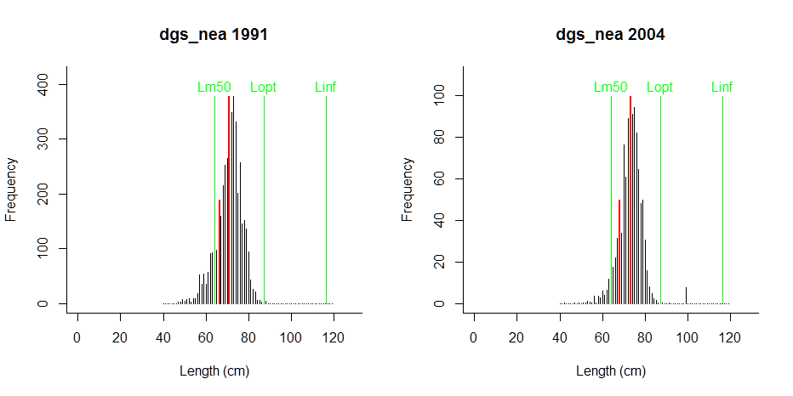
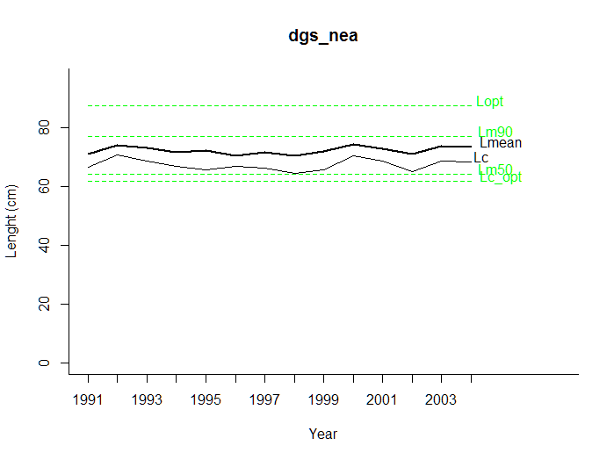

SPURDOG, FEMALES (I)
---------------------------------------------
Results of LFCOM analysis, Fri Mar 18 16:31:01 2016
Species = Squalus acanthias , stock = dgs-nea

External estimates of Linf, K, Lm50, Lm90, M, F
---------------------------------------------
Asymptotic length Linf = 116 cm
Growth parameter K = 0.1 1/year
Length at 50% maturity Lm50 = 80 cm
Length at 90% maturity Lm90 = 96 cm
Natural mortality of adults M = 0.1 1/y
Commercial fishing mortality F = 0.014 1/y
M/K (expected 1.0-2.0) M/K = 1
Comment: Data for females, Lm50 from assessment

----------------------------------------------
Lopt, Lc_opt and L(F=M) based on Linf, M, K, F
----------------------------------------------
Length at max cohort biomass Lopt = 87.2
Lc resulting in Lopt Lc_opt = 61.7
Mean length in catch if F=M L(F=M) = 83.3 cm

----------------------------------------------
Lopt, Lc_opt and L(F=M) based on Linf
----------------------------------------------
Length at max cohort biomass Lopt = 77.5 cm, assuming b ~ 3 and M/K ~ 1.5
Lc resulting in Lopt Lc_opt = 58.1 cm, if F ~ M
Lc resulting in Lopt Lc_opt = 64 cm, if F ~ 2 M
Mean length in catch if F=M L(F=M) = 79.2 cm

---------------------------------------------
Observed Lc and Lmean in 2004
---------------------------------------------
Mean length at first capture Lc = 66.8 cm
Mean length in catch Lmean = 74.5 cm

Time series
---------------------------------------------
Stock Year Lc Lmean Lpeak Lmax
1 dgs-nea 1991 58.6 70.2 63.7 105
2 dgs-nea 1992 59.3 71.1 67.7 109
3 dgs-nea 1993 62.9 71.4 69.3 108
4 dgs-nea 1994 59.0 70.6 68.0 107
5 dgs-nea 1995 65.9 73.8 78.3 107
6 dgs-nea 1996 58.0 67.9 62.0 103
7 dgs-nea 1997 58.5 73.4 64.7 105
8 dgs-nea 1998 59.6 69.9 66.3 108
9 dgs-nea 1999 59.2 71.8 66.7 110
10 dgs-nea 2000 69.0 78.9 78.3 107
11 dgs-nea 2001 66.9 74.9 74.3 107
12 dgs-nea 2002 65.0 74.4 80.0 107
13 dgs-nea 2003 68.1 77.0 75.7 107
14 dgs-nea 2004 66.8 74.5 77.0 111

SPURDOG, FEMALES (II)
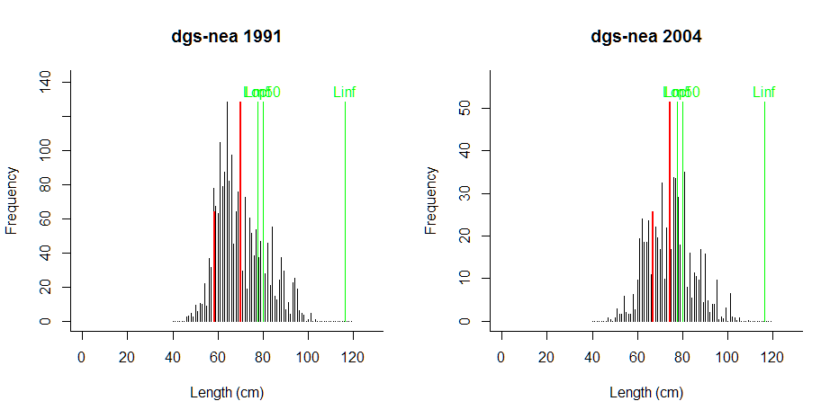
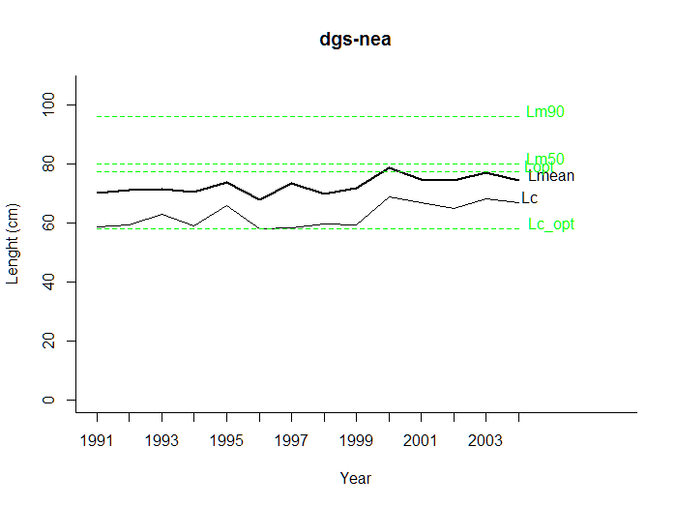

ATLANTIC SWORDFISH (I)
---------------------------------------------
Results of LFCOM analysis, Fri Mar 18 16:35:17 2016
Species = Xiphias gladius , stock = SWO_AS

External estimates of Linf, K, Lm50, Lm90, M, F
---------------------------------------------
Asymptotic length Linf = 264 cm
Growth parameter K = 0.12 1/year
Length at 50% maturity Lm50 = 156 cm
Length at 90% maturity Lm90 = 187 cm
Natural mortality of adults M = 0.2 1/y
Commercial fishing mortality F = NA 1/y
M/K (expected 1.0-2.0) M/K = 1.67
Comment: M and Lm50 from assessment; Linf from lit.

----------------------------------------------
Lopt, Lc_opt and L(F=M) based on Linf
----------------------------------------------
Length at max cohort biomass Lopt = 176 cm, assuming b ~ 3 and M/K ~ 1.5
Lc resulting in Lopt Lc_opt = 132 cm, if F ~ M
Lc resulting in Lopt Lc_opt = 145 cm, if F ~ 2 M
Mean length in catch if F=M L(F=M) = 160 cm

---------------------------------------------
Observed Lc and Lmean in 2003
---------------------------------------------
Mean length at first capture Lc = 125 cm
Mean length in catch Lmean = 157 cm

Time series
---------------------------------------------
Stock Year Lc Lmean Lpeak Lmax
1 SWO_AS 1975 167 192 202 299
2 SWO_AS 1976 159 179 182 259
3 SWO_AS 1977 184 209 212 269
4 SWO_AS 1978 167 198 195 299
5 SWO_AS 1979 155 183 177 293
6 SWO_AS 1980 165 183 196 295
7 SWO_AS 1981 140 175 183 295
8 SWO_AS 1982 136 167 157 295
9 SWO_AS 1983 142 170 152 284
10 SWO_AS 1984 124 168 148 290
11 SWO_AS 1985 138 166 168 301
12 SWO_AS 1986 132 168 166 301
13 SWO_AS 1987 164 172 189 295
14 SWO_AS 1988 134 163 167 295
15 SWO_AS 1989 134 156 165 301
16 SWO_AS 1990 141 164 171 301
17 SWO_AS 1991 134 161 163 301
18 SWO_AS 1992 141 161 158 301
19 SWO_AS 1993 134 166 157 301
20 SWO_AS 1994 133 159 157 301
21 SWO_AS 1995 136 159 158 301
22 SWO_AS 1996 132 158 156 301
23 SWO_AS 1997 122 160 162 299
24 SWO_AS 1998 122 155 158 301
25 SWO_AS 1999 129 155 148 301
26 SWO_AS 2000 122 150 144 299
27 SWO_AS 2001 122 156 149 301
28 SWO_AS 2002 125 154 144 299
29 SWO_AS 2003 125 157 159 301

ATLANTIC SWORDFISH (II)
